Manual for installing and configuring
MyWorkspace

Windows

You can access MyWorkspace using myworkspace.wur.nl. Here, you can access the same files on your network drive (among others) as you normally would when you are logged in to a computer at Wageningen University & Research.

It is useful to install the program VMware Horizon Client on the computer the first time you launch myworkspace.wur.nl. This manual explains how you can install the VMware Horizon Client and how to launch MyWorkspace from a Windows computer.

For more information, see: www.intranet.wur.nl/myworkspace

Quick Start
Step 1
Open a browser (e.g. Internet Explorer, Firefox) and type in the URL: myworkspace.wur.nl.  Please enter your username and password for your WUR account. Click on “Sign in”. | 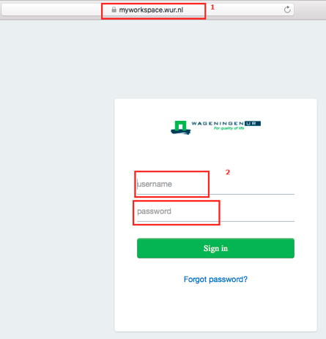

Step 2
Select any desktop with a double click.  Click on the link “Install the Horizon Client”. Then a new tab will open. | 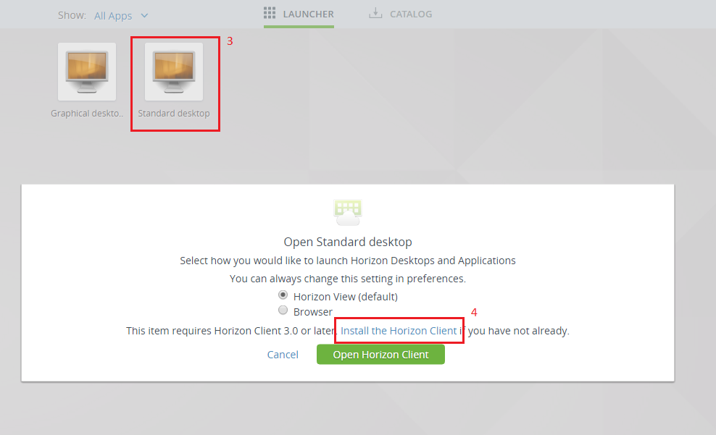

Step 3
Under VMware Horizon Client for Windows, click “Go to Downloads”. | 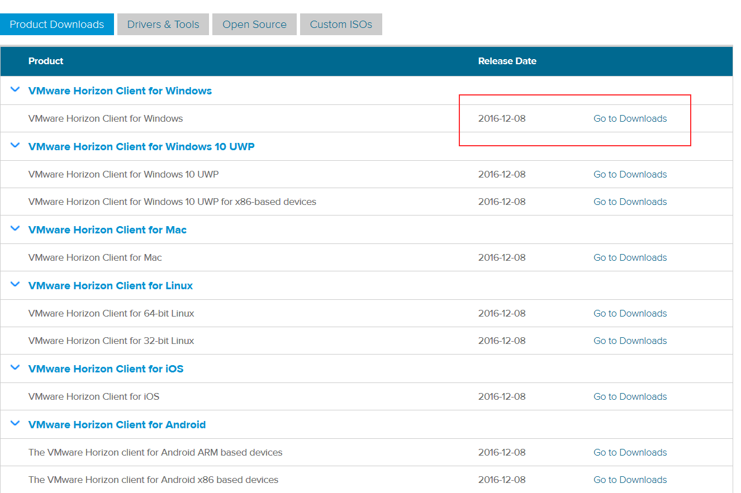

Step 4
Select “Download” | 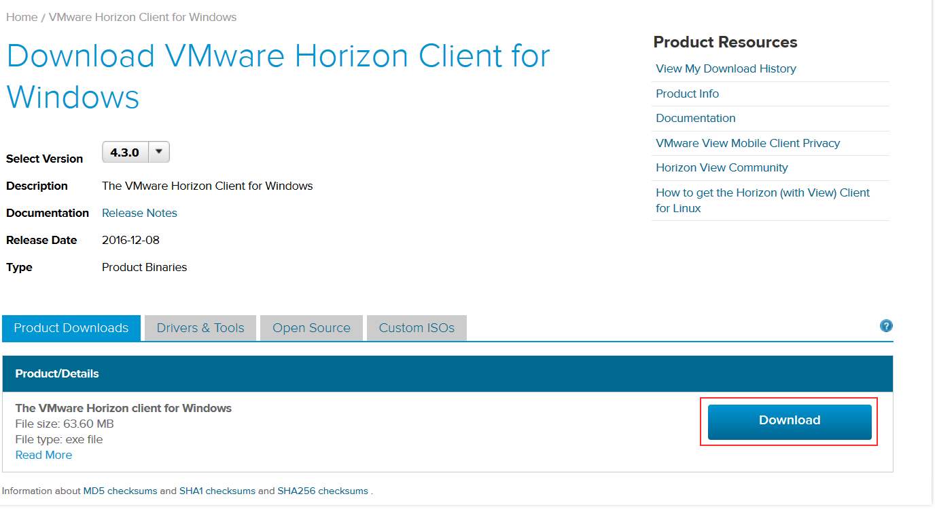

Step 5
Open the downloaded file. Go through the installation process as indicated here.

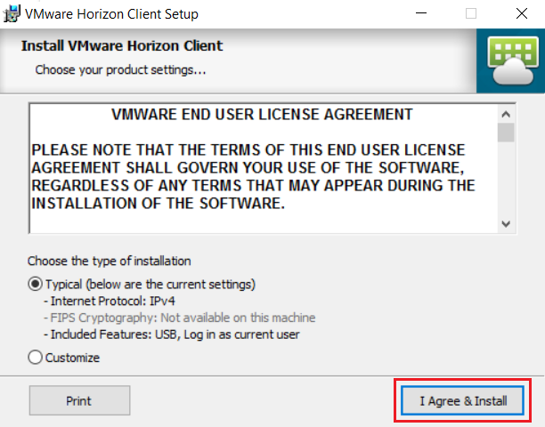 | 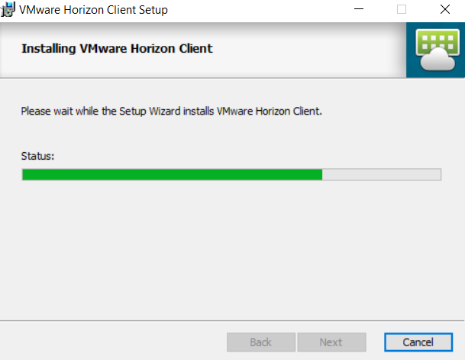
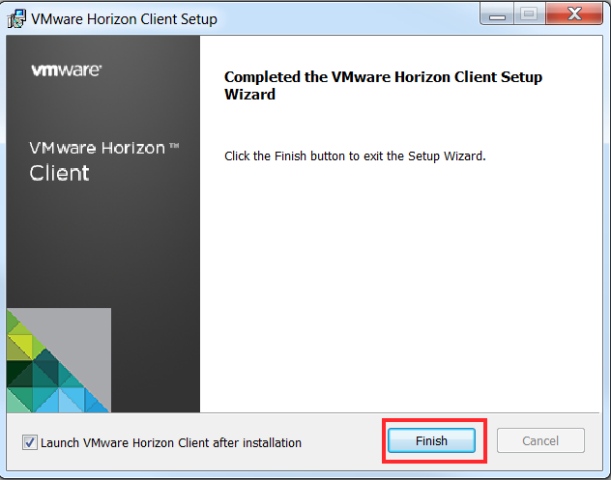

Step 6 | Step 7 | Step 8
Select “Yes” to restart the computer. | When the computer has been restarted, you can open the VMware Horizon Client via your desktop or the Start menu. | Select “+ New Server”.
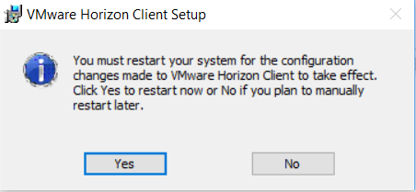 | 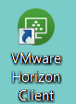 | 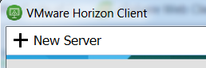

Step 9 | Step 10 | Step 11
In the tekst box, fill in:  workspace.wur.nl. Then select “Connect”. | Fill in your username and password for your WUR account. Select “Login” | Select the desktop you wish to use and launch it by double clicking on it.  Now MyWorkspace will launch. Log in with your WUR username and password.
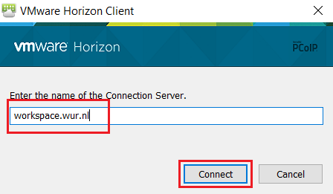 | 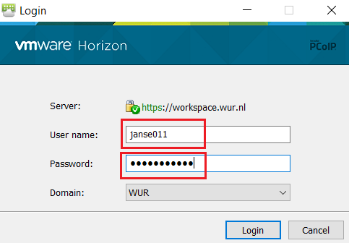 | 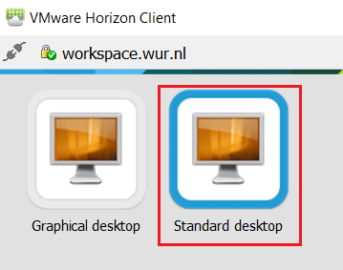

For more information about MyWorkspace for Wageningen University & Research, visit www.intranet.wur.nl/myworkspace.
Or contact the IT Service Desk: (0317-4)88888 / servicedesk.it@wur.nl

