ABG MSc thesis topics: 2018-2019
Update September 2018

Breeding Programs and genetic diversity:

ABG_MSc-thesis2018_001
Genomic versus pedigree inbreeding
Summary: Genomic selection has become the standard for modern breeding programs. The availability of genomic information enables computation of genomic inbreeding, which potentially is more precise than pedigree inbreeding. There are, however, at least four different ways to compute genomic inbreeding. From the perspective of a breeding program, it is important that a measure of genomic inbreeding is used that correlates well with pedigree inbreeding. This thesis will investigate which measure of genomic inbreeding is most closely related with pedigree inbreeding.
Daily supervisor: Mario Calus

ABG_MSc-thesis2018_002
Maternal genetic effects in conformation and movement
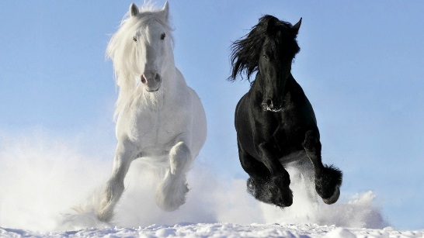
Summary: In practical horse breeding it is sometimes believed that the influence of the mother on performance is larger than the influence of the father; some people would consider a ratio of 60:40 to be more realistic than the 50:50 from theory. One option could be that the mother has an extra effect through maternal effects. In this study you will analyse the effect of maternal components on the performance traits in sport horses.
Daily supervisor: Bart Ducro

ABG_MSc-thesis2018_003
Effect of preselection on size in horses
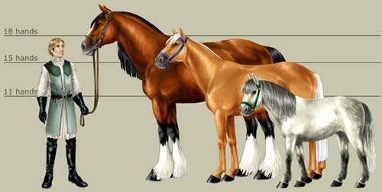
Summary: Preselection refers to sampling of observations on e.g. progeny which is not according to a random sampling protocol. In practical breeding preselection is occurring while people are not aware of it, e.g. admission to inspection or only sampling on animals that meet a minimum requirement (e.g. height at withers). The consequences of preselection on breeding value estimation might be substantial, irrespective whether this is a genetic or genomic evaluation. In this research you will study the effect of preselection on breeding value estimation in horses. You will mimic preselection in an existing dataset on conformation traits recorded at studbook inspection, and see what the consequences are. Next, you will apply methods by which the impact of preselection can be reduced and compare the different methods. If you wish, there might be opportunities to collect data on withers height in the field and analyse effect on preselection in this dataset.
Daily supervisor: Bart Ducro

ABG_MSc-thesis2018_004
Investigate the genetic diversity in a closed colony of baboons.
Summary: Wildlands Adventure Zoo Emmen has been keeping a closed colony of baboons for more than 20 years. Over the years the colony has slowly expanded and now counts close to 200 animals.
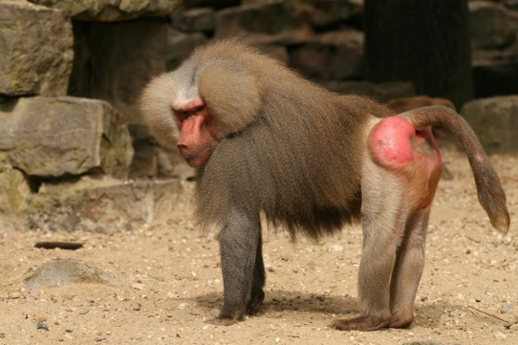
This year Emmen zoo is moving to a new location. This provided a unique opportunity to take blood samples of almost all animals. The samples will be genotyped with a 200 SNP panel to investigate the degree of relatedness in the animals. Student will work on the inheritance analysis of the genotypes and results will be compared with available family information and birth records of the females from Wildlands Adventure Zoo Emmen.
Supervision: Richard Crooijmans and Mirte Bosse.

ABG_MSc-thesis2018_005
Understanding the impact of climate change on African chickens
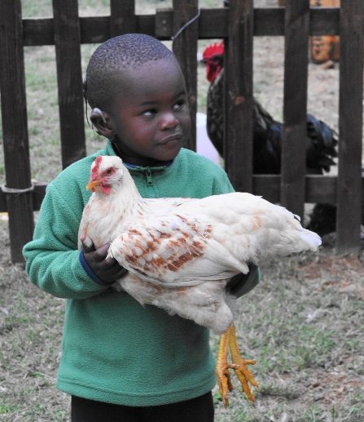
Summary: Climate change is altering the current distribution of the global climatic conditions by elevating the concentrations of greenhouse gases. These changes are associated with extreme changes of the hydrologic cycles (droughts and floods), and are expected to increase environmental temperatures. Smallholders in developing countries are said to suffer the harsher impacts of climate change. We would like to be able to predict the impact of these environmental changes on smallholder farmers. In this project, the student will predict where breeds can still be kept in the future when climate changes. These predictions are made with habitat distribution models which use information on the current climate of locations where the breed is kept now. With this model, different predictions of potential distributions can be generated under different scenarios of how the climate will change. You will use data from one or more breeds of chicken in Ethiopia, together with predictive scenarios on climate change from WorldClim. The result will be a prediction of the impact of climate change on chicken production by smallholder farmers in Ethiopia.
Supervision: Maria Lozano Jaramillo.

ABG_MSc-thesis2018_006
How do cultured fish keep their shape?
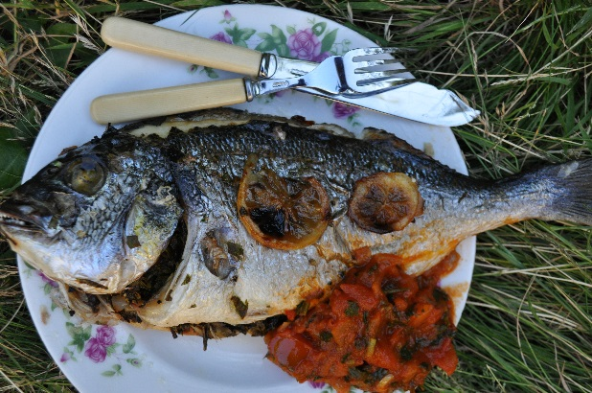
Summary: Fish for aquaculture are typically selected for growth. Selection for growth can have effects on the shape of fish. In this project we will use image analysis to investigate the genetics of shape and appearance. For this project we collaborate with a fish breeding company in Greece that produces high value fish species: sea bream and sea bass. The company is taking photographs of all the fish in their breeding program at multiple times during their growth. The shape and appearance of the fish, i.e. the exterior traits, are very important because they are sold as whole fish. In horses and cattle it is common to give scores for the exterior of the animals and to breed for this. Fish are also scored in a similar way, but obviously for different traits as horses, cattle or dogs. The important traits in fish are roundness, colour, belly shape, etc. In this project you will analyse the digital images of the animals to develop smart and objective measures to describe the exterior of the fish. In a second phase you try to estimate heritabilities for your new measures and investigate how they correlate, genetically, to the current scores given by human judges. The aim is to develop measures that can be included in the breeding program in Greece to improve the appearance of the fish.
Supervision: John Bastiaansen, Hans Komen

ABG_MSc-thesis2018_007
Big data from a school of fish : A computer vision system to measure shape and size.
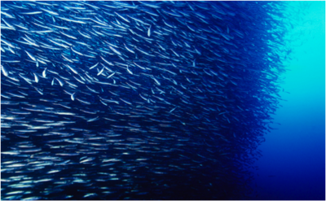
Summary: In animal breeding, one of the biggest challenges is to measure many phenotypes efficiently and accurately. Measuring animals is time consuming, and measurements taken by humans have a limit on how accurate they are and how many animals can be measured cost-effectively. In fish-breeding, regular imaging of fish is becoming the norm, to facilitate semi-automated phenotyping of the animals. Although improvements can be made by this approach, it does not take full advantage of the image data. Rather, what is needed, is a fully automated image analysis approach, that can take many more measurements. In addition, automated systems result in easily scaling up in numbers of animals measured without increasing labour costs that much, and in higher reproducibility of the measurement. From a scientific perspective the exciting prospect is to capture quantitative aspects of the phenotype that can only be measured subjectively by humans. How do you quantify, for instance ‘shape’, from looking at a picture or when only taking 2 or 3 manual measurements? A computer vision system can measure hundreds of points in a reproducible way. In this project you will develop a prototype of a fully automated fish phenotyping program. The programming part will be done using Python (a general and very popular programming language) and OpenCV (a specialized computer vision library that can be used in Python). However, more importantly, you will investigate and apply new ways to define shape and growth parameters that can be derived from your software. Depending on your interests, this can be approached either from biologically informed phenotype definitions, such as lateral line shape, operculum shape, etc, or from more general ‘big data’ type approaches, collectively called ‘Machine Learning’. Interested students will have the opportunity to learn basic programming in Python.
Supervision: Hendrik-Jan Megens, John Bastiaansen.

ABG_MSc-thesis2018_008
The Mediterranean belly challenge
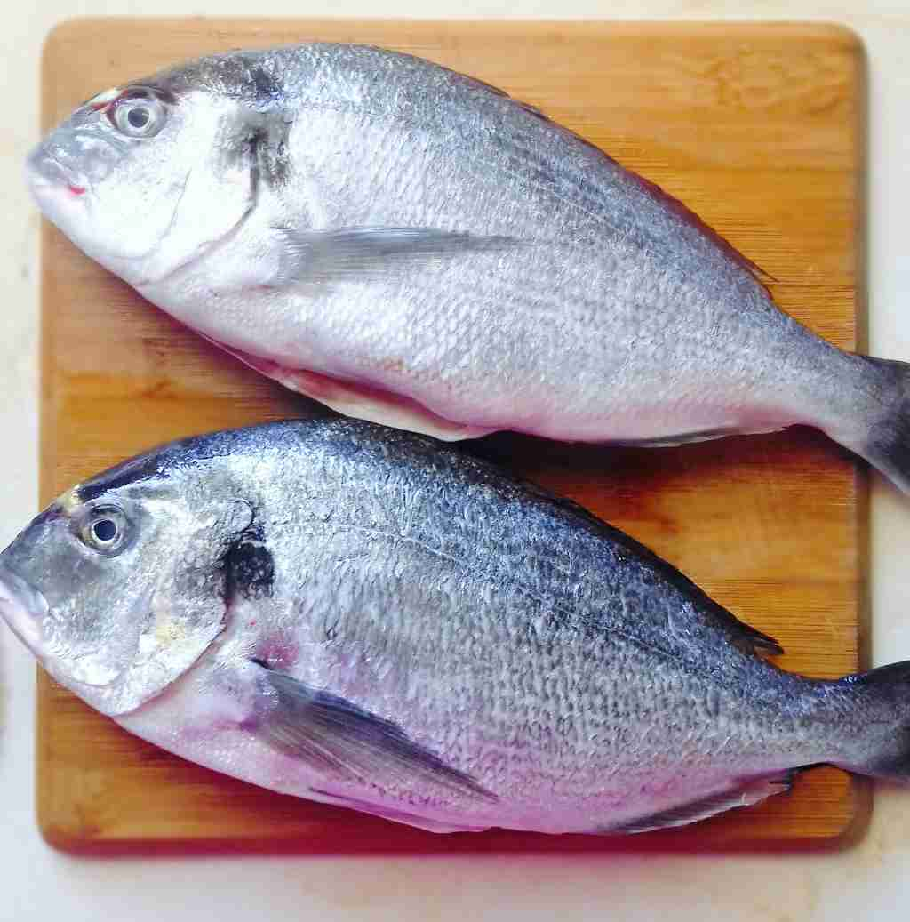
Summary: Sea bream (also called “Dorade” in Dutch) is an important fish that is produced in countries around the Mediterranean. Breeding programs for sea bream aim to improve the growth and survival of these fish. Improvement of quality is gaining importance. An important quality measure is the amount of fat that accumulates in the belly and around the organs of the fish. In this project we want to investigate the genetics of fat deposition in fish and the relationships with other measurements. This includes defining the traits from detailed measurements that are available on a pedigreed population of sea bream. The measurements are taken by a breeding company in Greece and include external measures with a fat meter that uses microwave technology to estimate fat content as well as scores given to the shape of the belly. In addition, after the external measures are taken a number of fish are used for detailed dissection of the different organs and fat masses. From all these measurements we are interested in how to predict the fatness of the belly. For this you will apply techniques to estimate the heritabilities and genetic correlations of the different phenotypes and investigate ways to predict breeding values for belly fat based on correlated traits.
There are possibilities to combine this thesis subject with an internship where you spend some time in Greece with the company.
Supervision: John Bastiaansen, Hans Komen

ABG_MSc-thesis2018_009
Fast growing fish also healthy?
Summary: Fish is generally known to be a healthy food for humans. To become a healthy food, farmed fish should be healthy itself. In this study we will investigate the genetic relationship of growth and health of the fish.
For this project health is measured as the condition of several organs, like the gills, the heart and the liver that play an important role in supporting the growth of fish. For instance by supplying oxygen, or by metabolizing fatty acids. These organs are expected to be good checkpoints for the overall health of the animal. For this study a large number of fish from a breeding population have been dissected and the health of their organs was scored by a veterinarian. The heritabilities of these scores as well as their correlations with growth will be estimated by you. In addition you will investigate whether difference in environmental conditions such as the season have an impact on the variation that is observed in organ health. From your results you will make recommendations on what is needed in a breeding program to make sure the fish stay healthy while selecting for improved growth.
Supervision: John Bastiaansen, Hans Komen

ABG_MSc-thesis2018_010
From sequence to sushi: Genetic diversity in a newly domesticated fish species.
Summary: The Yellow Tail Kingfish (Seriola lalandi) is one of several fish species that has recently made the transition from exclusively wild-caught to being cultured, and is now on its way to becoming a domesticated species. This species has a biology that is similar to tuna (although no direct ‘family relationship’): It lives in the oceans and is very mobile. These fish are found all around the world. The domestication process and related breeding are directed to efficient production and high quality meat. Most of the meat is produced for Sushi, a highly prized product. There is, however, currently hardly any knowledge on the variation in this species in the wild, or in cultured systems. We recently sequenced the genome of the Yellow Tail Kingfish, and conducted physiological experiments and gene expression analyses to gain a better insight in the biology of culturing this species. We have also sequenced 20 Yellow Tail Kingfish that were caught from the wild near South Africa from cultured populations in Chili and Australia. This whole-genome sequence data holds a very large amount of information that can give us knowledge on the evolution of the species and on the variation that is present in the populations that are currently in the process of becoming domesticated.
Questions that you can be working on: what is the effective population size? How much variation is there in the genome? What is the pattern of evolution in protein altering-, versus neutral evolution? And is there reason to fear inbreeding depression when a species that may have a very large population size in the wild is transferred to an enclosed and relatively small breeding system?
Supervision: Hendrik-Jan Megens, John Bastiaansen

ABG_MSc-thesis2018_011
Potential of genomic selection for better health in dogs.
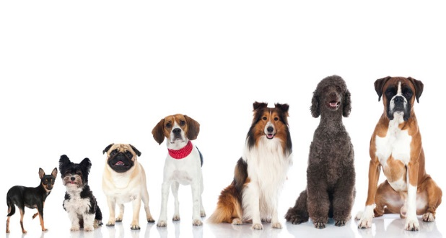
Summary: Health issues are prominent in most dog breeds. Selection may help to decrease diseases with a polygenic background. In the UK and Sweden breeding values are now estimated for hip-dysplasia in some of the larger breeds . Extension to other countries and breeds is not straightforward, especially because pedigree data across breeds and countries is often lacking. One possibility to overcome this would be to use DNA information. With genomic selection DNA profiles are linked to breeding values in a reference population. This then enables the estimation of breeding values for animals with only DNA information. An important aspect determining the accuracy of their breeding values is their relatedness to the reference population. This subject will investigate the feasibility of genomic selection in dog breeds. It will answer questions such as the required size of the reference population, breed composition of the reference population and the influence of different relatedness among breeds or among populations in different countries, whether or not in the reference population. Computer simulations will be used to provide answers.
Supervision: Jack Windig, Mario Calus and/or Jeremie Vandenplas

ABG_MSc-thesis2018_012
Genetic diversity in Dutch local cattle breeds stored in the gene-bank
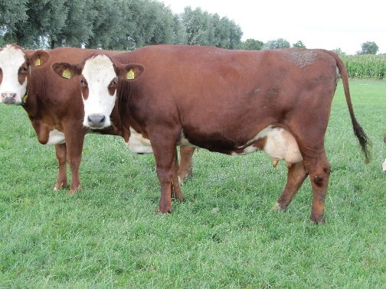
Summary: The DNA of all local cattle breeds stored in the Dutch gene-bank has been typed with SNP-chips at the end of 2016. Now a wealth of information on genetic diversity in the gene-bank and in the local Dutch cattle breeds is available, which can help to manage both the gene-bank and the breeds themselves. In this subject this genetic diversity will be explored. Diversity can be quantified in different ways (e.g. allelic diversity, marker estimated kinships, rows of homozygosity etc.) to answer questions such as:
- Do breeds differ in the amount of diversity stored in the gene-bank?
- How much does the genetic diversity of the different breeds overlap (and differ)?
- How does the diversity stored in the gene-bank relate to the diversity in live populations?
- Has the diversity in the breeds changed over time?
Student interested in the conservation of genetic diversity can apply. Having followed animal breeding courses or wildlife genetics will be helpful but is not required.
Supervision: Jack Windig (AS: possibly more student projects)

ABG_MSc-thesis2018_013
Cryopreservation of eel sperm
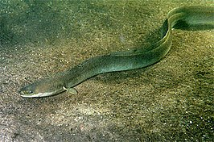
Summary: We would welcome a MSc student who is interested to investigate by literature review how cryopreservation of eel sperm can be improved. World-wide, eel populations have decreased strongly in numbers since the 1970s. The existing eel farms still depend on the catches of glass eels in nature which are then raised to market size. Only a restricted number of glass eels is available for aquaculture and societal concern exists about the lack of sustainability. Successful reproduction in captivity could supply aquaculture with glass eels and close the production cycle. This way, both eel aquaculture as well as management of the natural populations could become sustainable. The current status of European eel reproduction is that some research groups can produce larvae regularly which are then kept alive up till about 20 days post hatching. However, larvae cannot be fed yet and therefore they die around that age. Problematic is still the high individual variation in maturation response of female eels. Therefore it would be useful to have a good quality sperm storage available.
What we need from you is a review on cryopreservation methodology in fish, specifically eels. This review would provide a status update and recommendations on how to improve the current protocols. Your improved protocol will then be validated by us and compared with the currently available protocol and the use of fresh sperm.
Supervision: Arjan Palstra and Henri Woelders

ABG_MSc_thesis2018_014
Inbreeding depression across the genome of Holstein Friesian dairy cattle
Summary: Inbreeding depression refers to the reduced performance for traits as a result of inbreeding. Important traits for dairy cattle (including production, health and fertility traits) are known to be affected by inbreeding depression. Prior to the genomics era, the degree of inbreeding depression was quantified by regression of phenotypes on pedigree-based inbreeding coefficients. Now, with the wide availability of genotype data, it is possible to obtain more accurate genomic estimates of inbreeding depression. In addition, genotype data offers the opportunity to differentiate inbreeding across the genome and can, thus, be used to pinpoint genomic regions associated with depression for specific traits. Information on such unfavourable homozygous regions may then be incorporated in mating schemes to reduce their probability to occur in the offspring. We have a large database available with pedigree, genotype and phenotype information of Dutch Holstein Friesian cows. The objectives of this project are to 1) quantify the degree of inbreeding depression at the genome-wide level for a variety of traits, using pedigree-based and genomic inbreeding measures, and 2) identify genomic regions associated with inbreeding depression for these traits. We are looking for a student with an interest in the application of genomic data to animal breeding, the effects of inbreeding and how it can be managed, and/or with an interest in cattle breeding.
Daily supervisor: Harmen Doekes

Quantitative genetics:

ABG_MSc-thesis2018_015
Relation between litter size and survival in pigs
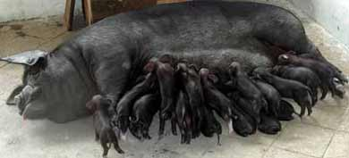
As litter sizes are further increasing in pigs there is a risk this will be at the expense of correlated traits like vitality of individual pigs. A closer look is required to this relationship to properly define breeding programs to avoid undesirable effects. Large datasets are routinely collected by breeding companies to study such a relationship. You will work with advanced statistical techniques like random regression to tackle this research question and will talk with people from the industry about practical consequences.
Contact: Han Mulder

ABG_MSc-thesis2018_016
Use of automatic oestrus data in breeding values for reproduction in dairy cattle
Oestrus detection is often facilitated using sensor devices like pedometers. These devices record many more data than actually used to alert oestrus Additional traits might be defined which have a relationship with reproduction in dairy cattle. In this study you will work with large data streamings from pedometers and you will develop new traits and investigate whether these are geneticallly determined. You will work together with people from Nedap and CRV
Contact: Bart Ducro and Han Mulder

ABG_MSc-thesis2018_017
Validating a model for the trait with maternal effects
Summary: Optimal modelling has a key role in improving predictability of breeding values of traits of interest, and thereby increasing genetic gain of the breeding program. In developing the optimal animal model, correlating predictions to the corrected phenotypes is a common method to validate a model in cross-validation analysis. However, for the traits affected by maternal effects, the conventional cross-validation method can lead to an overestimation of predictability of the model. To avoid this overestimation, we would like to use a different approach to calculate the predictability using half-sib correlation. It is unknown, however, if this approach is better than the conventional method of validating a model. Student will work on stochastic simulation of breeding programs and how to develop an appropriate models to improve predictability of breeding values.
Contact: Thinh Chu Tuan

ABG_MSc-thesis2018_018
Relationships between genomic breeding values with phenotypic data of resilience and performance of HF female calves at Dairy Campus
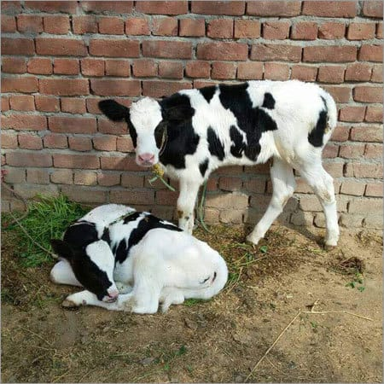
Rearing the best calves for replacement is an important goal for farmers. During two years in total 224 calves will be monitored at Dairy Campus in the first four months of their life for drinking, eating, growth, health and immune competence. The research question for this thesis is to which degree these parameters relate to the pedigree and genotypic breeding values of the calves, e.g. for resilience and health traits? So partly, this will give insight whether genetic differences in health and resilience traits are already visible in young calves. Furthermore, it may give insight to which degree phenotypes of calves can help to find resilience indicators. Activities are: connect the data and estimate relationships between genomic breeding value information with phenotypic information on health and performance parameters of the calves in the first 4 months of their life. Explore the data en report the results.
Further details, see:
https://www.dairycampus.nl/nl/Home/Onderzoek/Lopende-projecten/InnoCalfconcept.htm, https://www.dairycampus.nl/nl/Home/Onderzoek/Lopende-projecten/Innovatieve-fokkerij-voor-efficientie-en-gezondheid-.htm
https://www.wur.nl/en/project/GenTORE-GENomic-management-Tools-to-Optimize-Resilience-and-Efficiency.htm

Daily supervisor: Han Mulder/ Rita Hoving / Kees van Reenen

ABG_MSc-thesis2018_019
Analysis of survival when hens are kept in different group sizes
Summary: Piter will write summary
Daily supervisor: Piter Bijma/ Katrijn Peeters

ABG_MSc-thesis2018_020
Analysis of Genotype by Environment interaction in laying hens: the effect of beak trimming on egg production
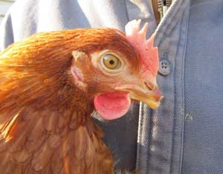
Summary: Beak-trimming is a common procedure in laying hens to reduce the damage due to feather pecking and to avoid feather pecking turning into cannibalism. There is a desire to get rid of beak-trimming, since it may affect welfare of the laying hens. However, beak trimming may affect egg production. In other words, families that are good egg producers when beak-trimmed may be suboptimal without beak-trimming. This may result in the selection of the wrong families if the selection and production system differ with respect to beak trimming. This is a form of GxE-interaction, which can be quantified by estimating the genetic correlation between egg production in beak-trimmed and intact birds. In this thesis project, you will statistically analyse data on egg production in laying hens, so as to quantify this GxE-interaction.
Daily supervisor: Piter Bijma

ABG_MSc-thesis2018_021
Breeding for general disease resistance in chickens
Summary: Livestock production has been, and is still changing dramatically due to societal concerns. Antibiotic resistant bacteria (amongst other reasons) led to a ban on antibiotic use. Group housing of animals is mandatory, and increases welfare. In addition group housing also increases disease pressure on animals. Robust livestock animals are needed for these challenging environments. In chicken, levels of natural antibody were associated to an increased survival during laying period. Therefore natural antibody levels seem to be a promising selection criterion for general disease resistance in layer chicken. Currently we are selecting two chicken lines for either high or low levels of natural antibodies. As expected, the high line showed a 2-fold lower mortality due to an E. coli-infection than the low line. In addition, some relevant genomic regions were identified. However many questions remain concerning natural antibodies, disease resistance, and consequences for production parameters. The project offers various opportunities for students interested in the link between animal breeding and genetics and immunology. However, a background in immunology is not needed! For more information on thesis possibilities, please send an e-mail to Marleen Visker.
Possible techniques: estimation of genetic parameters, estimation of maternal effects, genome wide association studies, estimation of correlated responses, (q)PCR, mutations, determination of immune repertoire
Supervisors: Marleen Visker, Henk Bovenhuis

ABG_MSc-thesis2018_022
Improvement of the efficiency of milking robots
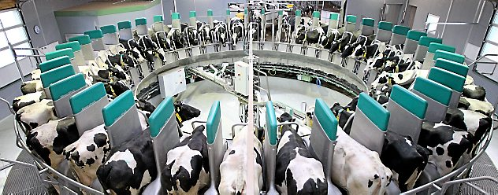
Summary: At this moment, efficiency of milking robots is determined by measuring the number of kg milk per minute robot time, and is only determined based on successful milking events. This efficiency can be estimated better when also unsuccessful milking events are taken into account, and breeding for this trait can result in a cow that makes more efficient use of the milking robot by generating less unsuccessful milking events and/or producing more kg milk per minute robot time. In this way, the output in kg milk per milking robot can be further improved. Unsuccessful milking events can be caused by poor udder conformation, or by agitation of the animal (starting phase of lactation, character, environment (flies), stress-experience). In this project, the student is asked to extract, check and structure the data from the milking robots at farms, define the traits, and to estimate the relevant genetic parameters. In addition, genetic correlations with other traits will be estimated. The project will be executed at CRV, Arnhem, under supervision of CRV and Wageningen University.
Contact person ABG: Han Mulder

ABG_MSc-thesis2018_023
Estimating genetic correlations between body weight, plumage condition, survival and performance in crossbred laying hens.
Summary: Feather pecking is an important economic and welfare problem in the commercial laying hen industry. During this thesis you will be using data of ISA, a Hendrix Genetics company to estimate genetic correlations between important traits (body weight, plumage condition, survival and performance) in four crossbred layer lines. Furthermore, you will investigate the effect of social interactions on these traits.
Daily supervisor: Esther Ellen

ABG_MSc-thesis2018_024
Genomic breeding value for feed intake in dairy cattle
Summary:
Daily supervisor: Roel Veerkamp

ABG_MSc-thesis2018_025
Estimating genetic parameters for body weight in crossbred laying hens
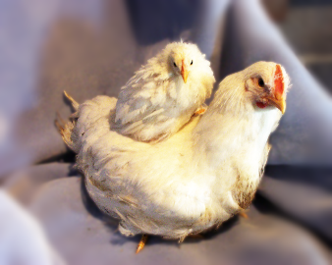
Summary: In this study, you will estimate genetic parameters for body weight in four crossbred layer lines. Body weight has been collected when the birds were approximately 40 weeks of age. To estimate genetic parameters, you will include genomic information in the analysis. During this thesis, you will work with several computer programs, including R and ASReml. You will have the opportunity to visit the breeding company Hendrix Genetics to discuss and present your results.
Daily supervisor: Piter Bijma/ Katrijn Peeters

ABG_MSc-thesis2018_026
Finding the solution for estimating significant SNPs in a GWAS analysis using a Bayesian approach.
Summary: Bayesian methods rely only MCMC-methods which is basically using an iterative approach to calculate the SNP-effects in a GWAS analysis. It might require 100,000’s of iterations. Finding the solution assumes that the solution exist and it a matter a searching for it in an efficient way.
Evolutionary algorithms have been described to do this efficiently. The idea is to develop an evolutionary algorithm for the Bayesian method such that it will find the answer quicker than by iteration. This might be especially useful if many SNPs become available due to sequencing (instead of genotyping) individuals. You will learn about R, Bayesian analysis, evolutionary algorithms; it is going to be very challenging!
Daily supervisor: Henri Heuven

ABG_MSc-thesis2018_027
Efficient genomic evaluation with a large number of genotyped animals
Summary: Single-step genomic evaluations combining data from genotyped and non-genotyped animals are becoming the method of choice to predict genomic breeding values. However, such genomic evaluations could become infeasible with more than 100,000 genotyped animals, mainly due to expensive inversions of the genomic relationship matrices. An algorithm computing an approximation of the inverted relationship matrices was recently proposed to remove this limitation. The aim of this thesis is to test and to validate this algorithm for genomic evaluations involving purebred and crossbred genotyped animals.
Daily supervisor: Jeremie Vandenplas

ABG_MSc-thesis2018_028
Disentangling the (antagonistic) correlation between production and disease and reproduction using markers.
Summary: Just as genetic variation can be explored using markers, i.e. determine which loci affect a trait, also genetic covariation can be explored. Some genes/loci have a positive effect on two traits while other loci have opposite effects on the two traits. The overall effect of all loci together is the genetic correlation. Once this genetic background is understood it might be easier to select for antagonistic traits. In this project you will earn how to use R to handle data files, ASReml to estimate genetic correlations and Bayz to disentangle genetic correlations using markers.
Daily supervisor: Henri Heuven

ABG_MSc-thesis2018_029
How accurately can we predict the accuracy of genomic breeding values?
Summary: The accuracy of estimated breeding values is an important parameter in breeding programs, since it determines the rate of genetic improvement (ΔG). In order to select the most optimal breeding program, it is important to be able to predict the accuracy of breeding values already before actually implementing the breeding program. Recently, an equation to predict the accuracy of genomic breeding values was derived, which can predict the accuracy when information from different traits or populations (breeds or environments) is combined in one training population for genomic prediction. Using simulations, the equation showed to be able to accurately predict the accuracy in different scenarios. The aim of this MSc thesis is to validate the equation for different scenarios using real data. During this thesis, you will learn more about genomic prediction and about the factors affecting the accuracy of genomic prediction. Moreover, you will get experience in handling large datasets containing genotype data, in performing genomic evaluations, and in calculating the input parameters for the prediction equation using real data. Please keep in mind that organizing the data before the start of the thesis might take some time. So please inform us ~3 months in advance about your interest in this topic.
Daily supervisor: Yvonne Wientjes

ABG_MSc-thesis2018_030
Estimation of breeding values for longevity in sheep?
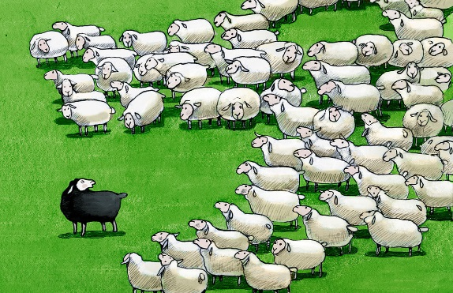
Summary: Considering sustainability in a breeding program is important in various livestock species and often this is done by including longevity in breeding. Breeding for longevity requires that the date of death or culling is known, which is often not the case in some species. One could consider the last date known to be alive as a proxy of longevity. E.g. in sheep lambing date is often recorded (or birthdate of the lamb and its dam is registered). In thesis you will analyse whether last date of lambing (or weaning of the lamb) is a good proxy for longevity in the Swifter sheep breed, and if this trait can be used for breeding for higher longevity. The dataset consists of ca. 1000 ewes and their lambing dates from the last 15 years. Issues you have to deal with in this thesis are censoring (we don’t know the true culling date), and connectedness between herds (although exchange of rams is taking place).
Daily supervisor: Gerben de Jong (CRV)

ABG_MSc-thesis2018_031
Painting chromosomes based on local ancestry
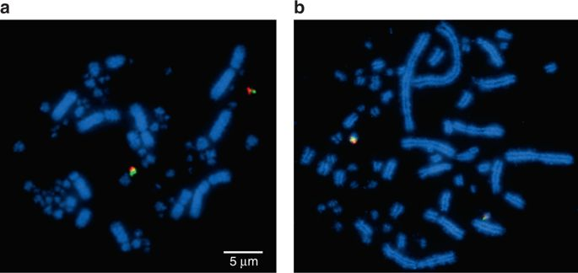
Summary: Analysis of genotype data from admixed populations provides important insights in the mapping of disease genes, in the control of population structure for genome-wide association studies, or even in the study of population genetic processes. In livestock, genotype data of animals from multiple breeds, or crosses, can be also beneficial for genomic selection. In this context of admixed populations, “painting” accurately the chromosomes of current individuals (i.e., estimating the ancestry at every locus) may be an important step for accurately performing such analyses, and several methods have been proposed. In this MSc project you will perform a literature study to make an overview of the different available methods and software, and their characteristics. You will potentially compare the efficiency of selected software using simulated datasets for crossbred animals.
Daily supervisor: Jérémie Vandenplas

ABG_MSc-thesis2018_032
Efficient computation of genomic relationship matrices with a large number of genotyped animals
Summary: Single-step genomic evaluations combining data from genotyped and non-genotyped animals are becoming the method of choice to predict genomic breeding values. However, such genomic evaluations could become infeasible with more than 100,000 genotyped animals, mainly due to the expensive creation and inversion of the genomic relationship matrices. Use of distributed memory systems could potentially remove this limit. The aim of this thesis is to develop and test a software for distributed memory systems that is able to compute and inverse genomic relationship matrices with a large number of genotyped animals. The software will be developed in Fortran or C/C++.
Daily supervisor: Jeremie Vandenplas

ABG_MSc-thesis2018_033
Developing an state of the art routine for finding (regions containing) causal mutations.
Summary: Recently Sun et al. (GSE (2016) 48:77) have described how linkage information and co-segregation can be disentangled for genomic prediction. The hypothesis is that this model is also suited to discover causal mutations affecting quantitative traits. Knowledge regarding causal mutations become very important for across population predictions as well as for genome editing.
I’m looking for an enthusiastic person that likes to be trained in the field of R and Bayesian Analysis, i.e. in the field of quantitative genetics combined with statistics and programming.
Daily supervisor: Henri Heuven henri.heuven@wur.nl

ABG_MSc-thesis2018_034
Genomic evaluations that combine large number of genotyped and non-genotyped animals
Summary: Genomic evaluations are now applied in several production systems, such as those for cattle, pigs and chickens. A current challenge is to deal with the (future) large amount of genomic information. Recently, several models were proposed to combine large amount of data from genotyped and non-genotyped data. Comparison of these models is required to develop an optimal genomic evaluation that is able to deal with many genotypes. Therefore, the aim of this thesis is to review the different models proposed in the literature and to test these models using “small” datasets. During this thesis, you will learn more about genomic evaluation, and you will gain programming experience.
Daily supervisor: Jeremie Vandenplas, Mario Calus

ABG_MSc-thesis2018_035
New phenotypes to take the dairy cow into the future
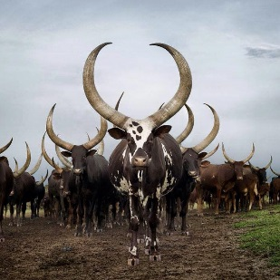
Summary: The dairy industry is striving to make progress in sustainability and production efficiency to ensure a profitable industry in the future. In the age of genomics numerous difficult to measure or expensive phenotypes are under investigation for inclusion in the selection index. Recent advances in breath analysis technologies have resulted in innovative ways to obtain phenotypes that are linked to climate change such as methane, carbon dioxide and nitrous oxide as well as those linked to metabolic disorders such as acetone and ethanol. However, little is known of the genetic background of breath phenotypes in dairy cattle and their inter-relationships with selection traits. The candidate is expected to critically analyse new phenotypes to ensure they are 1) repeatable 2) heritable and 3) determine their genetic relationships with other economically important traits.
Supervision: Yvette de Haas

ABG_MSc-thesis2018_036
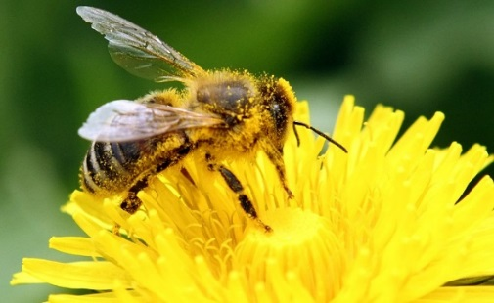
Genomics in honey bees
Summary: The pedigree in honey bees differs considerably from the usual situation studied in animal breeding, like in cattle, pigs or poultry. Observations are not done on one single individual as in dairy cows, growing pigs or laying hens, but on thousands of workers, jointly called a colony. The dam of the workers, of the colony, is the queen that is the only single individual in the pedigree. The sire again is a group of animals, the group of queens producing the multitude of drones that mate with a virgin queen. This pedigree poses considerable challenges in estimation of breeding values of honey bees and in the application of genomics as well. The thesis is about the optimal design of a reference population. What ‘animals’ to include to reach maximum accuracy with least effort. The thesis also is about the question what avenues there are to utilise genomics. Is it primarily an issue of unravelling pedigree relationships or an issue of shorting of generation intervals, or both.
Supervision: Pim Brascamp

ABG_MSc_thesis2018_037
Factors influencing meat quality of organic pigs assessed during slaughter.
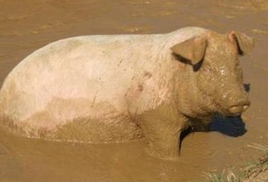
The organic slaughter plant ‘de Groene weg’ is currently slaughtering daily about 200 – 300 piglets from different suppliers. There is a noticeable variation in carcass and meat quality among batches from different suppliers which might be due to age at slaughter, sex and genotype etc. Further quantification of the differences between batches require additional traits to be considered. This research will give you the opportunity to perform quite some practical work as well as data analysis.
Contact Egbert Kanis/ Bart Ducro

ABG_MSc-thesis2018_038
Cross-breeding in Sri Lanka dairy cattle
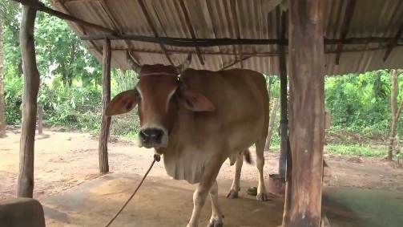
Cross breeding using western breeds on local breeds in Sri-Lanka is not always successful and depending on the genotype used. A large dataset has been built and analysis would reveal which bulls best can be used for cross breeding
Contact: Wim Houwers

Genomics, including bioinformatics:

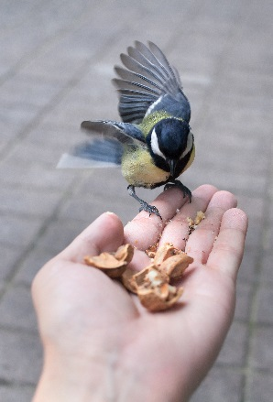
ABG_MSc_Thesis2018_039
Whole genome bisulfite sequencing (WGBS) is a technique for profiling genome-wide DNA methylation. However, analysis of WGBS data still poses considerable challenges especially in the mapping and SNP –calling phases. Although many computer programs have been developed for mapping and calling, most of the programs have barely succeeded in improving either quantity or quality of the results. In this project we would like to compare extensively different mappers and callers to develop the best combination for WGBS data analysis by using the Parus major datasets. We will also test how this pipeline will work with reduced representation bisulfite sequencing (RRBS) data.
Contact: Veronika Laine (NIOO) and Ole Madsen

ABG_MSc_Thesis2018_040
Infer Effective population size in livestock species using machine learning.
Effective population size (Ne) is one of the most important parameter in population genetics and conservation biology. The effective population size is defined as the size of a simple population that would have the same increase in homozygosity and the same random drift in allele frequencies as the population studied. Changes in effective population size have been linked to the loss of genetic diversity, increased level of inbreeding and genetic drift in biological populations and particularly in endangered species. Recent methods approximate past changes in Ne allowing the reconstruction of the population history by estimating changes in historical Ne, making it feasible to distinguish between historical and recent human-influenced levels of genetic diversity. However, the estimation of Ne is not always that straightforward, since many more demographic events, such as bottlenecks and selection, may also affect it. Different demographic scenarios have been simulated using computational simulations, and particularly ABC methods. However, the recent emerging use of supervised machine learning in population genetics for inferring demographic history is quite promising not only from a computation perspective, but also for the higher performance and accuracy reached by ML algorithms, including feed-forward artificial neural network, random forests, and extra-tree classifiers.
The aim of this MSc thesis is to develop an algorithm that is able to infer changes in effective population size in livestock species as a result of different demographic processes using whole-genome sequence data of hundreds of individuals. Skills that will be developed are programming in Python and machine learning.
Contact: Chiara Bortoluzzi, Ronald de Jongh, Hendrik-Jan Megens

ABG_MSc_Thesis2018_041
Elucidate the genetic variability available in Dutch chicken genetic collections.
During the last decades, the development of, and increased interest in, efficient selection programmes, have led to a remarkable reduction in the genetic diversity of poultry genetic resources. Such genetic decrease has been caused by an accelerated genetic improvement in a limited number of breeds only. As a consequence, highly productive breeds have often replaced traditional breeds across the world, many of which have gone extinct, while those that survived have been marginalised. In the case of traditional Dutch chicken breeds, selection for the original production traits has ceased, as breeds are nowadays used for purposes beyond production, such as ornamental hobby farming. In The Netherlands, the continuing efforts to preserve chicken diversity nationally have been reinforced by the national gene bank, which uses cryopreservation to secure the genetic diversity of traditional rare breeds. At the moment, the Dutch gene bank holds a comprehensive collection of frozen semen of more than 250 animals of officially recognised heritage breeds collected over 24 years (1985-2009). Although gene bank collections represent a complementary alternative for genetic diversity conservation, the lack of molecular, demographic, and functional characterisation studies of the chicken material present in the Dutch gene bank may challenge practical future uses of the frozen material. Such knowledge gap needs to be urgently addressed, in order to open up the use of animal semen collections in the near future.

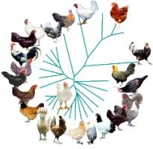
The aim of the MSc project is to exhaustively characterise the chicken diversity captured in the Dutch gene bank, in order to address two important issues in the management and conservation of both in-vivo, traditional breeds and gene bank collections, including 1) the value of the germplasm repository in recreating in-vivo traditional chicken breeds in case of reduced genetic diversity, or extinction in extreme cases, along with 2) the relevance of using frozen semen to minimise inbreeding and genetic drift in small, managed populations. The MSc student will characterise the genetic diversity and breed identity of gene bank collections in comparison to managed populations, to investigate their potential contribution to the Dutch genetic diversity. In particular, the between and within breed genetic diversity will be quantified, along with the part of it that is not present in current in-situ populations or genetic collections. Moreover, genetic collections will be assessed as potential reservoirs of advantageous diversity and interesting phenotypes that may have both disappeared from the current managed populations. Since breeds have gone through different selection and demographic processes, different levels of potentially detrimental variation can be found across the genome, which may cause or increase inbreeding. Demographic events will be investigated by mean of haplotypes and haplotype blocks structure, since their genetic background and diversity level can be used to infer past and recent demographic history, along with selection history. On the other side, the effects of accumulated detrimental alleles in selected haplotypes on inbreeding depression will be characterised and evaluated in relation to their functionality, in order to provide directions for breeding and conservation efforts, along with a better exploitation of genetic collections.
Contact: Chiara Bortoluzzi, Anouk Schurink, Hendrik-Jan Megens

ABG_MSc_Thesis2018_042
The effect of inbreeding on reproductive traits in pig.
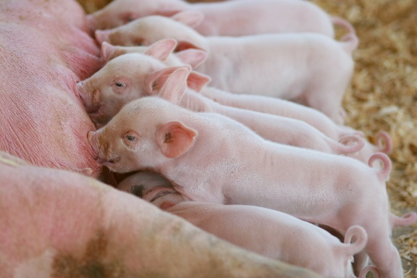
Deleterious genetic variation contributes to the presence of rare genetic diseases in animal populations. In an inbred population, however, these deleterious alleles will accumulate to higher levels of homozygosity, affecting population fitness. Therefore, it is generally assumed that the higher the inbreeding within a population the lower the fitness of the offspring. The current availability of genotype data for large commercial pig populations opens new possibilities to investigate the role of inbreeding on reproduction by estimating the level of inbreeding and genomic relationship of the parent animals. More precisely, the student will investigate the effect of several genomic parameters (e.g. parental identity by descent (IBS), inbreeding, runs of homozygosity, genetic relationship) on reproductive traits in pigs (e.g. total number born, number of stillborn). Goal of the project is to get insight into the relationship between the level of parental genomic relatedness and reproductive success.
Contact person: Martijn Derks
Status: available

ABG_MSc-thesis2018_042
Estimation of de novo mutation rates in pigs using family-based sequencing analysis
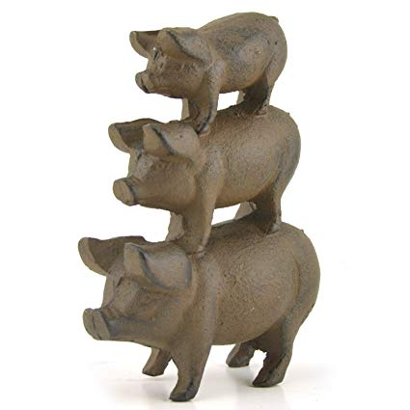
Summary: De novo mutations generates new genetic variations which potential can have an effect on phenotypes. Our understanding of de novo mutation in farm animals is still limit, specific in terms of e.g. 1) where in the genome do de novo mutations arise and 2) are there local differences in de novo mutation rates in the genome? Whole genome sequencing data from families makes it possible to estimate de novo mutations. In this project whole genome sequence data of 1 family trio and 1 family quartet (parent + offspring) of pigs will be use to estimate de novo mutation rates. Different tools available for detecting de novo mutation from family data will be used and compared.
Daily supervisor: Ole Madsen

ABG_MSc-thesis2018_043
Analysis of selective sweeps during speciation of the Sus family
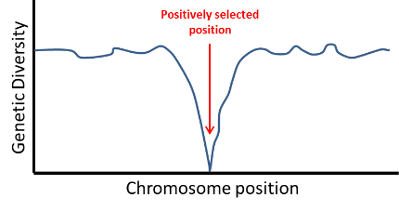
Summary: Use of whole genome sequence data of multiple individuals of three species (Sus scrofa, Sus barbatus and Sus cebifrons) to study specific selective sweeps during speciation.
Daily supervisor: Martien Groenen/Hendrik-Jan Megens

ABG_MSc-thesis2018_044
Analysis recent genome rearrangements in the genomes of species within the Sus family based on de novo assembled genomes of three species (Sus scrofa, Sus celebensis and Sus cebifrons)
Summary: Whole genome alignments of the de novo assembled genomes (from NGS data) of Sus celebensis and Sus cebifrons against the pig (Sus scrofa) reference genome to identify insertions, deletions and inversions.
Daily supervisor: Martien Groenen/Hendrik-Jan Megens

ABG_MSc-thesis2018_045
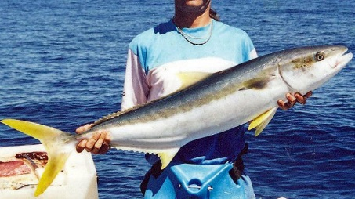
Yellowtail kingfish genomics: studying the genome and variome of a newly domesticated marine fish species.
Summary: Population genomics of the YTK fish based on whole genome sequence data from 20 individuals from 3 different populations.
Daily supervisor: Hendrik-Jan Megens/Dick de Ridder (bioinformatics)

ABG_MSc-thesis2018_046
Correlations between tissue specific miRNAs and mRNA expression
Summary: In recent years it has become evident that phenotypic variation is often caused by variation in gene expression. Large scale sequencing projects in humans and model organisms (ENCODE projects) have shown that gene expression is a complex process where both genetic and epigenetic variations play a role. Understanding this complex process of gene regulation is still deficient in farm animals and the need for such an understanding is not only important for gaining fundamental insight in the functional genome of farm animals but will likely also facility future breeding goals. In this study you will use two type of epigenetic data (miRNA and DNA methylation) from three different pig breeds to assess the role of these epigenetics marks in gene expression. Material & Methods: Analysis of miRNA-seq and RNA-seq data from 5 tissues from 3 individual pigs using NGS software like Tophat, Cufflinks and the miRDeep2 pipelines
Daily supervisor: Ole Madsen

ABG_MSc-thesis2018_047
CVN analysis in different pig breeds using 650k SNP genotypes
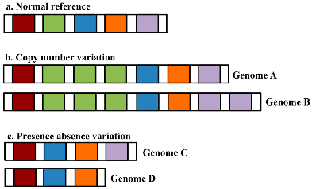
Summary: You will work with a large SNP genotype data set of around 100 pig samples of different breeds. By using PennCNV software you will identify CNVs. You will characterize the CNV regions by looking at overlapping genes. You will look at breed differences and function of the genes involved. Compare results with SNP genotypes from whole genome sequence data and from 60K SNP chip.
Daily supervisor: Martien Groenen/Richard Crooijmans

ABG_MSc-thesis2018_049
Comparison of gene copy numbers between placental and non-placental livebearing fish
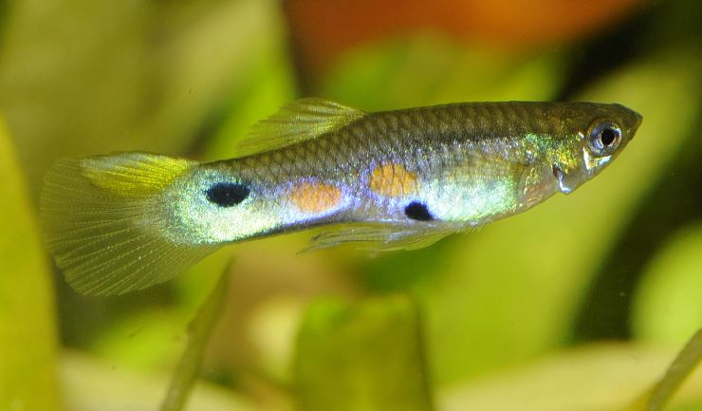
Summary: Livebearing fish of the family Poeciliidae show a striking difference in the amount of nutrients that are transferred to the embryo after fertilization of the egg. In some species, the embryos start with a large amount of yolk and receive few nutrients from their mother during pregnancy (non-placental or lecithotrophic) while for other species the embryo receives many nutrients from its mother during pregnancy (placental or matrotrophic). Currently, the genomic basis for this difference is unknown. However, it is known that gene duplications can be an important driving force of the evolutionary processes that cause differences between closely related species. Using newly assembled reference genomes, you will assess the differences in gene copy numbers between placental and non-placental poeciliid fish, and test the hypothesis of gene duplications acting as a driving force of the evolution of the placenta in poeciliid fish.
Daily supervisor: Henri van Kruistum

ABG_MSc-thesis2018_050
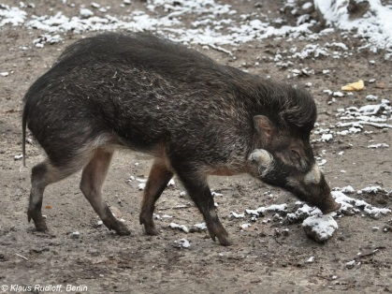
Sus cebifrons (Visayan warty pig) de novo genome assembly, annotation, and transcriptome analysis for conservation genomics
Summary: Further improvement of a de novo assembled genome based on a comparison with the pig (Sus scrofa). Use of RNAseq data from Visayan warty pig for gene prediction (use of programs like Trinty, PASA and MAKER)
Daily supervisor: Hendrik-Jan Megens/Martien Groenen/Ole Madsen

ABG_MSc-thesis2018_051
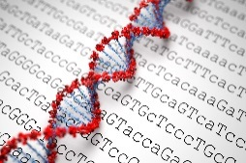
Assessment of risk of inbreeding depression in domesticated animal populations based on whole-genome re-sequencing data
Summary: Project is based on WGS data from several hundred individual animals (available for chicken, turkey and pigs).
Daily supervisor: Hendrik-Jan Megens

ABG_MSc-thesis2018_052
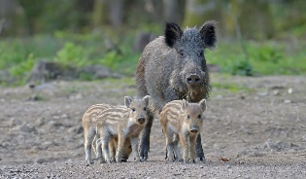
Conservation genomics of wild boar
Summary: Population genomics analysis of whole genome sequence data of wild boars from different regions in Europe and Asia.
Daily supervisor: Hendrik-Jan Megens

ABG_MSc-thesis2018_053
Does genetic variation of morphology vary among insular populations of common voles?
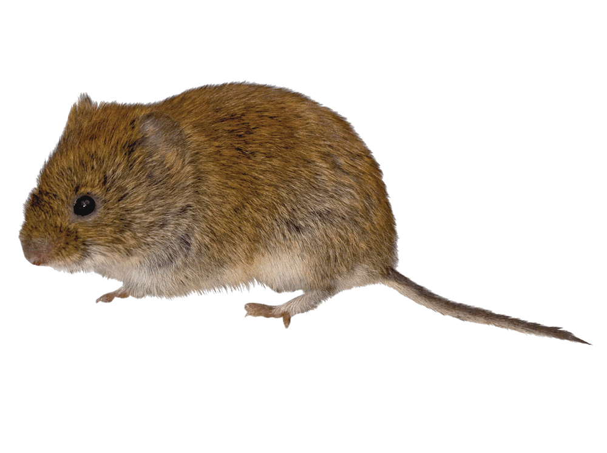
Summary: It has been shown that selection has led to genetically different morphology in insular populations of voles. An interesting follow-up question is whether this selection has also differently depleted additive genetic variation. To address this question data from a laboratory breeding experiment will be analysed using quantitative genetic methods.
Daily supervisor: Phillip Gienapp (NIOO)

ABG_MSc-thesis2018_054
Elucidating the genomic background of broiler growth rate and its relation with health
Background
Summary: Within this project you will have the possibility to:
- Analyze an existing RNAseq state-of-the-art experiment
- Use several software tools for bioinformatics, systems biology, and statistical analyses
- Combine the results of all methods to reach biological conclusions with important knowledge about the response to selection, which can be used in broiler breeding
Daily supervisor: Marinus te Pas

ABG_MSc-thesis2018_055
The course of genomic evolution in birds
Summary: Genomic tools experienced an intense development in the last years, which resulted in a large amount of published genomic data for wild and domestic birds. Genomic data which shows variation between species can give valuable insights on the course of evolution, highlighting important molecular events and its nature. To evaluate the genetic variation between bird species this project propose the use single nucleotide polymorphisms (SNP) and the number of copies within specific genomic intervals (copy number variation - CNV) currently available in the literature. Thus, the project will include a brief review on the ‘Genetic variation between different bird species’ and a implementation of an in-silico analysis to identify genes and biological pathways selected in each of the analysed species.
Daily supervisor: Vinicius da Silva

ABG_MSc-thesis2018_056
Meta-analysis of intestinal transcriptomics data of broilers
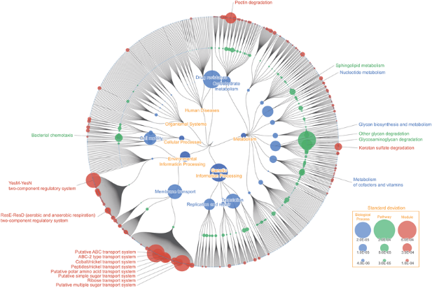
Summary: The first aspect is to perform a literature study, focusing on the temporal and spatial development of the gut in broilers, what is already known in broilers mostly regarding the genes involved in the following processes; functional, morphological, immunological, and also the colonization of the gut microbiota. The second aspect is getting hands-on experience in data acquisition from public online repositories for transcriptomics data, as well as data handling and analysis in R. The emphasis of this project is on the functional analyses of the acquired data, such as cluster analysis and generating gene association networks. The last aspect is to combine the meta-analysis of transcriptomics data followed by functional analyses, and (re)view this in light of known literature and describe the added value of such an approach. Deliverable: Concept scientific article.
Daily supervisor: Dirk-Jan Schokker

ABG_MSc-thesis2018_057
Title: What is needed to keep a ‘old’ laying hen vital?
Summary: In the (near) future laying hens will be getting older (up to 100 weeks), the underlying question is how to keep these ‘old’ laying hens vital. Important aspects are the energy/metabolism homeostasis and immune system, as well as the calcium requirements. Underlying mechanisms can possible be steered via nutrition and/or genetics, so it is important to investigate which contribution both can have. The focus of this project is on the genes and their context, such as signalling pathways or molecular interaction networks. The aim is to generate and analyse molecular interaction networks based on ‘known’ literature. Subsequently, expand these networks by integrating transcriptomics data. Another aspect of this project is to elaborate on potential indicators for health, for example which genes/metabolites or organs/tissues are most discriminatory for ‘health’. Deliverable: Concept scientific (review) article with case-study of network approach.
Daily supervisor: Dirk-Jan Schokker

ABG_MSc-thesis2018_058
Insights of the Lakenvelder phenotype in farm animals
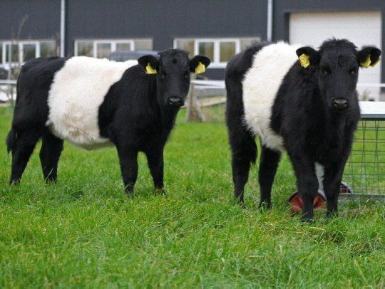
Summary: Coat colouring in farm animals is a complex phenotype. The” Lakenvelder” phenotype is a phenotype occurring in several species. We would like to know how the genetics and genomics behind this trait. Furthermore we would like to have a summary of all genes involved in coat colour over species. We do have SNP genotypes of Lakenvelder chicken and cattle available. A selective sweep analysis in chicken and in cattle Lakenvelder can be performed to find potential new genes associated with this trait. This project is partly a literature study and SNP data analysis. A comparative study between species will be part of the task.
Daily supervisor: Richard Crooijmans
Status: available

ABG MSc Thesis2018_059
Detection of deleterious recessive haplotypes in great tit population (Parus major).
Deleterious genetic variation contributes to the presence of rare genetic diseases in animal populations. It is estimated that each individual carries a number of deleterious recessive alleles. The current availability of large numbers (>2,500) of genotyped individuals in great tit allows for novel genetic methods to identify deleterious recessive haplotypes. Recessive inherited diseases can be identified by testing for statistical depletion, even absence, of certain haplotypes in homozygous state. In this project you will develop methods to identify these regions of missing homozygosity in the great tit genome and assess the abundance and frequency of these haplotypes in current great tit populations.
Contact person: Martijn Derks
Status: available

ABG MSc Thesis2018_060
Inheritance of a chromosomal-wide inversion in great tit
Large inversions in bird genomes are known to affect different phenotypes. A striking example is the non-canonical reproductive strategy in ruff, which is associated with an inversion that in turn underlies lower testosterone levels. Moreover, inversions have a prominent role in the evolution because they can lead to strong differentiation between the inverted and non-inverted region. Recently, we identified a chromosome-wide inversion on PM1A present in 5-10% of wild great tit (Parus major) populations, which indicates an evolutionary role for the inversion haplotype.
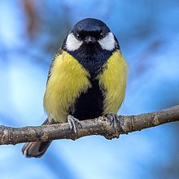
This 1A inversion is indeed highly differentiated from the normal version of the chromosome 1A and until this point was demonstrated to occur just in heterozygotic state. From 2017 onwards we will start to breed birds containing the inverted chromosome 1A to allow detailed evaluation of inversion inheritance. The student shall then be able to explore whether the heterozygotic state is mandatory for birds carrying the inversion haplotype. Therefore, the student should illustrate different levels of genomic complexity within inverted and non-inverted 1A chromosomes, discuss associated phenotypes as well as their putative evolutionary roles. This is a collaborative project between Wageningen University & Research (WUR) and Netherlands Institute of Ecology (NIOO-KNAW), supervised by two researchers in each institute and will require knowledge on bioinformatics and genetics.
Supervisors: Vinicius Henrique da Silva (WUR), Mirte Bosse (WUR), Veronika Laine (NIOO-KNAW), Marcel E. Visser (NIOO-KNAW)

