2020-2021

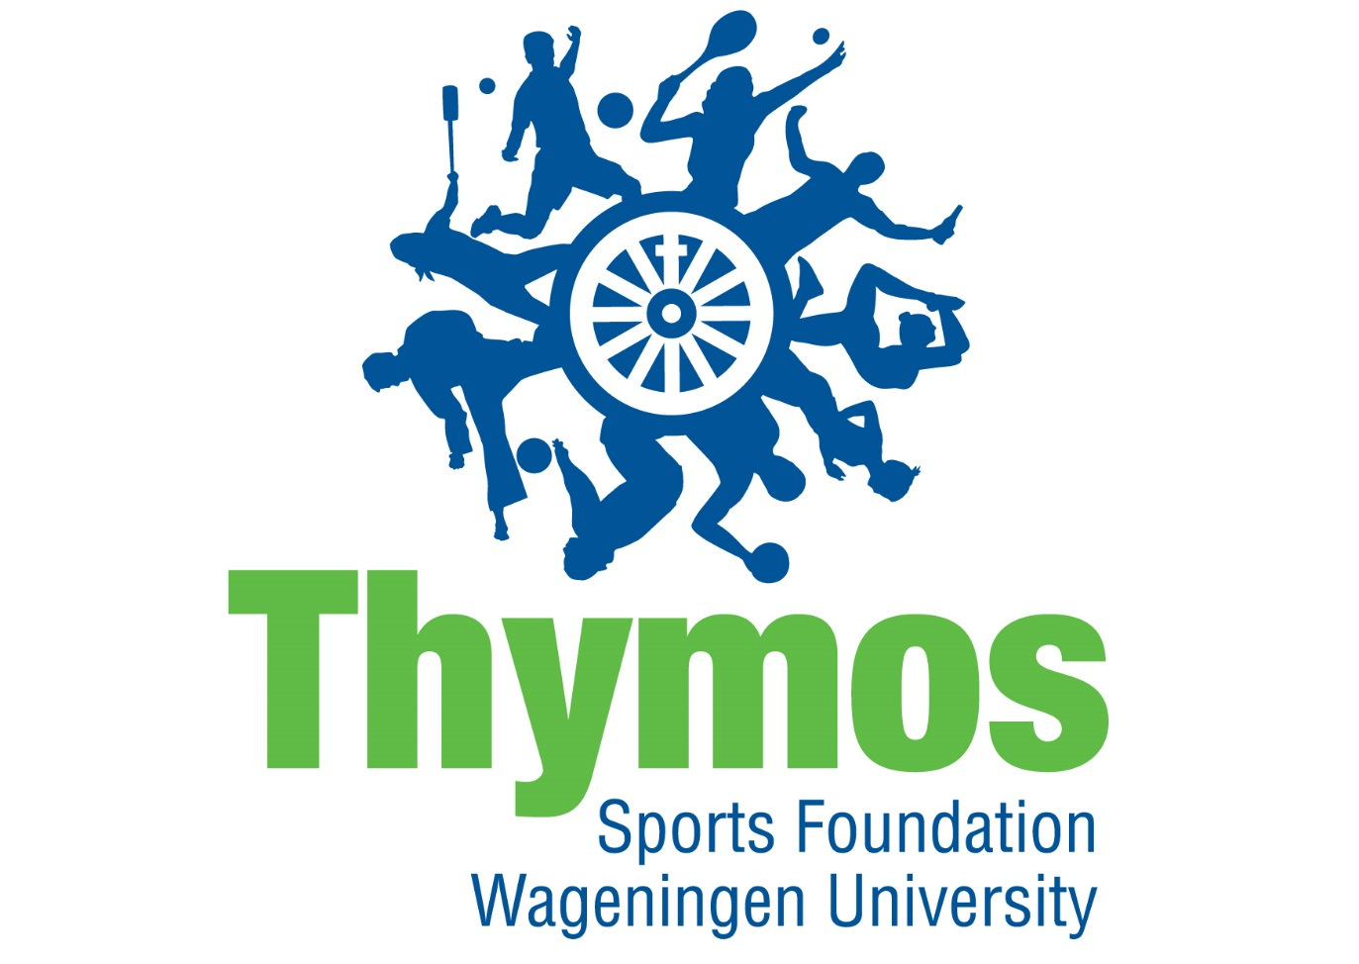
Dear potential board member!

In this information booklet you will find all the information about a full time board year at SWU Thymos. We will explain the goal of the sports foundation and what has been done the last years. Furthermore, we will explain what each and every board position entails. The positions are chair, secretary/vice-chair, treasurer, commissioner of publicity and commissioner of sports. Finally we will explain in detail how you can apply and what we expect from you. We hope that after reading this booklet that you know the basics about SWU Thymos and that you have become enthusiastic to dedicate yourself a year to student sports in Wageningen. If you have questions or just want to drink a cup of coffee you can always visit us in our office.

Good luck with making your choice!

Daily Board SWU Thymos 2019/2020

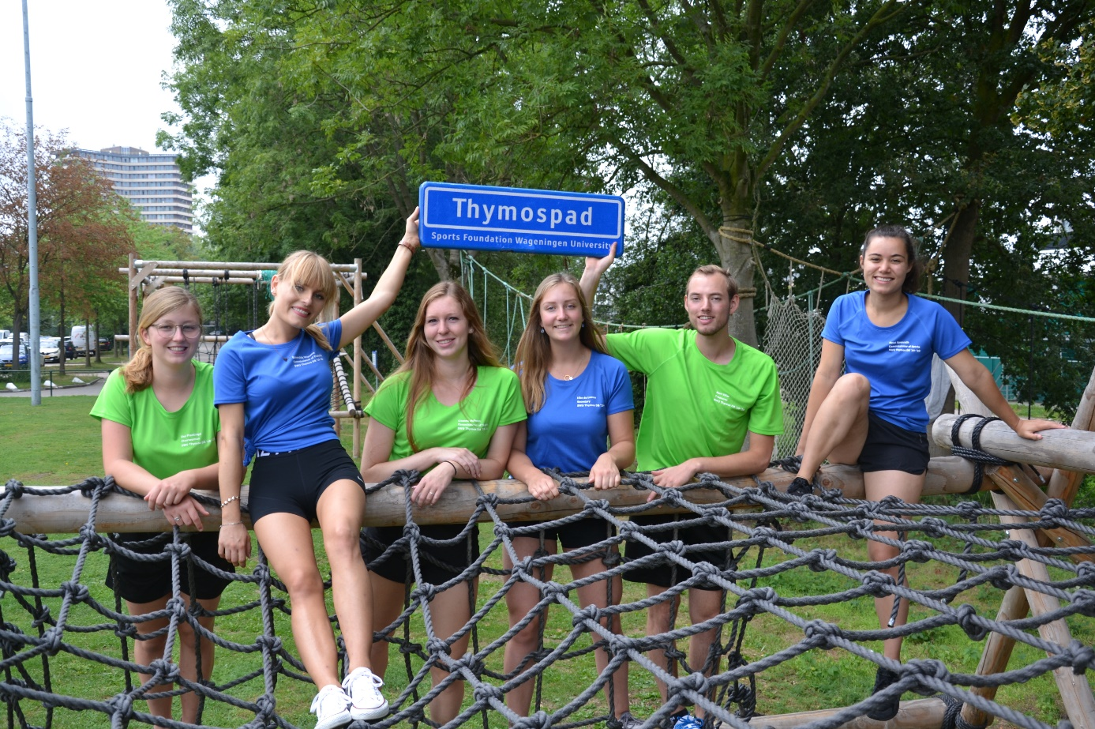

Daily Board of Sports foundation Wageningen University Thymos

We are looking for a new Daily Board and maybe we are looking for you! Do you want to have a break from studying for a year, but still want to learn something? Do you think student sports are important? The Daily Board of SWU Thymos might be something for you!

Who are we?
The Daily Board (DB) of SWU Thymos consists of six persons: a chair, secretary/vicechair, treasurer, commissioner of publicity and two commissioners of sports. All six board members receive a grand from the University. They commit themselves every day to student sports in Wageningen.

What is our goal?
Our goal is to create a favourable and beneficial sports climate by offering the needed facilities (together with Sports Centre de Bongerd (SCB)) and by organising events for students. These are all kinds of activities like Thymos Experiences, tournaments and yearly events.

What we do
We organise more than 30 sports activities in a year! All these activities are very different from each other, like tournaments, experiences and events. There are several activities that return every year, but we also try to think of something new every year.

At the moment there are 31 student sports associations (ssa’s) in Wageningen. SWU Thymos is looking after their interests in several ways. Besides that, we support students who want to establish a new student sports association.

We also try to look after the interests of students that are not bound to a ssa. Think of users of the gym and the squash courts. They can always come to us with their complaints or remarks. Furthermore, we work together with SCB. For example we discuss the sports programme and our policy with each other.

On national level we work together with Student Sports Netherlands (SSN). This umbrella organisation helps us with organising Dutch Students Championships and offers us workshops to develop our skills as a board. Because of SSN we have contacts with a lot of other student sports foundations in the Netherlands.

Board positions:

Because of practical reasons it is not possible to fill the position of chair, secretary/vicechair, treasurer or commissioner of publicity when you are not fluent in Dutch.

Chair
As a chair, you are responsible for the running of things in the board. You are up do date about all general businesses. Putting important discussion points on the agenda, planning meetings and maintaining the overview are a few of the main tasks as chair. For the outside world you represent the board in for example meetings with Sports Centre de Bongerd (SCB), the municipality Wageningen, the WUR, the Student Council, the Student Alliance Wageningen or other Student Sports Foundations in The Netherlands. In those meetings it is important to be aware of the opinion of the board and to correctly bring out this opinion, even if your personal opinion differs from this. Regular meetings with your colleague board members is therefore important. In your board year you will mostly develop communication skills. Your position consists of a varying range of tasks. Next to this, you are the first one if new and important issues arise.

Main tasks
Meetings
Apart from the weekly Daily Board (DB) meetings, there are also regular gatherings with the General Board (GB), Board of Advice (BoA) and Sports Centre the Bongerd (SCB). On a national level meetings with Student Sports the Netherlands (SSN) take place where you can get a say on a national level. During these meetings you will get in contact with other student sports foundations from other student cities across the Netherlands with whom you can share experiences. Finally, during the occasionally meetings with Sports Council Wageningen you will represent SWU Thymos in municipality Wageningen. As you can see, a lot of your time will be spend on meetings. During these meetings you will often chair the above-mentioned meetings or to make the voice of the DB heard.

Thymos internal
Within the board, you will guide the group with their activities. In other words, this means to be ready for everybody and help where needed, divide tasks equally and supervise the progress of the team as well as each member individually. If times are getting hard you will have to pick up the pieces and lead the way. Additionally, it is very important to show interest in the (private) lives of the board members and give them the appreciation they deserve. Organising team and individual evaluations is part of your job.

Thymos external
You have to keep yourself up to date about what is happening in and around the Sports Centre. Showing yourself and paying attention to the employers is therefore apart from fun also important. SWU Thymos collaborates with the SCB in terms of the sports program and the renewal of the sports centre. Don’t forget to remain critical towards the Sports Centre, as it is the responsibility of SWU Thymos to represent the ssa’s, the individual sportman and SWU Thymos itself towards the Sports Centre.
As mentioned before, as the chair you represent SWU Thymos to external partners and meetings, for example with SSN and other sports foundations. This also includes having contact with highly-placed individuals such as from WUR, the municipality or other organisations. During these meetings you can also exchange knowledge and come up with new ideas to boost and improve the student sports climate in Wageningen or to improve the sports foundations itself.

Other fixed tasks
Next to the above mentioned duties, you as a board are responsible for the policy of SWU Thymos. Every calendar year a new policy is written by the daily board. Remaining critical towards these policies is key. Together with the secretary you will organise the policy writing week. During the year, the progress regarding this policy has to be checked regularly. As the chair you will organise meetings to discuss this and keep the overview on what has been done and what still needs to be done.

Flexible tasks
Apart from the above mentioned, fixed tasks, there are also several flexible tasks which will be divided among the board members at the beginning of the year. Part of them are organising events such as the lectures, the gala, the Health Week or the winter sports. But these tasks also include being for example responsible for fun activities with the board, the Batavierenrace and the WinterAID.

As the chair you have an important position in the board containing a variety of different, diverse tasks. Communication, having interest in others and being able to take charge and lead the way are important features for the position of chair. This sometimes means that you should listen well to others and not be afraid to make decisions. It is a beautiful position in which you are informed about all activities. At the end of your board year, you will have made a lot of new connections with a lot of new and interesting people, both formally and informally. Also, you will do a lot of fun things next to all the hard work, for example join our events and activities. And finally you will work together for a whole year with a fun, enthusiastic group of people who all have the same goal.

If you have any questions after reading this, don’t hesitate to contact us or come by our office for a walk-along day.

With sportive regards,
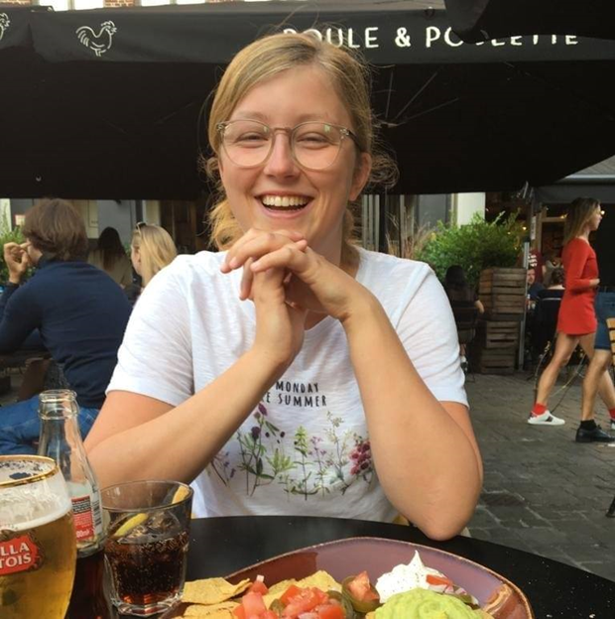
Ilse Plantinga
Chair 2019/2020

Secretary/vicechair

As secretary and vicechair your tasks are very diversified. In addition you can plan most of it by yourself. The permanent duties of the secretary and vicechair include the following:

Secretary
Take minutes
As secretary you will take the minutes of the DB-meetings (once per week), General Board Meetings (GMAs) (4 times per year) and a number of smaller meetings. You take minutes during the meeting and will finish them later on. In the beginning it will take some time to get used to it, but you quickly get into it. Because you’re taking the minutes you’re always intensely involved with the meeting and you will train yourself to select the most important things during the discussions.

Post and archive
The secretary opens all the incoming post and notes all the important post in the post book. This post ends up in the archive. There is a physic and digital archive, as secretary you are responsible for keeping both archives arranged, however every board member is responsible for his/her own folders. To make sure this happens you will plan an archive day twice a year, during which all the folders will be cleaned out and organised.

Contact person associations
The secretary is the contact person of the (student)sport associations. This implies that whenever associations have questions they can direct them to you, this also implies that you will provide the associations with information coming from the DB. It implies mostly mail contact. The organisation of the lunches in the beginning of the year, the training together and the second meetings at the end of the year also belong to your tasks. Furthermore you’re involved with supporting the associations whenever they experience problems. Besides that, associations in formation are your responsibility too.

News mail
Every month SWU Thymos will send a news mail to all the sports rights holders. The news mail contains information about the events and arrangements of SWU Thymos that are important for that month. The texts will be send by the other board members and you will put these all together so that it forms a nice whole, after which you will send the mail.

Regulations and statutes
The secretary knows the regulations and statutes and is responsible for possible adjustments. It’s the secretary’s task to prepare possible adjustments of the regulation and present them during the GMA.

Policy
Together with the chair you will be busy with the policy of SWU Thymos. You will write the policy and together with the chair you will take care of the substantive part of the policy week. During the policy week the entire DB will decide what the next policy of SWU Thymos will have to be, afterwards you will work everything out. Also, together with the chair you will make decisions about the content of the GMAs and you will take care of some of the papers for this. These occasions require a more formal tone than the other tasks which gives you’re function some extra diversity.

GNSK
As secretary you’re also the contact person for the NSK’s and GNSK. For the GSNK this means that you will find a team captain for every sport en that you will send information towards the associations and the GNSK-committee. You’re also the one who will register teams and will make sure that the university clothing will be gifted to all participants.

Year report
At the end of every college year you will make a year report. All important events from the past year will have a place in this report, not only the events of SWU Thymos but also the events of the associations will be mentioned. Therefore it’s good to take note of all these events and around may you will ask the ssa’s to write a text for the year report. The year report will be written in English, so it’s a good training for your language proficiency.

Flexible tasks
Next to the tasks I mentioned above you have a number of flexible tasks. There are a number of tasks to be divided between the board members and everybody has to carry out a few of them. For example, I organised the Board Education Days this year and was a member of the application committee. The board members also help out during the events organised by the commissioners of sport. During most of the experiences and events almost all the board members are present to support and off course also because it is a lot of fun.

Vicechair
As secretary you work closely together with the chair and when the chair is absent you will take over his/her tasks. This means that you will then be the external contact person, lead the meetings and will be responsible for the board. As vicechair you will join the chair to several internal meetings as well as external meetings. Because you’re visiting important meetings and you’re involved with the tasks of the chair you will stay up-to-date about important affairs, which is a lot of fun.

In short
The function of secretary/vicechair is very varying, this makes the year very enjoyable and educational. During the year you’re developing yourself a lot. You will become more skilled in your normal tasks and you’re being challenged by floating and even new tasks. Because you have a lot of formal and informal contact with many different parties, this function will also be helpful for your communication skills. Next to that you’re also writing the policy, the year report and many other documents, so you’re language and writing skills are being improved. These skills will certainly be helpful for your future. It’s a year full of sports, challenge and fun!

With sportive regards,

Elke de Leeuw
Secretary/vicechair 2019/2020

Treasurer

As the treasurer SWU Thymos you are responsible for all the financial tasks of SWU Thymos, the most important job in the board! Besides these financial tasks, you have also some non-treasurer tasks. Your range of tasks is very diverse. It consists of general tasks like attending meetings and contributing to the many events that SWU Thymos organises.

Fixed tasks
Financial administration
The most important task of the treasurer is the coordination and administration of the financial transactions. I know, this may sound a bit vague. In practice this means that the treasurer is responsible for paying invoices, drawing up invoices, control budgets and clearances of all the events, handle subsidy requests and keep record of the treasury. In order to maintain an overview, every transaction is processed in an online accounting program: Exact. This is an comprehensible and practical program that is indispensable for you as treasurer!

Budget and clearance/balance
At the beginning of your board year you have to start with making the budget of the next calendar year. You can integrate a part of your plans for the coming board year in this budget, and it is the first great job that you have to do.
In January starts the greatest project of the year: the clearance and balance! This means that you have to make an accurate overview of all the expenses and incomes of the past year. During both processes (budget and clearance/balance) you are advised by the Financial Control Committee, but also by different (financial) staff workers from the university.

Subsidies
The treasurer of SWU Thymos has also the task to assess all the subsidy requests and pay these subsidies to the associations and students. Besides that, you also manage the Sponsor Budget from Wageningen UR. The university makes this budget available to sponsor sport events organised by students sport associations (ssa’s) and ssa’s can submit a request for this subsidy. Together with the head of the Sports Centre the Bongerd (SCB) you deal with these requests.

Materials for ssa’s
SWU Thymos acquires a lot of materials for all the 31 ssa’s. All the material requests are handled by the treasurer of SWU Thymos in cooperation with the head of the SCB. In coordination with the Daily Board, you assess whether SWU Thymos purchases sports materials for the ssa’s.

Other fixed tasks
Next to the tasks I already mentioned, you also take care of the administration and salaries of the bar staff of the Sports Pub. As the treasurer, you are in contact with a lot of different stakeholders, like the treasurers of ssa’s. Also treasures from student sport foundations in other cities, the SCB, Student Council and the university are important stakeholders for the treasurer of SWU Thymos. This is very nice, and also a great opportunity to expand your network. Furthermore, you are an important advisor for the treasurers of the ssa’s when they have financial related questions. In short, you are always busy with something as the treasurer of SWU Thymos!

Flexible tasks:
Besides these tasks related to the position of treasurer, you are also busy with other things during your board year. You attend every week the board meeting, and you also have other so-called flexible tasks. Many of these flexible tasks consist of organizing events or participating in committees within SWU Thymos. I joined the anniversary committee (in Dutch: Lustrum) and the WinterAID committee. Besides that, I also organise lectures related to sports.

A I explained, there is a lot to do outside of the financial stuff. After the normal office hours (from 9 to 5 o’clock), there are many more fun moments you experience with the rest of the board. For example, you try to train one time with all the 31 ssa’s, you visit constitution drinks in and outside Wageningen and you participate of course in the SWU Thymos events! It is important to have a good time between all the hard work you have to do. This makes your board year diverse and fun!

With sportive regards,

Bart Vilier
Treasurer 2019/2020

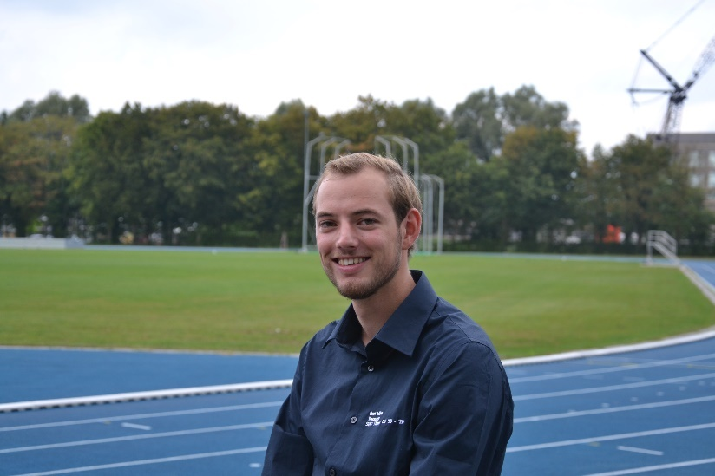

Commissioner of publicity

As commissioner of publicity you are responsible for the promotion and brand awareness of SWU Thymos. It is the position in which you can be most creative and in which you have a lot of personal input. You ensure the appearance of SWU Thymos to the outside world. Due to the many promotional means and possibilities, it is a very varied position. In short, it means that you can make as much of it as you want! You learn how to plan, think creatively and be flexible. The nice thing is that you are involved in every event and you are responsible for one of the most important things, namely informing enough people and making them enthusiastic to register!

You can use many illustrative programs to design and develop your ideas. For example, I have worked a lot with Adobe Photoshop, InDesign and Adobe Premier Pro this year. Moreover, you learn more and more during the course of the year and you become faster and more time efficient.

The great thing about the PR function is that you can take care of the appearance of SWU Thymos every day. Many people see your work and this entails a lot of responsibility. If you have all the standard promotions in order, you can let your creativity run free and come up with new ideas. Furthermore, you still have your flexible tasks, which of course must always be done as well as possible. Below are your most important tasks within SWU Thymos:

Fixed tasks
Posters and Flyers
One of the creative activities you engage in is the design and printing of posters and flyers for events. You can do this as extensively as you want, as long as the time and budget allow it. The content is determined in consultation with the commissioners of sports. What the event entails is determined by them, you come up with ideas and the treasurer tells you what can and cannot be done within the budget.

The Sports Guide
You are responsible for the largest edition of SWU Thymos, the annual sports guide. It contains all the different student sports associations and the lessons & courses offered by the Sport Centre. You take care of the layout of the articles (supplied by others or written by yourself), the photos and the overall layout of the sports guide.

Website and photos
You spend a part of your time maintaining the website. It is an important means of promotion and communication and registrations for events and competitions all go through the website. So things have to be constantly adjusted to keep the site up-to-date. Moreover, it is interesting to learn how a website works and what you can do with it! You also take care of taking and processing photos during events and other activities, so that they can be viewed on our website and Facebook page.

Social Media
Another responsibility is to maintain the social media channels! Facebook is one of the most important and fun promotional tools. As a Com Pub, you are trying to use Facebook in a playful way to get students excited about sports and the events of SWU Thymos! We also have an Instagram account that must be kept alive and inspiring. 2 years ago we created a LinkedIn business profile where we can show important achievements and events.

Sports calendar
This A6 flyer with an overview of our upcoming events is being handed out on the Forum escalators once every 2 months. It appears to be a good way to reach students who, for example, do not follow our Facebook page. Every time it is nice to try to stand out among all the other flyers.

Other Promotion
In addition to the larger projects, you also have a number of small issues that you are also involved in. For example, we try to appear in the resource as often as possible and you, as Com Pub, design the narrowcasting for events that is shown on the screens in the Sport Centre and university buildings. You also take care of the SWU Thymos promotion during the information days, AID information market and sports day and you can also get started with making videos (we have a GoPro!). Lastly, the information leaflets of the ssa’s must also be replaced once every 2 years. So in your year you are responsible for revising half of the ssa folders!

Flexible tasks
In addition to your regular duties, you are also busy with many other things during your SWU Thymos board year. You have a meeting with the entire board every week about issues that concern SWU Thymos. In between, you also often consult each other about policy issues and important decisions. Besides that, you can help by organizing an event yourself in every position. This year, for example, I co-organized the Surf your Stress week and the sports gala and I am on the "fun things committee" that organizes the board change weekend, among other things.

In short:
Your days look very varied and you can put all your inspiration in your publications. It is a very free position where you are busy with anything and everything to familiarize the students with sports and all the activities that SWU Thymos has to offer. A challenging and great position! It is also a very educational year, in the form of design, creative thinking, communication, collaboration, organization and planning, which will benefit you in the future! Moreover, it is just great to be part of a board where you meet a lot of new people and can do a lot of sports!

With sportive regards,
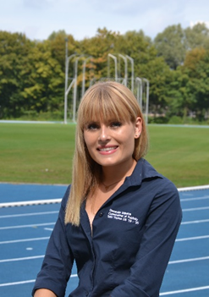
Esmeralda Wijnsma
Commissioner of Publicity 2019/2020

Commissioner of Sports
As Commissioner of Sports you are responsible for the organisation of events, experiences and the Thymos Internal Competitions (TICs). These are the marquee activities that SWU Thymos provides to the students of Wageningen. They also offer a low-threshold to get students moving. This accessibility aligns with the motto of SWU Thymos: ‘Move and your body will recharged’. SWU Thymos represents sports in the broad sense, so we want everybody to be able to join our activities. Since there are over thirty activities every year, there are two Commissioners of Sports.
Besides your main tasks, you are responsible for the policy- and decision making of SWU Thymos alongside your fellow board members. Your activities, policies and decisions will be discussed during the weekly meetings of the daily board of SWU Thymos.

Main Tasks
Events
Events are activities that often take up an entire evening. Our events usually consist of multiple games or sports and return every year. Think about the Ball & Stick Tournament, Squash Tournaments and the Dance Evening, all of which attract a major crowd! The size of each event differs, which means the amount of organisation effort also differs. For large events like the Battle of the Studies and the Sports Night you will form a committee. This committee will be guided by you and your fellow Commissioner of Sports. For smaller events you will often involve the student sports associations in the organisation of the evening. As a Commissioner of Sports, you have the freedom to organise new events. You can also decide to cancel existing events if you so wish.

Experiences
Experience are often one-time activities. During an experience, we offer the possibility of practicing a sports which you probably wouldn’t try out by yourself. Because of this, experiences are a unique activity. In contrast to events – which are usually free – there are costs for participating in an experiences. A number of experience are currently recurring every year, including the Indoor Ski Experience in Bottrop and Ice Skating in Biddinghuizen. Other experiences we organized this year include the Climbing Park Experience, the Glow Golf Experience and the Self-defence Clinic. Again, you are free to come up with new experiences. Dare to be creative!

Organisation of Events and Experiences
For both events and experiences you are in charge of finances (budget and clearance), planning, promotion (the Commissioner of Publicity will help of course), registrations, informing the rest of your board, coordination during the event and finally the evaluation. For events you will have to communicate inside de Bongerd to make reservations of halls and other parts of the accommodation. This is not necessary for experiences, which regularly take place outside de Bongerd. You do however need to organise transport for these (provided they do not take place at de Bongerd).

Thymos Internal Competitions (TICs)
Thymos offers internal competitions for soccer, futsal, knotsball and beach volleyball. Additionally, there is always the possibility to look into new additional TICs. During these TICs, students play against each other in different levels. Teams may consist of housemates, club mates, study mates, AID group members or any other kind of group. Every year we host three rounds of the TICs. TICs are ideal for students who do not want to be part of a student sports association but do like to play games together. During the TICs you are responsible for registrations, scheduling, contact with the teams and maintenance of material. You also discuss the available hours with the Sports Centre in which you can organise the TICs. You are completely in charge of the TICs. A huge responsibility!

Expectations
This function is unique because you share it with someone else. This means you have to discuss and cooperate properly. Your main concern will be organising, which means you need to be an organised planner! Furthermore, being capable of dealing with stress and being flexible are also important. Events and experiences won’t always go as smooth as you planned, so it is your job to find out why and make sure problems do not recur. As you will often contact institutions and student boards, communication skills and professionalism are also useful qualities.

Flexible Tasks
Besides the usual day-to-day activities, the Commissioners of Sports fill a wide range of other tasks as well.
Lisanne organised the Winter Sports and is busy with the swimming lessons and the Thymos gala. Dewi on the other hand helped organising the Thymos policy week and is now working on the Winter AID and the 13th Thymos lustrum.
In conclusion, Commissioner of Sports is a challenging and beautiful board position! You will be in close contact with sports and the organisation of activities. Throughout the year, you will notice your own development in your position. Best of all; you can put your own creativity into practice!
If you have any more questions about the position of Commissioner of Sports or if you would like to join us for a day, you are always very welcome to contact us!

With sportive regards,

Lisanne Hofman and Dewi Spenrath,
Commissioners of Sports 2019/2020
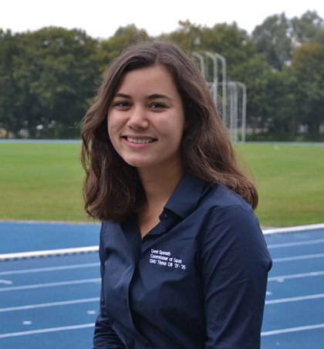
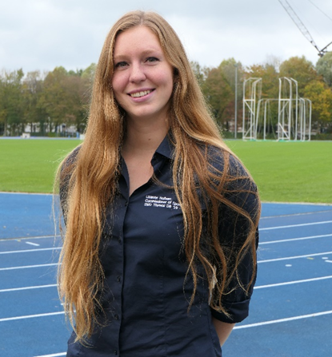

Interested?
Do you want to come along for one day with one of the board members to get a better picture of a board year? Come by our office or send an e-mail to make an appointment. For further questions you can also contact us by e-mail or phone.

Letter of application

We would like to receive your CV and letter of application, which should be maximum 2 A4s. The purpose of this letter is to get to know you better and to discover what your motivations are to become a board member, before actually having an interview. There are several questions we would like to see answered, but you are free to fill in the remainder. The questions we like to see answered are written down below.

- Which studies are you in? And in which year?
- What are your connections to sports? And your connections with sports in Wageningen?
- Have you already been active in a board/committee? Which ones, and what did you learn?
- What is your motivation to apply for a board year at SWU Thymos?
- Did you already think about positions within the board? Which positions do you want to take in the board and why? Which function(s) do you not want to take, and why?
- What are your qualities? And what do you want to learn within you board year?
- What are your bad and good personality traits. How can this contribute to the board and which traits might be challenging for the rest of the board members?

If you want to apply for a board year at SWU Thymos you can send an e-mail to swu.thymos@wur.nl. In the attachments we would like to see a letter of application with a maximum of 2 A4s in which you give answer to the questions mentioned above. Furthermore, you have to send your CV. The deadline to apply is Tuesday the 31st of March 2020. If you have any further questions, you can always visit us at our office or call to 0317-482746.

With sportive regards,

Elke de Leeuw & Ilse Plantinga
Selection committee SWU Thymos 2019/2020

