Three internship/thesis opportunities in relation to Regenerative Higher Education

Possibilities for ELS-thesis/internship
There is a need for more regenerative forms of education that connect addressing societal and wicked challenges and personal (re)vitalizations for both students and teachers. In practice, there are several emerging educational innovations that aim to do this across universities (of applied sciences). But little is known what happens in practice, based on which premises, with what results, and what we can learn from these initiatives.

These regenerative higher education initiatives generally connect to lab-based approaches (living labs, field labs, challenge labs) on the edge of science and society. These forms of education, which have the potential to be regenerative for places, people and even the are often characterized as relational, transboundary, transformative, and mindful of uncertainty, ambiguity, and complexity and inclusive of cognitive, socio-emotional an embodied form of learning. Understanding how these learning constellations are designed and enacted, and how they affect personal transformation and wider societal change, could be paramount for connecting universities to the grand sustainability challenges of our times.

Figure 1 illustrates our key conceptual underpinnings derived from these two interconnected strands of literature as we research regenerative education from a relational pedagogical perspective. Your work can contribute to this emerging education paradigm.

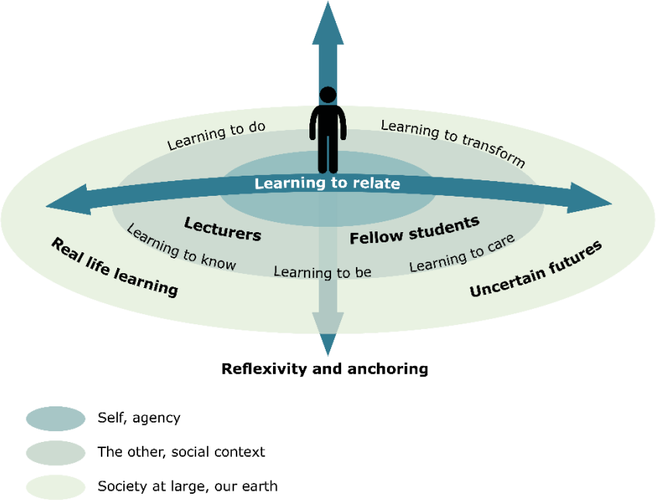

Figure 1: Model of Relational Pedagogy elements for Regenerative Higher Education by Hordijk et al. (2021).

Existing literature on sustainability in higher education highlights what education could or should do (intended curriculum), yet fewer articles describe in detail

how this is done (enacted curriculum) or assess whether the aspired outcomes are actually achieved and what helps or hinders their realization. Through this research, we aim to expand our theoretical and a practical understanding of regenerative higher education and its potential impact.

This project is part of a larger collaboration between six universities of applied sciences and three research universities (WUR, VU, TUD, UVA).

If you are interested:

Please provide a 1–2-page motivation and proposal based on one of the projects below. Creative research methods using for example arts, film, drawings as well as in depth studies of existing practices will be prioritized. To get an overview of creative research in education please check out this and for an overview of creative methods more generally please check out this. For the first three projects The Regenerative Education Podcast Series can be used as the (primary) data set. For these projects, understanding Dutch is necessary. If you would like to propose an alternative proposal that contributes towards regenerative higher education, please feel free to do so. Please consider reaching out to (one) of the representatives from the list below to discuss topics and supervision possibilities in your home institution for this route. If desirable/feasible the thesis can be developed into a peer-reviewed journal article of which you would be a co-author.

The four indicative projects¹:

- Project 1: The first project examines the system’s innovation dynamics of Regenerative Higher Education that emerged from The Regenerative Education Podcast. This project aims to explore through a transition perspective how these innovations emerged, and which potential futures are likely.
- Project 2: The second project examples the role of universities in the co- creation of regenerative futures. This could be primarily a philosophical inquiry in line with the works of Barnett & Jackson 2019 – Ecologies of Practice and the reader by Peters & Barnett ‘The idea of the university’.
- Project 3: Examining the lived experience of educator’s trying to design and enact regenerative higher education. What are the psychological qualities of educator’s trying to engage in this work?
- Project 4: Using the Regenerative Education Design Practices Tool; How can Regenerative Higher Education be (Re)designed in Dutch Universities (of Applied Sciences). This project further develops the design tool that was derived from the podcast-study and includes hosting (physical) workshops with educators.

We are looking for you when you:

- Have a warm heart for sustainability in all its richness and ambiguities

1 Please note we only have funding for 3 positions, so a selection of which projects (including additional ones proposed) will be done.

- Are interested in pursuing a PhD after your masters and are motivated to do peer-reviewed (practice-led) academic research.
- Are interested in rethinking and redoing higher education
- Are interested in innovative qualitative research
- Have a passion for engaging with social media and multi-media communication about research for sustainability
- Are studying for a masters in any field as long as you have demonstrable interest in the topic and are willing to work in transdisciplinary ways.
- Are able and willing to work in a team of critical-creative scholars!

What we offer:

You will join the Mission Zero Student Lab (MZSL) with about thirty or so student-researchers working on sustainability transition questions ranging from anything from the energy transition to the circular economy. In addition, you will be invited to the MZSL student activities and workshops throughout your time with us. These positions are location independent, and you will be supervised by Bas van den Berg, director of education of Mission Zero and/or Nina Bohm, PhD researcher and lecturer at TUD/WUR, and, when not enrolled at HHS or TU Delft, by one scientific staff member of your home university who is connected to this project. Below you will find the list of affiliated scientific staff members and PhDs and their universities.

Name | Affilitation
Prof. Dr. Arjen Wals | Wageningen University & Research
Dr. Michaela Hordijk | University of Amsterdam
Dr. Mieke Lopes Cardozo | University of Amsterdam
Dr. Debby Gerritsen | University of Amsterdam
Koen Wessels, PhD candidate | University Utrecht, Academy of Hope
Marlies van der Wee, candidate | Rotterdam University of Applied Sciences
Bas van den Berg, candidate | The Hague University of Applied  Sciences
Daan Buijs, PhD candidate | Wageningen University & Research
Nina Bohm, PhD candidate | TU Delft/ Wageningen University & Research
Linda de Greef, | University of Amsterdam, Programme Manager Education Innovation, Institute for  Interdisciplinary studies UvA
Naomie Tieks, MSc candidate | Wageningen University & Research

The supervision will consist of weekly (digital) meetings alternating as a cohort and individuals. Depending on the quality of the work we will also help you disseminate the findings in appropriate formats such as conference presentations or even journal articles. To do this, we will follow the guidelines for ethical co-authorship used by the WUR. These positions are open for master students from any background, we prefer to work in the February-July period but are open to an earlier start in exceptional cases. Finally, you will receive compensation of 450 euro per month for the period of the internship/thesis/graduation.

How to apply:
Please submit a CV, motivation and 1–2-page research proposal to b.vandenberg@hhs.nl the 23rd of December, 2021. We will reach out with an invite for a chat early January and let you know within the week if we want to go on this journey with you.

ELS-thesis or ELS-internship
WUR students can use these options as an internship or Thesis, supervised by ELS (Education and Learning Sciences). To discuss this option, contact judith.gulikers@wur.nl (ELS-thesis and internship coordinator) and/or Arjen.wals@wur.nl as content expert in this area and project.
Note. Feel free to also contact us later that dec 24rd if you are interested in discussing options in relation to this topic!

