Small Fish and Food Security: Towards innovative integration of
fish in African food systems to improve nutrition

Mass balance approach to small fish production trade and consumption in Ghana and around Lake Victoria

Background:
Small fish – sardines, herrings, small carps in freshwater and marine environments - have always been an important part of the diet in African societies. Large quantities of small indigenous fish (SIS) are produced and processed by mainly the small-scale artisanal, and often part-time sector, and traded over vast regions in Africa to consumers. For instance, Dagaa – Rastrineobola argenta – caught in Lake Victoria is found in dried form in markets from South-Sudan to South-Africa. Surprisingly, these species are largely neglected in policies on food security. This neglect has resulted in large knowledge gaps with regard to local importance, the natural production potential, as well as possibilities for improvements and innovations in catches (volumes, technologies, information), processing (nutritional value, products, safety, losses) and trade (losses, diversification, consumer awareness). Small fish are not well represented in catch or trade statistics and their importance and sustainability needs documentation from improved catch and effort statistics, and good quantified estimates of flows through the various nodes in the value chain to obtain insights in demand and value.

Objectives:
The aim of the Small Fish for Food project is to obtain a quantified view on the flows from fisher to consumer of small fish in Ghana, Uganda, Kenya and possibly Tanzania by making a mass balance of production and trade flows. Research questions include:
1. how much small fish is produced in selected sites and is that sustainable?
2. what are the various flows and intermediate steps from fisher to consumer, how much, what values, and is there competition between different flows?
3. what are the important points for intervention to improve flows of nutritious fish?
4. does demand drive fisheries production?

Methodology:
- Data collection in Ghana, Uganda or Kenya using structured interviews and tracing of fish.
- Estimates of conversion ratios between dried and fresh fish over the value chain?
- Construction of a mass balance model using the ECOPATH modelling framework.

Requirements:
Students pursuing MSc degree in Biology, Marine Resources Management, Animal Sciences or related disciplines (including social sciences). Funding for 8 students is available. BSc projects can also be defined but without field work. A aptitude for quantification is needed.

Contact information:
Paul van Zwieten (paul.vanzwieten@wur.nl), Aquaculture and Fisheries Group, Wageningen University and Reserach, Address: Zodiac (building 122), De Elst 1, 6708 WD Wageningen. Tel: + 31 (0)317 483920
Start date:
January 2019 to December 2021

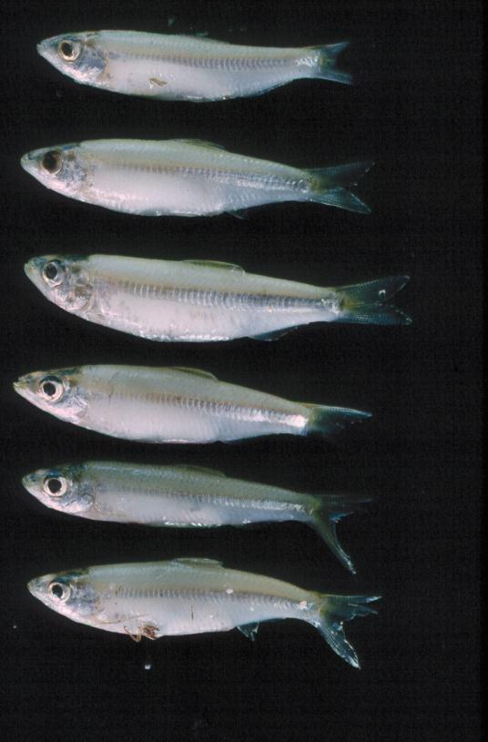
Chisense (Microthrissa moeruensis) Photo: Paul van Zwieten

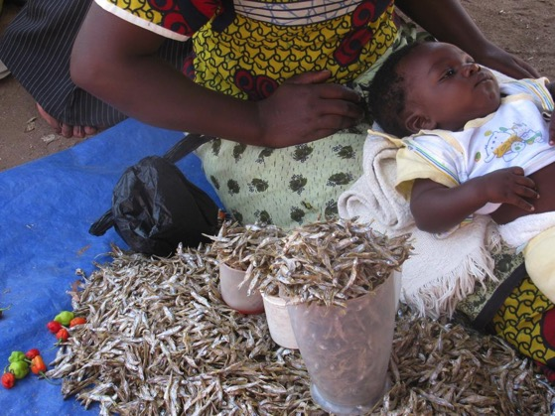
Dagaa (Rastrineobola argentea) is sold at a local market in Tanzania. Photo: Modesta Medard

