A methodology to test strategies to increase consumer’s willingness to wear alternative textiles

Final wildcard project report

René A. de Wijk, WFBR Consumer Science & Health

Siet Sijtsema & Liam Dwyer, Wageningen Economic Research.

Betina Piqueras Fiszman, WUR Marketing and Consumer Behavior.

Date

Jan 15, 2023

This project has been funded by the investment theme Transformative Bioeconomies: Towards a materials transition that phases out fossil feedstock

# Introducing the format

When submitting your Wildcard project you committed to providing several deliverables:

1. A short accessible document for the inter- and transdisciplinary group of people involved in the programme that describes your methodological innovation project / proof of principle project and its rationale;
2. A presentation at a community meeting of the investment theme;
3. A report of the results of your learning journey that describes the key lessons learned about your methodological innovation or proof of principle.
4. Additional deliverables formulated by you as part of the submission, labelled ‘Project specific deliverables’ in this format.

All Wildcard projects already provided presentations as stipulated under 2. This format then is meant to document deliverables 1, 3 and 4.

In section 2 of the format we ask some additional questions related to possible follow-up.

# 1. A short accessible document (max. 600 words)

Prior innovative WUR food studies demonstrated that foods, especially newer foods, may trigger certain irrational negative feelings such as feelings of disgust. Due to their subconscious nature, these negative feelings are poorly accessible by the consumer even though they may be strong enough to prevent that the food is being consumed. These negative feelings are not limited to foods, but may also be triggered by ‘alternative’ textiles, such as second-hand clothing, or clothing made from rest or side stream materials. Even though the consumer may rationally know that the clothing is clean and safe, the negative feelings with regard to e.g hygiene, health and intimacy may prevent the consumer from even touching these clothes which hampers widespread acceptance of these textiles.

In this wildcard project, a recent WUR methodology to objectively measure negative feelings for foods, and to test possible ways to alleviate these feelings, was applied for the first time to textiles for this project. In the case of foods, these negative feelings were not restricted to the moment food was actually consumed but probably build-up gradually during the ‘journey’ between the moment that the food was selected and purchased, unpacked, the product specifications were inspected, the food was prepared and was ultimately consumed. Similarly, in the case of textiles for this wildcard project the consumer made a virtual ‘journey’ through the various phases of exploring, label inspection, purchasing, unpacking, leading up to the moment that the textile was actually touched. During each of the phases, objective responses such as hear rate, skin conductance, and facial expressions, were continuously monitored. In this set-up it was possible to introduce in certain phases small interventions, such as specific information regarding the textiles sustainability, aimed at reducing the consumers’ negative reactions during touching. Study results using this methodology identify possible interventions that increase the consumer’ acceptance of ‘alternative’ textiles. An example of the application of this methodology to consumer acceptance of ‘alternative’ textiles is shown in the figure below.

# Innovative idea and objective

The innovation of this idea lies in the fact that consumer’s reactions to various types of textiles are not only measured during touching of these textiles but also during various stages preceding the moment that clothing is actually touched. These stages include entering the clothing store, selection of the clothing, inspection of the label with information about the background of the material, up to the moment that a dressing room is entered to try on the clothing. A combination of standard and advanced type of measurements provide insights into the contribution of each of these stages to consumer’ acceptance of the clothing during touching. These insights may help to develop successful strategies to boost the use of alternative textiles by consumers.

# Relevance to the materials transition in textiles and/or building materials?

Traditional textiles are a mayor contributor to fossil carbon use. Possible replacement materials of traditional (new) textiles include new materials such as polylactic acid or biomaterial from nettles, and reused or recycled worn materials. Identifying ways for the successful transition of traditional towards alternative textile materials will have positive environmental consequences.

# What did you do?

An experimental study was developed and conducted with 31 participants. In this study we monitored consumer’ reactions to four types of textile samples in one 1-hr sessions during three phases of typical clothing-consumer interactions during the purchase of a t-shirt: 1) in a clothing store (discount or upscale), 2) information about the t-shirt material (reused, recycled, PLA, organic cotton and nettles), and 3) touching the textile. Phases 1 and 2 were standardized, i.e., participants viewed video segments which displayed each phase from the perspective of the consumer. In phase 3 the participants actually probed the textile shown in the preceding videos with the fingers. Participants’ reactions were monitored during the three phases 1) implicitly with heart rate, skin conductance (arousal) and facial expressions (valence) and 2) explicitly with questionnaires after touching.

# Main result, achievement and highlight

Reactions during touching were not only affected by the tactile properties of textile but also by the prior information about store type and type of material. Probing material believed to come from reused clothing triggered scared and disgusting facial expressions and increased heart rate and skin conductance (p<0.01). Reactions to new materials such as nettles and polylactic acid triggered were similar to reactions to organic cotton. Reused clothing triggered stronger reactions in an upscale store.

# Key message

The newly developed methodology of this study demonstrates the contributions of store and material information on experiences during touching of textile. The type of clothing store and way material information is provide may play a critical role in the acceptance by consumers of more sustainable textile materials.

# Visual abstract

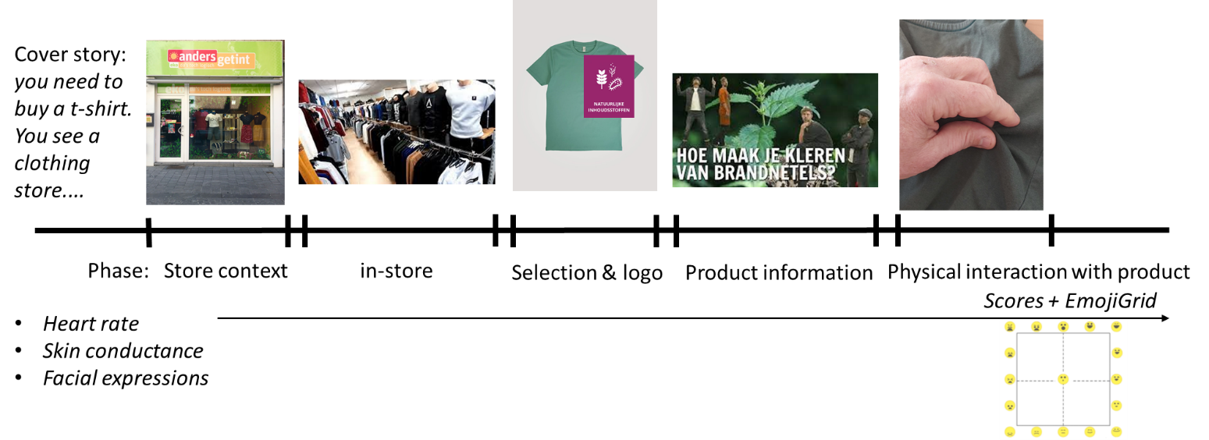

*Figure 1: a virtual journey through phases of shopping for ‘alternative’ textiles (in this case clothing made from nettle), selection, product information, ending in the physical touching of the textile. During each phase consumer reactions will be monitored with implicit measures to identify aversive – or appreciative- reactions.*

*Figure 1: a virtual journey through phases of shopping for ‘alternative’ textiles (in this case clothing made from nettle), selection, product information, ending in the physical touching of the textile. During each phase consumer reactions will be monitored with implicit measures to identify aversive – or appreciative- reactions.*

# 2. Questions about ‘readiness’ and possible follow-up (max 200 word)

This section serves the investment theme to understand the development the project has undergone. We aim at selecting Wildcard projects to be taken up by one of the domain flagships (building materials, textiles). To make a selection, we need to know what the progress has been, where the project is now, and what potential there is.

## Where you started

At the start of the project, the new methodology had been explored for foods. This is the first time that the methodology was applied to textile, i.e. non-foods.

## Where are you now

All planned steps in this project were successfully carried out.

## Potential and next steps

This project was a (successful) first exploration using this new methodology in the non-food (textile) domain. The results show differences in consumer’ reactions towards various types of traditional and alternative textiles. Follow-up studies would test 1) consumer’ reactions to different textiles materials, 2) which type of information about materials trigger most positive consumer’ reactions, and 3) which type of store is best suited for sale of specific types of textiles.

## Innovation readiness

Innovation readiness is 7.

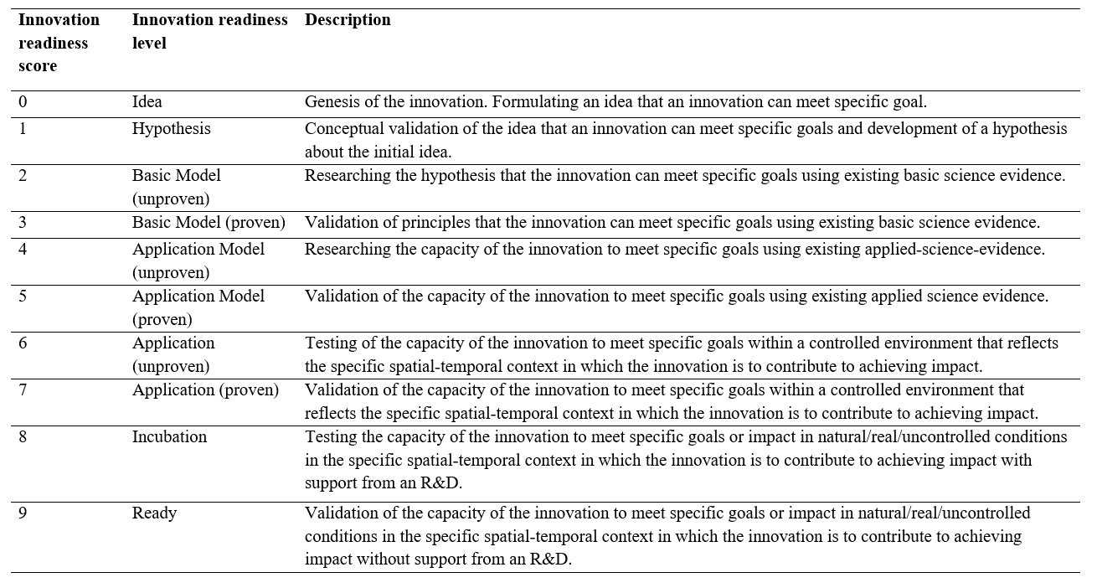

Table 1: Innovation readiness levels as distinguished by Sartas et al, 2020.

# 3. Learning Journey (max 300 words)

We would like to understand a bit more about the process you went through, and whether and how being part of the investment theme Transformative Bioeconomies influenced your learning. We ask the project leaders to consult others when answering these questions.

1. Did your Wildcard project involve new collaboration with disciplines or people? If so, briefly explain what was new. *The project intensified the collaboration between WFBR, WEcR, and WU-MCB. The application of sensory/consumer methodology to non-food (textile) stimuli was new prior to the project.*

2. If applicable, did the new collaboration alter your original thinking about the topic? Did it change research directions or courses of action? If so, briefly characterize how. *Yes, we realize that methodologies developed for the food-domain, can also be useful for the non-food domain.*

3. Did interactions during community days and/or meetings organized by the investment theme alter your original thinking about the topic? Did such interactions change research directions or courses of action? If so, briefly characterize how. *We realized that the measurement of consumer’ reactions to textiles is a rather underdeveloped area. Hence, we anticipate follow-ups of the present project.*

4. Did you meet any challenges during implementation of your wildcard project? If so, what kind of challenges where these? *Not really. Everything went according to planning.*

5. If applicable, how were these challenges eventually addressed? Did activities organized by the investment theme contribute to overcoming challenges? If so, briefly indicate how.

6. Has your involvement in the investment theme resulted in any new initiatives or spin-offs that would probably not have emerged if you had not participated? If so, briefly indicate how these new initiatives came about. *Not yet, but – as indicated above- we anticipate follow-ups in the future.*

# 4. Additional project specific deliverables

1. Identification of ‘alternative’ textiles suitable for testing (e.g. used textiles, textiles made from rest – or side stream materials, type of clothing category e.g. upper wear such as jackets (June-July 2022). *Five types of textiles materials were selected for testing: organic cotton (baseline), polylactic acid, nettles, reused, and recycled materials.*
2. Identification of potentially successful interventions (e.g different labels recycled from fishnets, clean second hand) to increase consumers’ acceptance of ‘alternative’ textiles via different outlets such as ‘kringloopwinkel’ or shop selling both new and vintage clothes (June-July 2022). *Two store types were selected for testing consumer’ reactions to the textile materials: a discount store and a upscale clothing store.*
3. Set-up, execution of study following previous innovative WUR studies developed for foods (September-October 2022). *Study was successfully executed and finished by the end of October 2022.*
4. Analysis and reporting November-December 2022).  *Analysis was complete December 2022, and a first draft for a scientific paper was written.*