Dyes and additives for fossil-free textile chains: linking fiber production, protected cultivation of high-value products and processing

  - Final wildcard project report

Anja Dieleman, Mark van Hoogdalem, Luisa M. Trindade, Marieke Bruins and Paulien Harmsen

December 19, 2022, revised based on comments on February 16, 2023

This project has been funded by the investment theme Transformative Bioeconomies: Towards a materials transition that phases out fossil feedstock

1. Project summary

Introduction
The production of materials for textiles (fibres and auxiliaries like dyes) is one of the largest consumers of fossil-based carbon-based materials. Next to that, the industry is responsible for (water) pollution caused by amongst others dyeing of the textiles. Historically, cloths were dyed with dyes from natural origin, derived from plants, insects or non-organic materials such as soil or minerals. When the chemical industry progressed, synthetic dyes were found to give a more intense and uniform colour and were cheaper to produce. Thereby, knowledge and experience on natural dyes was reduced to a very small group of experts. However, in recent years, interest in natural dyes is increasing again, in search for a non-fossil, circular textile chain.

Wageningen University & Research is investing strategic funding in the transition towards renewable materials to be applied in fields related to comfort and shelter, such as textiles. Wageningen researchers of multiple disciplines cooperated in a project with the aim to contribute to a to value chain, in which crops are grown in protected cultivation to produce plant -based dyes which can be used in a fossil-free textile chain, (re-)using “waste” material of the production system. This project combines different areas of expertise, such as the cultivation of renewable feedstock, production of high-value crops in fossil-fuel free protected cultivation systems while re-using carbon dioxide from industry, selection of most suited crops and varieties, and knowledge of processing and products in fossil-free value chains.

Selecting crops for dyes
The starting point of the project was the concept of “dual-function” crops, where dyes would be the primary harvestable product, next to fruits (e.g. tomato), flowers (e.g. marigold) or stems for fibres (e.g. nettle). These crops would be grown in controlled conditions (such as greenhouses or vertical farms), so that concentrations of secondary metabolites to be used as dyes in textile chains could be controlled in a sustainable way. Based on these conditions, we made an inventory of plant species that could provide natural colourants that could be used as dyes in textile chains. However, the inventory showed that crops that contain valuable colourants in high concentrations, are primarily trees which do not fit in an indoor cultivation system, or herbaceous plants that do not have another harvestable product than the dye, although fibres might be harvested of some. Thus, we changed perspective, and selected crops primarily on their characteristics as a producer of valuable natural dyes, on their suitability for high productivity protected cultivation, on the gene pool of these crops and the options for valorisation of the side streams of these production systems. Based on this evaluation, we selected two interesting crops that have potential to fulfil the demands from all perspectives used.

Madder and true indigo
Based on the inventory, Rubia tinctorum (madder) and Indigofera tinctoria (true indigo) seem to offer most perspective to be used as a natural, plant-based dye to be used in a fossil-free, circular textile chain. Both crops yield high quality dyes with intense colours. Indigofera tinctoria has been grown in the field commercially and in protected cultivation, and the concentrations of the colourant indican which is the precursor of the indigo dye can be affected by a number of factors, such as the crop variety, plant age, spectral composition of the light (red light), photoperiod, planting density, CO₂ supply and nutrition. The crop offers perspective as a colourant for natural textiles, such as cotton, linen (cellulosics), but also wool and silk (proteins). The side streams offer perspective to be used e.g. to derive proteins. What remains to be done for this crop is set-up a cultivation system and processing system to grow the crop, extract the dye and valorise the side streams. This might lead to a viable business case, which then might be rolled out having a commercial perspective.

The design of a cultivation system for of Rubia tinctorum (madder) will be more challenging. Traditionally it was grown in the field, and roots had to be dug out deep, to harvest the red colourant alizarin. To make this into an economically viable business case, new varieties have to be selected or bred that have an altered morphology with smaller root systems that can be cultivated in protected cultivation with altered root substrates (e.g. nutrient solution), with tailor-made control of the environmental conditions. Furthermore, efforts are required to investigate potential use of the main side stream material of madder cultivation which are stems and leaves.

Developing a business case
In the field of using plant-based natural dyes, there is much “old” and (nearly) forgotten knowledge, that is kept in old journals and recipes for colouring textiles. In the decades, the plant-based dyes are largely replaced by fossil-based, chemically produced dyes, that have a more intense and long-lasting colour and are cheaper. However, currently there is a small, but increasing demand for fossil-free textiles, which also includes dyes from natural origins such as plants. Some commercial companies are getting actively involved in the use of fossil-free textiles, using natural dyes and looking for the right species, genotypes, cultivation methods, colourants and business cases. Based on this project, we could support and cooperate with them to make next steps.

Visual abstract

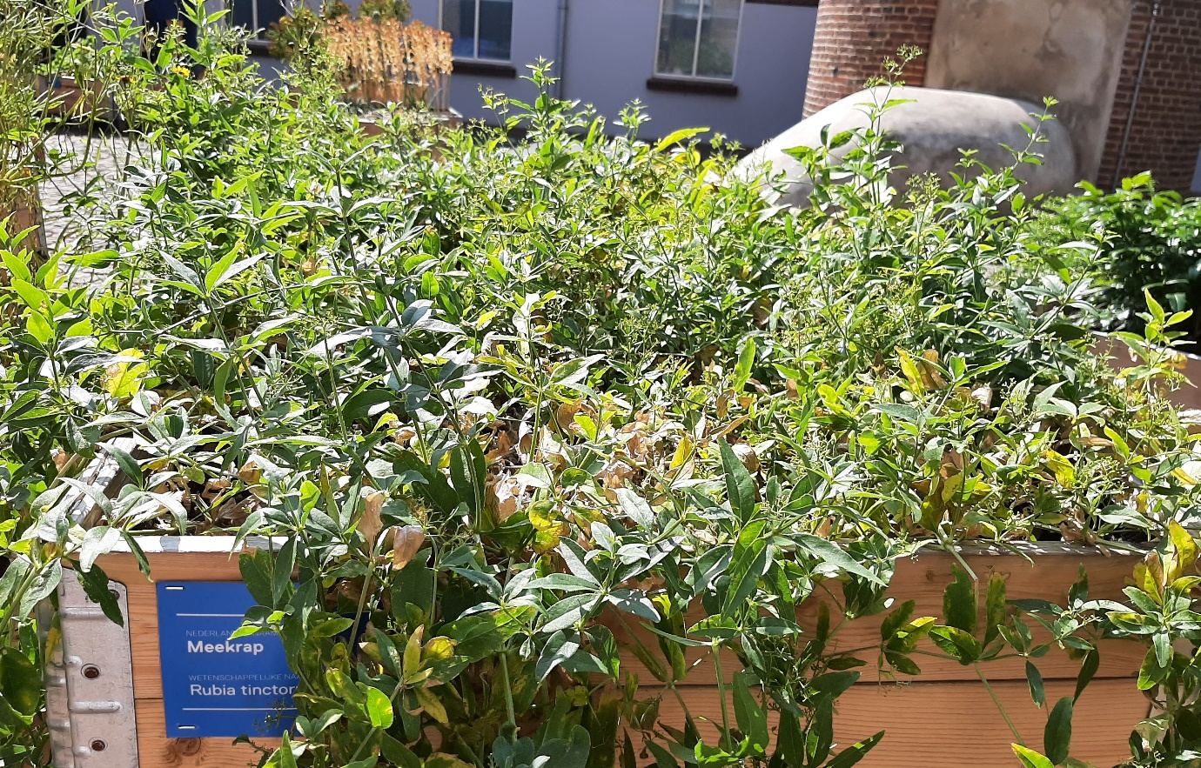
Figure. Rubia tinctorium, a potentially interesting crop to produce dyes of plant-based origin to contribute to a non-fossil circular textile chain.

2. Readiness and possible follow-up

Where we started
Historically, cloth was dyed with dyes from natural origin, derived from plants, insects or non-organic materials such as soil or minerals. When the chemical industry progressed, synthetic dyes were found to give a more intense and uniform colour and were cheaper to produce. Thereby, knowledge and experience on natural dyes got lost. However, in recent years, interest in natural dyes is increasing again, in search for a non-fossil, circular textile chain. In order to realise this, knowledge on non-fossil dyes of natural origin has to be built up again, and placed in the perspective of modern breeding and cultivation technologies within a business case where side steams are valorised.

Where are we now
The starting point of the project was the concept of “dual-function” crops, where dye would be the harvestable product, next to fruits, flowers or stems. These crops would be grown in controlled conditions (such as greenhouses or vertical farms), so that concentrations of colourants could be controlled in a sustainable way. In the project, we made an extensive inventory of plant species that could provide natural colourants that could be used as dyes in textile chains. However, the inventory showed that crops that contain valuable colourants in high concentrations are primarily trees which do not fit in an indoor cultivation system, or herbaceous plants that do not have another harvestable product than the dye. Thus, we changed perspective, and selected crops primarily on their characteristics as a producer of valuable natural dyes, on their suitability for high productivity protected cultivation, on the gene pool of these crops and the options for valorisation of the side streams of these production systems. In this evaluation, we were able to use all expertise’s that were represented in the project team. Based on this evaluation, we selected two interesting crops that have potential to fulfil the demands from all perspectives used.

Potential and next steps
Based on the inventory, Rubia tinctorum (madder) and Indigofera tinctoria (true indigo) seem to offer most perspective to be used as a natural, plant-based dye to be used in a fossil-free, circular textile chain. Indigofera tinctoria offers perspective as a colourant for natural textiles, such as cotton, linen, wool and silk. The side streams offer perspective to be used e.g. to derive proteins. What remains to be done for this crop is set-up a cultivation system and processing system to grow the crop, extract the dye and valorise the side streams. This might lead to a viable business case, which then might be rolled out having a commercial perspective.

The design of a cultivation system for of Rubia tinctorum (madder) will be more challenging. Traditionally it was grown in the field, and roots had to be dug out deep, to harvest the colourant alizarin. To make this into an economically viable business case, new varieties have to be selected or bred that have an altered morphology with smaller root systems. These new varieties will be better suited for cultivation in protected cultivation systems with altered root substrates (e.g. nutrient solution).

Innovation readiness
There is a small, but increasing demand for fossil-free textiles, which also includes dyes from natural origins such as plants. Some commercial companies are getting actively involved in the use of fossil-free textiles, using natural dyes and looking for the right species, genotypes, cultivation methods, colourants and business cases. Based on this project, we could support and cooperate with them to make next steps.

3. Learning Journey

The objective of this project was to contribute to a value chain, in which high-value crops grown in protected cultivation can be used in a fossil-free textile chain, using “waste” material of the production. In the project, we cooperated well in a team with expertise’s in the fields of chemistry, plant physiology, breeding, biorefinery and indoor cultivation. During the first meetings, we had to learn on each other’s perspectives, terminology and understanding of the research questions in the project, which yielded interesting discussions. A visit to the Textile Museum in Tilburg was a real accelerator for this process.
We approached the topic of selecting appropriate crops for the production of natural dyes from these different fields of expertise, where some crops proved interesting for side streams, but impossible to cultivate indoors and vice versa. The different perspectives really added to our understanding on what is important for crop selection next to our own perspectives based on our expertise’s. The project led to a promising short-list of crops that we could continue with to build an interesting business case that might contribute to a fossil-free textile chain.

1. Did your Wildcard project involve new collaboration with disciplines or people? If so, briefly explain what was new.
In the project, we cooperated well in a team with expertise’s in the fields of chemistry, plant physiology, breeding, biorefinery and indoor cultivation. During the first meetings, we had to learn on each other’s perspectives, terminology and understanding of the research questions in the project, which yielded interesting discussions. A visit to the Textile Museum in Tilburg was a real accelerator for this process.

2. If applicable, did the new collaboration alter your original thinking about the topic? Did it change research directions or courses of action? If so, briefly characterize how.
The new collaborations opened up new ways of thinking of the entire chain of breeding, cultivation, processing and using side streams. This has widened the thinking of the topic, and has resulted in a wider, more extensive, chain-wide approach of the topic. This has altered the final conclusions of the project, and thus the courses of action that will follow from it.

3. Did interactions during community days and/or meetings organized by the investment theme alter your original thinking about the topic? Did such interactions change research directions or courses of action? If so, briefly characterize how.
Not really, since the project team itself contained sufficient expertise in project execution and project management. Furthermore, the project team consisted of staff with all the expertise’s required to execute the project well (within the time and budget limitations of the project).

4. Did you meet any challenges during implementation of your wildcard project? If so, what kind of challenges where these?
Challenges met were content-wise. As described in chapter 1: The starting point of the project was the concept of “dual-function” crops, where dyes would be the primary harvestable product, next to fruits (e.g. tomato), flowers (e.g. marigold) or stems for fibres (e.g. nettle). These crops would be grown in controlled conditions (such as greenhouses or vertical farms), so that concentrations of secondary metabolites to be used as dyes in textile chains could be controlled in a sustainable way. Based on these conditions, we made an inventory of plant species that could provide natural colourants that could be used as dyes in textile chains. However, the inventory showed that crops that contain valuable colourants in high concentrations, are primarily trees which do not fit in an indoor cultivation system, or herbaceous plants that do not have another harvestable product than the dye, although fibres might be harvested of some. Thus, we changed perspective, and selected crops primarily on their characteristics as a producer of valuable natural dyes, on their suitability for high productivity protected cultivation, on the gene pool of these crops and the options for valorisation of the side streams of these production systems.

5. If applicable, how were these challenges eventually addressed? Did activities organized by the investment theme contribute to overcoming challenges? If so, briefly indicate how.
See above, the project team revised its perspective, and started making new choices. Activities by the investment theme did not directly contribute to this process.

6. Has your involvement in the investment theme resulted in any new initiatives or spin-offs that would probably not have emerged if you had not participated? If so, briefly indicate how these new initiatives came about.
This project has opened up a new network within WUR, where breeding, high-tech cultivation systems, chemistry and processing are connected. We expect that this collaboration will last, and generate new initiatives.

4. Additional project specific deliverables

Deliverable 1: workshop with researchers in the fields of cultivation of fibre crops, textile value chain, plant secondary metabolites, high-value crops in vertical farms, processing, waste streams and circularity. Aim is to develop a cross-disciplinary understanding of the system, how the different disciplines could add value, and what the consequences for other parts of the value chain are.
This workshop was held at the beginning of the project.

Deliverable 2: presentation of a system design of production of high value crops that provide dyes for the textile value chain, including selection of compounds, carbon footprint, connection with industry for CO2 supply, re-use of other plant parts and processing.
The system design was presented at the Community meeting in November.

Deliverable 3: dissemination of the system design to relevant stakeholders and the research community by presentations and (internet) news items (D3).
The project team is currently writing a “long-read” for the WUR website, which can then also be used for communication to third parties. This will be finished in 2022. This “long-read” is largely what is described in this report in chapter 1.

Deliverable 4: report describing the learning journey in the design of the system.
The report is delivered as a (limited access) report entitled “Dyes derived from plants for fossil-free textile chains: selection and evaluation”. This includes the analysis of a number of plant species for their suitability to be used commercially to produced dyes. The long-list of plant species is delivered as a separate (excel)file. The deliverables can be found at https://teams.microsoft.com/l/team/19%3aC9rI6gH09yk1acpK1WVKMpLqPgb-j40iGDRrSD7cKzQ1%40thread.tacv2/conversations?groupId=884b0066-fe18-48a5-8452-dca882cb2a6e&tenantId=27d137e5-761f-4dc1-af88-d26430abb18f

This summary was written before the format of this report was known, and appears to have quit some overlap with the questions that are asked in chapter 2 of this report. This summary is the summary of the report we deliver (see chapter 4), and will be published as a “long read” on the WUR website

