Uncertainty as a catalyst for creative action
Workshop design to foster the competence “being able to use uncertainty as a catalyst for creative action”

Abstract

Background: Uncertainty is inherent to sustainability challenges. To address sustainability challenges, learners therefore need to develop capacities for dealing with uncertainty. In literature, those capacities have been called uncertainty competences.
Research question: The thesis at hand explored the question how education can foster such uncertainty competences. The focus lay on a specific competence from Tauritz’ (2019) framework: The competence being able to use uncertainty as a catalyst for creative action. This research addressed a gap in understanding how theoretical knowledge about the competence can be translated into a workshop design for educational practice.
Methodology: The research was structured according to the educational design research (EDR) approach. EDR addresses questions for educational practice through developing an intervention (lesson, course, curriculum) in a real-life context. The research approach consists of designing an intervention in several cycles of prototype development, testing, evaluation and refinement of the prototype. Eventually, the prototypes’ outcomes are assessed. Figure 1 visualises how the thesis translated EDR into concrete research steps to address the two research questions (in blue and orange).
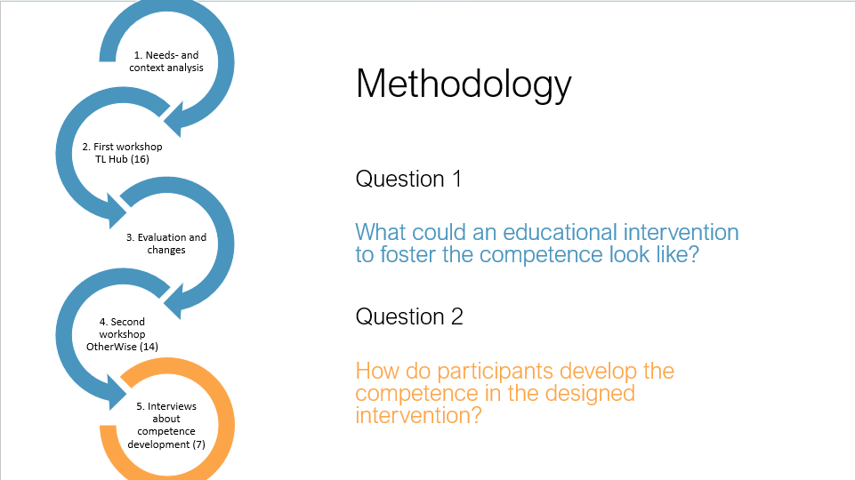
Figure 1: The five research steps

Findings: The designed workshop was evaluated in terms of participants’ competence development. There were four key findings: First, explicitly addressing uncertainty creates a fertile ground for learners to explore the concept of uncertainty and their experience with it. Second, to facilitate this exploration, the research showed that creative learning activities support learners in embracing the discomfort uncertainty may encompass. However, the workshop’s use of creative methods surfaced the learners’ need to process abstract and non-verbal activities in order to learn from them. Third, the evaluation of my workshops suggested that sharing experiences of uncertainty with peers can make learners more comfortable with uncertainty. Realising that others are uncertain too was the main take-away for many participants of both workshops. Lastly, the crucial role of emotions in dealing with uncertainty needs more scientific attention, in particular the relation between uncertainty and insecurity.

