Phasing out fossil feedstock-based materials in the Fashion industry

  - Final wildcard project report

Radha Jethu-Ramsoedh, Marloes Moed,
Anita Hardon, Josephine van Zeben

18 January 2022

The investment theme has funded this project Transformative Bio economies:
Towards a materials transition that phases out fossil feedstock

Introduction
The world’s biggest fashion brands fuel plastic pollution and the climate crisis through their reliance on synthetic fibre made from fossil fuels. The system seems locked into a focus on growth and disposability, however, there are bright spots. Concerns about plastics pollution and the climate crisis have resulted in a plurality of strategies to stimulate increased use of sustainable materials (supply side) and increased demand for sustainable fashion (demand side); and, policies that enable this transition have been adopted. From January 2023 onwards, producers in the Netherlands will be responsible for the recycling and reuse of textiles and the costs of waste-management.

Our nine-month methodological innovation project sought to learn from innovative efforts to phase-out and recycle carbon-based – synthetic - materials in the fashion industry, including initiatives to promote the uptake of alternatives and the growth of niche grassroots initiatives.

Our study found that after the food and construction industries, the fashion industry, with its heavy reliance on fossil feedstock, supply chain is the third most polluting business sector. The fashion industry's current rapid consumption model is unsustainable because the planet is becoming overburdened on all fronts, with severe adverse consequences for climate, nature, and the availability of raw materials. Never before has the need for the development of sustainable business practices in the fashion industry been more acute.

The objective
The world’s biggest fashion brands fuel plastic pollution and the climate crisis through their reliance on synthetic fibers made from fossil fuels. The system seems locked into a focus on growth and disposability. Therefore, action plans are being put in place. Concerns about plastics pollution, including microplastics, and the climate crisis have resulted in a plurality of strategies to stimulate increased use of sustainable materials (supply side), and increased demand for sustainable fashion (demand side); and, policies that enable this transition have been adopted. The European Commission, as a part of the Sustainable Products Initiative (SPI), aims to 'increasingly invest in and incentivize the uptake of circular business models. These include product-as-a-service models, peer-to-peer sharing and reverse logistics, on-demand manufacturing, reuse and repair services, to name a few. This is necessary to decrease overall demand for energy and resources and decouple growth from primary resource use'.

The objective of this study is
- to briefly review the legislative efforts;
- make a quick scan of the actors involved in reducing the fashion industry’s reliance on carbon-based material, and examine their diverse phasing-out/recycling strategies (recycling, the use of non-carbon-based materials, clothing swapping events, online second-hand clothes platforms, fashion in the metaverse, vegan fashion) and
- briefly review the materials transition of textiles.

Review of legislative efforts
Please note that this part gives a brief overview of the legislative effort for this project. We have created additionally a final wildcard project report “Juridical Innovation for Fashion Industry”.
The European Union and many of its member states are calling for a transition to a circular economy; however, it is still unclear how to make that happen. To achieve a fully circular economy, all product chain activities must achieve full circularity. This is a huge challenge for the coming years, also for the fashion industry.

From 2023 onwards, producers in the Netherlands will be responsible for the recycling and reuse of textiles and the costs of waste management. In our project, we interviewed companies that are active in the fashion industry to learn from their innovative efforts to phase-out and recycle carbon-based – synthetic - materials they were taking, including, for example, the uptake of alternatives. In parallel, we performed a quick scan of the legislation processes and actors so as to have as complete a picture as possible of potential bottlenecks.

Our main findings were that although the sustainable fashion movement is gaining traction, the environmental and social impact of the fashion industry remains a huge issue. The fashion industry is responsible for 8-10 % of worldwide carbon emissions. It is the second-largest consumer of the world’s water supply and is responsible for vast amounts of microfibre pollution in our oceans. And the problems are not confined to the environment. Workers around the globe continue to suffer from unliveable wages, child labour, modern slavery and unsafe working conditions.

Quick scan of upcoming legislation reveals that in March 2022, a strategy for sustainable and circular textiles was published by the European Commission to implement 'The commitments made under the European Green Deal, the new circular economy action plan (CEAP), and the industrial strategy and aims to create a greener, more competitive, and more modern sector more resilient to global shocks.'
The Strategy proposes measures for the entire life cycle of textile products, supporting the ecosystem during the green and digital transition. It focuses on how textiles are designed and consumed, including looking at sustainable technological solutions and innovative (circular) business models.

Some of the measures include; new design requirements for textiles to make them last longer, easier to repair, and recycle under the Ecodesign for Sustainable Products Regulation (ESPR) and more transparent information on textiles and a Digital Product Passport (DPP). Furthermore, tight controls on greenwashing by ensuring the accuracy of companies’ green claims, with stricter rules to protect consumers and direct links to the upcoming Green Claims Initiative

At the same time, actions are planned to address the unintentional release of microplastics from textile Harmonised EU rules on extended producer responsibility for textiles as part of the revision of the Waste Framework Directive in 2023.

In the Netherlands, the introduction of the EPR for textiles in scheduled for the Spring/Summer of 2023. Although the instrument EPR is based on the Polluter Pays Principle, one of the key principles underlying the European Union’s environmental policy, it is not free of criticism. There is concern that when the Dutch municipalities collect the textiles for the companies, not the taxpayer but the consumer will pay for the collection of the textiles.

Case studies research
For this project cases study research is conducted in which an analysis of outcomes of the case studies in light of the legislation is done. A quick scan of the actors involved in reducing the fashion industry’s reliance on fossil-based carbon-based material in the Netherlands was done. The main objective is to examine their diverse phasing-out/recycling strategies, recycling, the use of carbon-based materials, clothing swapping events, online second-hand clothes platforms, fashion in the metaverse, and vegan (plant-based fashion).

In total seven fashion or fashion related businesses were interviewed and analysed on the Circularity principles. which included gathering more information about these companies and interviewing key actors within the companies about their practices.

The findings of the case study research reveal the one of the seven companies interviewed indicated that they are not at all concerned with sustainability in a broad sense as part of their business operations. Most companies interviewed indicated they were aware of the (upcoming) legislation.
The interview with one of the fashion companies shows that the circular business model of “leasing” is not economically viable. Raising the question of whether such a circular business model works in the fashion industry.

The materials transition in textiles
The methodological innovation project seeks to learn from innovative efforts to phase out and recycle fossil feedstock based – synthetic - materials in the fashion industry, including initiatives to promote the uptake of alternatives and the growth of niche grassroots initiatives.

The following notes needs to be made on the textile materials. To assess the sustainability of any specific material, it is essential to have deeper look at the entire value chain, including the production processes. The idea behind circular economies is that the materials can be recovered at the end of the pipeline. However, the fashion industry uses many composite materials which cannot be recycled into new raw materials for the fashion industry. Also, for some uses, such as garments for sport and fitness purposes. In this case synthetic materials have superior properties.

Facing the challenges in achieving circularity in the fashion industry, we decided to use the R-ladder factor in our assessments, The R-ladder (circularity ladder) describes various strategies (called R strategies or circularity strategies) that contribute to reducing the use of primary raw materials. For circularity strategies higher on the ladder, fewer materials are required, thus avoiding environmental pressure from raw material use. In doing so, the ladder provides a priority order from high to low.

Notable, there is still much debate in the literature about the specific interpretation of the R-ladder. For example, ladders occur in which the number of steps ranges from 3 to 10. This R-ladder was created by PBL Netherlands Environmental Assessment Agency.
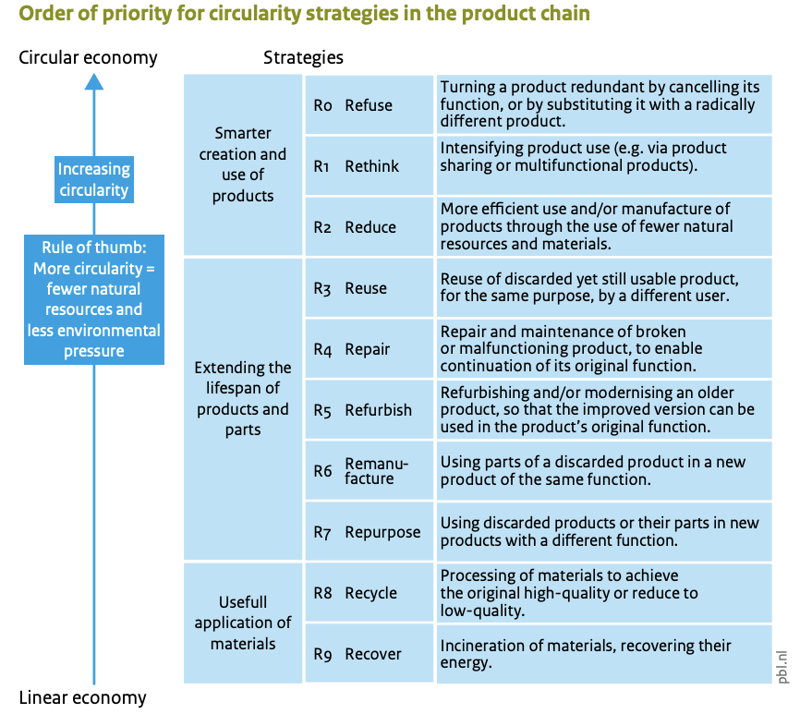

Main results
As mentioned, case studies were conducted with seven companies to study the intersections between consumer demands for sustainable fashion, and technological efforts to design more sustainable materials and fashion-wearable clothing, along with the legal and economic affordances that enable the transformation into a circular fashion economy. Through deep learning from seven fashion case studies (representing both up and downstream efforts), our Wildcard project will generate an understanding of the ways societal, economic, legal and ecological aspects are intertwined in efforts to make the fashion industry more sustainable and open for a circular transition.

First of all, a selection of in total twenty-six fashion companies in the Netherlands was made. These companies were selected to represent a range of strategies to reduce the carbon-foot print of the fashion industry. One could describe it as a ‘diversity sample’. Each of these companies was rated on the R-ladder based on their practices. The main focus of the interview questions was about their views on circularity if they aiming to achieve circularity? If so, how? Their awareness of laws related to circularity and potential obligations under these laws, and their circularity practices.

Based on this mapping invitations were sent out to all these companies and finally, in total, seven fashion companies opened up their doors for a semi-structured interview, e.g.:
- Four Amsterdam retailer (High-end multiband store, with own collection)
- B-Spoken retailer (High-end sustainable multi-brand store and own collection)
- Karel Lagerfeld (Luxury brand, mono-brandstore)
- PapajaRocks (Sole proprietary designer)
- Aarden retailer (Sustainable retailer corporate suites)
- Upset Textiles (Innovative Recycling company)
- Stitch (Fashion-tech startup)

Our findings can be summarized as follows:

Four Amsterdam (www.fouramsterdam.com)
Multi-brand store with own collection
Since 2012 FOUR Amsterdam is the retailer of menswear with a unique combination of streetwear, contemporary and luxury brands. With a multi-brand concept store and excellent one-on-one service the aim is to make the shopping experience seamless and unforgettable.
- Vision: excellent one-one service for consumers, high-end luxury brands
- Mission: to enhance the lifestyle and luxury the store is offering
- Strategy: Global recognition and expansion. ​
- Production of garments in Italy
R- Ladder:
- Down the ladder: circularity is not in the picture.​
Legal Awareness: Not aware of any new laws and regulations​

B-Spoken (www.b-spoken.com)
Fashion Retailer
The CEOs of this company are working for decades in Luxury Fashion, Lifestyle and High Tech. The company received various awards in Design and Quality as well as various prestigious publications on Fashion TV and high-end publications in society magazines and social media. They launched their B-Spoken Company to cater to the need of a growing clientele for a sustainable luxury ifestyle with a high-quality service. The company is providing customized sustainable lifestyle products through their own created Digital Platform and the production is being done through their local artisan manufacturing facilities with the aim to save expenses and CO2 Footprint while optimizing transparency within their supply-chain.
- Vision: to create a sales platform of high-end sustainable luxury lifestyle Mission: to deliver products directly from Italian factories to consumers.
- Strategy: the company manages a local factory-to-consumer strategy.
R- Ladder:
- RECYCLE: uses materials that are recycled and that can be recycled in the future. Most B-Spoken garments are made of over 60% recycled materials.
- REFUSE: to work with artisans from the Eastern part of the world as they believe Italian artisans are more transparent and have sustainable practices in place as well as a safe and healthy work environment.
- RE-USE: Consumers can sell their B-Spoken products back to B-Spoken for a discounted price. Depending on the product quality, B-Spoken will resell the product on its sales platform (website).
Legal Awareness:
- the company is aware of recent legal developments such as ERP stating that producers and importers who place a product on the Dutch market are responsible for it and it effect on the environment thus, sustainability.
- takes all Dutch legislation into place and works with recycled materials a result of this and is looking into future developments to help prolong the life cycle of their products (more specifically garments).

Karl Lagerfeld (www.karl.com)
Luxury brand
Fashion icon Karl Lagerfeld was renowned worldwide for his aspirational, relevant and cutting-edge approach to style. Driven by consumer engagement, the company's immersive retail experience includes more than 200 mono-brand stores worldwide, with key locations in Paris, London, Munich, Moscow, New York, Dubai and Shanghai. The brand further connects with consumers through a premium wholesale distribution network in the Netherlands (Europe). The Karl Lagerfeld spirit and according to his mantra, is “Embrace the present and invent the future.” The brand’s global teams work between two main offices — in Amsterdam and Paris, which support innovation, creativity and collaboration.

- Vision: “As a true Karl family, we are driven and inspired and in a unique place to build the world’s leading accessible designer brand.”
- Mission: To translate Karl’s legacy into meaningful stories and experiences for their customers.
- Strategy: The company lives by its 7 C’s (Customer Centric Approach).
R-Ladder:
- Focus on the top of the ladder: Refuse and Reduce
- Additionally: Sustainability Ambassador; Amber Valletta.
- Primary focus: People, Planet & Partners.
- Sustainable Development Goals are embraced.
Legal awareness:
- Legal Department, which is well aware of the upcoming laws audit to get the business certified.
- constant research into innovative and sustainable materials/looking into options for sustainable materials making.
- ensure they receive the transaction certificate from the supplier to the company.

PapajaRocks (www.papajarocks.com)
Designer Studio
PapajaRocks is a sole proprietorship company with a design studio. The company designs special prints for clothing products and is being defined as a young sustainable clothing brand. It is the passion of the designer to design unique t-shirts, sweatshirts and other garments. The aim is to contribute to the sustainable fashion industry with respect or nature and society by creating designs based on jungle prints and nature and urban lifestyle prints.

- Vision: sustainability and ethical values ​​are of high importance
- Mission: create more nature on the street by combining urban features and nature into the print.
- Strategy: sales by E-commerce
R- Ladder:
- Re-think: Circular sourcing recycles polyester and organic cotton
Legal awareness:
- Not aware of regulations of the fashion industry
- Select Supplier on green certificates

Upset Textiles (www.upsettextiles.com)
Circular Manufacturer
UPSET is building a new textile value chain, where increasing recycling rates is at its core. The company combine this environmental ambition with high social principles and carefully select its partners in the value chain and ensure they align with our high social standards. The aim of the company is to bring innovative (not mechanical) recycling technology to India, with the potential to revolutionize the mainstream mode of production. This technology enables the processing of 100% cotton textile waste into 100% recycled yarns. UPSET aim is to create a 360 degrees and future-proof chain, meaning that are developing the required infrastructure to guarantee 100% circular and socially fair produced yarns.
To leverage its mission, the company solely offer their yarns to partners throughout the supply chain who embrace our United Nations’ Sustainable Development Goals based values.

- Vision: Building a circular and socially fair textiles value chain.
- Mission: Creating a high-quality material from 100% recycled fibers.
- Strategy: Partnership with PurFi in Belgium. Purfi’s rejuvenation technology transforms post-industrial textile waste into sustainable circular fibres while maintaining an extremely low carbon footprint. Purfi’s technologies make use of every fibre captured in its process resulting in “Zero Waste” from the customer’s materials. While traditional recycling, which in most cases typically uses aggressive mechanical tearing, resulting in mostly downcycled end-products, or caustic chemicals and high resource costs, which produces an expensive end-product).
R-ladder:
- Processing waste into new materials that can be used for new products; using waste as a resource. Collecting and sorting garment in India and Kenia:
- Input: post-production (cutting waste) material
- Output: 100% recycled fibers
Legal awareness:
- Aware of Legislation
- The aim is to create partnerships and collaborations

Aarden Fashion (www.aarden.space)
Specialist in suites & corporate wear
The owner of Aarden has a background in Biology and has an awareness of the environmental impact of the fashion industry and learned about the environmental and social impacts of the fashion industry. So, the idea came up to start a sustainable fashion label. In order to gain more knowledge, the owner decided to do a Master's program in Environmental Management and chose sustainable fashion as her thesis topic. The aim was to start up slow fashion label. A fashion label that puts people and the planet before profit. Aarden is a vision that unites love for the craft of making clothes with a passion for environmental and social justice.
- Vision: Less polluting by offering a sustainable collection
- Mission: Production in Marocco and within Europe

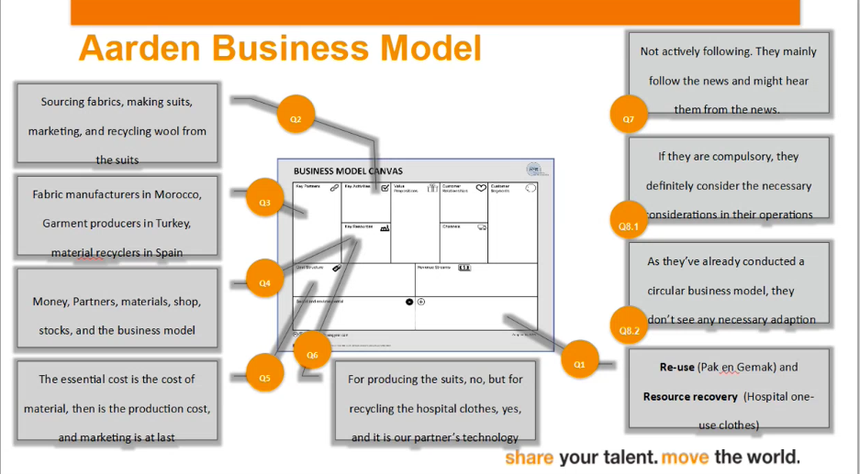

Stitch fashion (www.stitch.fashion)
Fashion-tech start-up
Stitch brings the power of people and technology together to future-proof your value chain, from design to sales, by offering visual software solutions and people-led services. The company provides a digital audiovisual platform to immerse customers in a brand and the collection of the brand. The Digital Showroom is accelerating a transformation which is looking into a remote wholesale sell-in and digital product creation. An interesting fact is that the former owner was the PVH Group, which is the owner of Calvin Klein, Tommy Hilfiger etcetera.

- Vision: Change the value chain of the fashion industry
- Mission: Help businesses become more adaptable and resilient.
- Strategy: Provide a digital platform to help fashion brands improve their digital workflows from design to sales.
.
R-ladder:
- Providing a material database:
- Help designers to make circular choices
- Choosing from a sustainable source
- Consider the use of recycled fabrics and deadstock.
- Consider a circular recycling model

Legal awareness: based on upcoming regulations, the company is looking into a Digital Product Passports (DPP), and designs should include a QR code or RFID tag to inform consumers of the origin of materials and recycling policy.

Key findings
The studied retailers' view on circularity (often inflated with sustainability) is diverse. Some are not at all concerned and feel fine saying so (e.g., Four Amsterdam), while others have made their brand around sustainability/circularity (B-Spoken). “Product as a Service” (e.g., the Corporate Suite Lease plan offered by Aarden) does not seem to work well for fashion. Thus, far only three customers have signed up. Legal awareness also varies widely between companies. Some multinationals, such as Karel Lagerfeld, have a dedicated legal team, while others, such as PapajaRocks (sole proprietorship) are not familiar with the law or potential legal issues.

Most initiatives are very niche and not easily scalable. B-Spoken is successful in the high-end segment, as is Karl Lagerfeld, which is already a very robust brand, so more leverage. The companies that appear most successful in combining environmental and financial success benefit from many (30+) years of experience in the fashion industry and an intrinsic desire to improve the industry (e.g., UPSET). More generally, degrowth would address a lot of issues but this is not considered a viable business model (e.g., the lease plan also does not seem to work well, which could be classified as degrowth).

The main obstacles we identify is that successful models appear to depend on long-term knowledge and experience. If long-term knowledge is indeed necessary (in terms of motivation and expertise) then the pool of ‘game changers’ becomes much smaller and reduces successrate of startups. Lack of expertise about sustainability and industry can lead to unsuccessful business models and/or not real greening but just ad hoc small changes that do not lead to any real/tangible change.

Greenwashing is a concern. It creates skeptical consumers and some companies actively want to distance themselves from this, so do not even try (e.g., Four Amsterdam). This problem is augmented by the fact that it is very difficult to judge what is actually sustainable if you are only one part of the value chain since you cannot see/control all the other parts and also often not yet clear what is sustainable and what is not.
Finally, monitoring and enforcement are completely lacking (also problems of implementation/transposition), also in the Netherlands. The table hereafter gives a visual overview of the case studies and the designation on the R-ladder of Circularity.

Visual abstract: based on the R-ladder of Circularity, the companies can be distinguished as follows:

Smart design and use | R1 | Refuse: This strategy includes discarding products: “prevent material use by making product obsolete or replacing with different product/ service. Avoid both virgin and processed materials.  -Companies/ organizations: Karl Lagerfeld/B-Spoken/Stitch
Smart design and use | R2 | Rethink: This strategy includes using products more intensively by sharing them or making them multifunctional.  -Companies/ organizations: PapajaRocks/Stitch
Smart design and use | R3 | Reduce: Reduce is about manufacturing products more efficiently or making them more efficient in use:” reduce the use of raw and processed virgin materials”  -Companies/ organizations: Karl Lagerfeld/Stitch
Increase product lifespan | R4 | Re-use: Products can have a longer life through reuse:” re-using products, components, or virgin materials (whether or not they have previously been refurbished).  -Companies/ organizations: Aarden Fashion
Increase product lifespan | R5 | Repair: This strategy is also about extending the life span of products but by repairing them.  -Companies/ organizations: --
Increase product lifespan | R6 | Refurbish: Extending the life span of products: Refurbish products and parts such that they are ‘like new.  -Companies/ organizations: B-Spoken (interior products)
Increase product lifespan | R7 | Remanufacture:  This strategy also involves extending the life of products by revising product components. making new products or parts from previously made products and/or parts.  -Companies/ organizations: --
Increase product lifespan | R8 | Repurpose: Reusing products and/or parts but with a different purpose/function, whether or not combined with Refurbish  -Companies/ organizations: --
Efficient use of materials | R9 | Recycle: This strategy involves processing and reusing raw materials.  -Companies/ organizations: UPSET Textiles /B-Spoken
Efficient use of materials | R10 | Recover: The strategy of recover involves recovering energy from materials (also called thermal upcycling)  -Companies/ organizations: Aarden Fashion

2. ‘Readiness’ and Follow-up
This project started from zero point. Subsequently, a quick scan of the actors involved in reducing the fashion industry’s reliance on fossil-based carbon-based material in the Netherlands was needed.

The main objective was to examine their diverse phasing-out/recycling strategies (recycling, the use of carbon-based materials, clothing swapping events, online second-hand clothes platforms, fashion in the metaverse, vegan (plant-based fashion). The outcome of the case studies is presented at a one-day think tank to a multidisciplinary expert panel, who responded to the analysis made by the student.

Moreover, lessons are learned on the interdependencies of technical, social, legal, economic and ecological aspects of the transformation to sustainable fashion affordances, which enable the transition to sustainable fashion. The economic interdependency is inclusive of natural capital (ecological systems) and social capital (relationships amongst people) and challenges capital that continual growth is good and bigger is better if it risks causing harm to the ecological and human system. In our view, the EU proposed action plans and legislation is based on the Polluter Pays Principle as one of the key principles underlying the European Union’s environmental policy, it is not free of criticism. As already mentioned, the is a concern that when the Dutch municipalities collect the textiles for the companies, not the taxpayer but the consumer will pay for the collection of the textiles.

Furthermore, sustainable technology is an umbrella term that describes an innovation that considers natural resources and fosters economic and social development. In our field research, we found companies that are creating and offering visual software solutions to scale digitization across the value chain. Therefore, recommendations for further research on (digitalization) ways to phase out carbon-based fashion are made.

Potential and Next steps
Based on the abovementioned recommendations for further research is made.
On the degrowth in fashion, the question is how and in what way degrowth can be put in place. Our recommendation would be to introduce deductible taxes for leasing corporate clothing. The Dutch Income tax used to have deductible taxes for corporate sustainable garments. In our opinion, the option needs to be considered as consumers might consider purchasing sustainable business clothing for a higher price due to the tax advantages.

Regarding the organization of repair activities, we have to look more into information/visibility/opportunity, but the question might be how we can scale up these repair services.

Another alternative to be considered might be implementing a “quota” on fossil feedstock-based materials. In the past the Multi-Fiber agreement (1995) was put in place in order to protect the textile industry within the EU. Under the multi-fiber arrangement, exports from developing countries were subject to quotas. Each country was assigned a specific allowable number of exports for each product. Only a certain percentage of goods were allowed into each developed nation per year. Once that quota was reached, the country could not import/export additional goods until the next calendar year. Specific products included yarn, fabric, and ready-made clothing products.
Based on the aforementioned, the measuring point at this moment could be “unsustainable” Fiber Agreement could be introduced in order to phase out fossil feedstock-based materials in the fashion industry.

Regarding consumer awareness, in our view, a consumer survey among the 7 living generations needs to be conducted. The 7 living consumer generations are:
- Baby Boomers: born 1946 to 1964.
- Generation Jones: born 1955 to 1965.
- Generation X: born 1965 to 1980.
- Xennials: born 1977 to 1983.
- Millennials: born 1981 to 1996.
- Generation Z: born 1997 or after.
- Generation Alpha: born 2010 or after
The aim is to find out their awareness and decision-making process for purchasing fast-, slow-, sustainable and circular fashion products. We have to keep in mind that one of the fashion economy's basic principles is “demand and supply”. Thus, if consumers are not willing to purchase unsustainable products, the industry needs to reflect on this.

Finally, new business models are coming up, such as second-hand trade platforms, clothing libraries, and sharing economy models. In order to trace and follow up, profound field research is needed.

Innovation readiness
Where does the project/innovation stand in terms of readiness? Is this something that can be piloted or rolled out in the outside world, or is this something that needs some further development and (lab) testing before it can be piloted in society? Is it possible/meaningful to indicate an ‘innovation readiness’ level using the below scale? If so, how would you score your project idea?
N.A.

3. Learning Journey
The team involved in this Wildcard was overwhelmed by the complexity of achieving circularity in the fashion industry. The R-scale proved a good instrument to review the initiatives. Our Wildcard involves a novel collaboration between researchers with different disciplinary backgrounds from Wageningen University, Wageningen Research, the Hanze University of Applied Sciences and the Amsterdam Fashion Academy.
The project team include:
- Anita Hardon (KTI/WU-SSG, Anthropology of Care),
- Josephine van Zeben (Law/SSG),
- Phil Macnaghten (KTI/WU-SSG, responsible innovation),
- Marloes Moed (external PhD Law/WU-SSG, Research Centre biobased economy of Hanze University of Applied Sciences),
- Egbert Dommerholt (Biobased Business Valorisation, Hanze University of Applied Sciencies)
- Radha Jethu-Ramsoedh (Commercial Law WUR/Amsterdam Fashion Academy),
- Paulien Harmsen (WR/Wageningen Food & Bio-based products).

The collaboration between researchers working with Fashion schools which seek to teach Higher Education students to consider sustainability in their future fashion business, with legal experts and experts on the transition from WUR, proved extremely valuable. At the expert meeting, the findings were shared with the materials experts of the investment theme, which made for a very interesting discussion on how to reduce the carbon footprint of the fashion industry.

Fashion without fossil-feedstock based materials seems unlikely, as polyester and other synthetic fibres have utilities. Reduce and re-use initiatives need to be scaled up to in order to make the transition to a Circular Fashion Economy. Furthermore, the challenge we faced in this project was that the willingness of fashion companies to participate in the case study research. It was difficult to organize interviews for the case studies. Most of the fashion companies are afraid of negative publicity and opening up their company and revealing their view on the topic of sustainability and circularity.

4. Additional project specific deliverables
- The Final wildcard project report, “Juridical Innovation for Fashion Industry” - completed
- Presentation of case studies report - completed (Q4 of 2022)
- A visualization of all our findings with a graphic designer – ongoing (will be done in Q1 of 2023). The interim results can be accessed here (designs have already been completed, the animation is still forthcoming).

Shukla, N. (2022) Fast fashion pollution and climate change, Earth.Org. Earth.Org. Available at: https://earth.org/fast-fashion-pollution-and-climate-change/ (Accessed: November 10, 2022).
Hedberg, A. and Sipka, S., 2021. Building a circular economy: The role of information transfer. EPC Discussion Paper 17 November 2021.
See https://environment.ec.europa.eu/strategy/textiles-strategy_en
Saccani, N., Bressanelli, G., & Visintin, F. (2023). Circular supply chain orchestration to overcome Circular Economy challenges: An empirical investigation in the textile and fashion industries. Sustainable Production and Consumption, 35, 469-482.
Consolidated text: Directive 2008/98/EC of the European Parliament and of the Council of 19 November 2008 on waste and repealing certain Directives (Text with EEA relevance)
See https://business.gov.nl/amendment/fashion-chains-must-collect-discarded-clothing
See https://business.gov.nl/amendment/fashion-chains-must-collect-discarded-clothing
Potting J, Hekkert MP, Worrell E and Hanemaaijer A. (2016). Circulaire economie: Innovatie meten in de keten [Circular economy: measuring innovation along the chain (in Dutch)]. PBL Netherlands Environmental Assessment Agency, The Hague.
Vase, R. (2022). Driving a Circular Economy for Textiles through EPR-28 February 2022.
Pauluzzo, R. and Mason, M.C., 2022. A multi-dimensional view of consumer value to explain socially-responsible consumer behavior: a fuzzy-set analysis of Generation Y’s fast-fashion consumers. Journal of Marketing Theory and Practice, 30(2), pp.191-212.

