Practical Steps for Writing a Thesis at The Agricultural Economics and Rural Policy Group of Wageningen University

Dear BSc and MSc students,

This document serves the purpose of orienting you about writing your BSc or MSc thesis at AEP. It has two parts. The first one presents short profiles of AEP faculty. They might be useful, especially if you are unsure who your supervisor could be. The second part walks you through the steps you must take to complete the thesis successfully.

AEP Faculty Profiles

Dr. Dušan Drabik
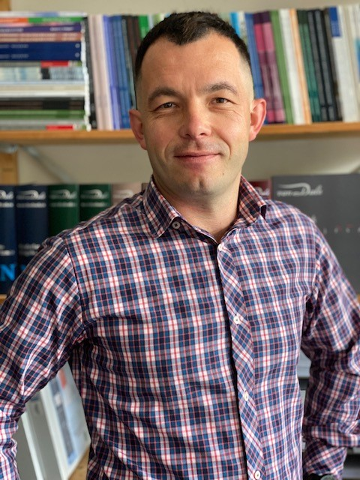
AEP internship, BSc, and MSc theses coordinator
E-mail: Dusan.Drabik@wur.nl
Office: Leeuwenborch, C2105
You might know me from: Microeconomics, Advanced Microeconomics, Industrial Organization
Areas of interest: policy analysis, bioeconomy, food waste, biofuels
Methods I typically use: microeconomic models, equilibrium models
You can see my publications at research@wur and a more detailed profile at we@wur.

Dr. Liesbeth Dries
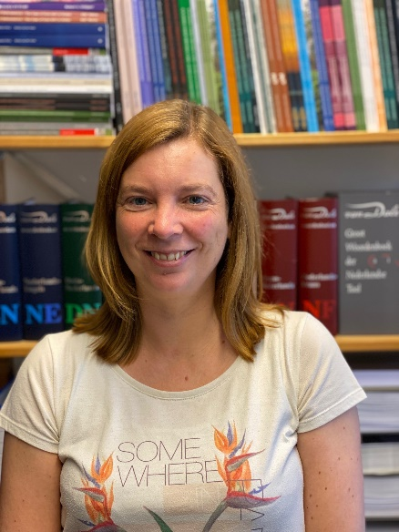
E-mail: Liesbeth.Dries@wur.nl
Office: Leeuwenborch, C2116
You might know me from: Economics of EU policies for sustainability transitions, Institutional Economics and Economic Organisation Theory
Areas of interest: food supply chains, agri-environmental schemes, EU agricultural and food policies, sustainability
Methods I typically use: econometrics, case-study
Projects I work on and you could, too:
NOVASOIL - Innovative business models for soil health
EFFECT - Contracts for environmental goods
agroBRIDGES - Connecting producers and consumers through short food chains

You can see my publications at research@wur and a more detailed profile at we@wur.

Dr. Koos Gardebroek
E-mail: Koos.Gardebroek@wur.nl
Office: Leeuwenborch, C2117
You might know me from: Econometrics, Advanced Econometrics,
Areas of interest: price analysis, policy analysis
Methods I typically use: econometric models of different kinds, machine learning
You can see my publications at research@wur and a more detailed profile at we@wur.

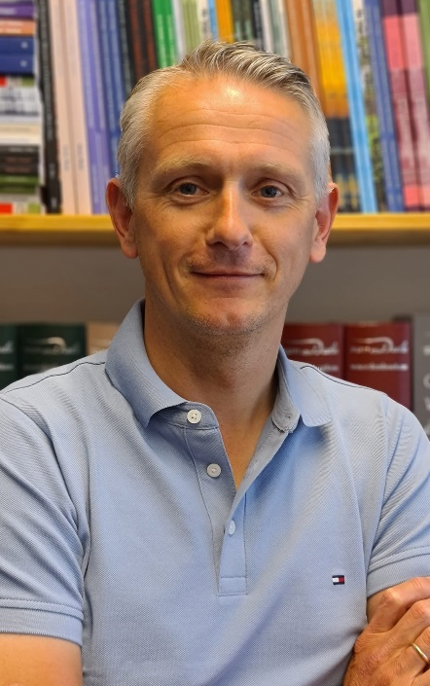

Dr. Esther Gehrke
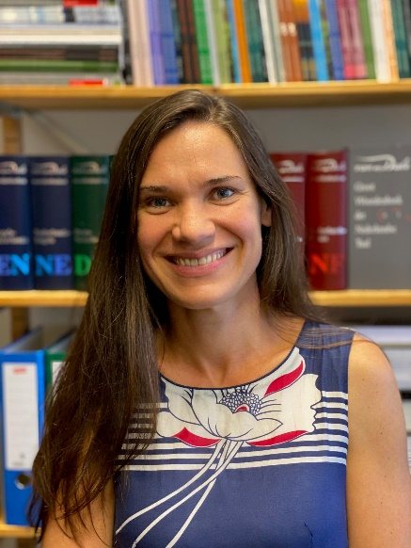
E-mail: Esther.Gehrke@wur.nl
Office: Leeuwenborch, C2115
You might know me from: Introduction Economics, Economics of Agribusiness, Central Themes
Areas of interest: development, education, demography, and agricultural productivity growth
Methods I typically use: econometrics (e.g., randomized control trials, quasi-experimental techniques)
You can see my publications at research@wur and a more detailed profile at we@wur.

Dr. Rico Ihle
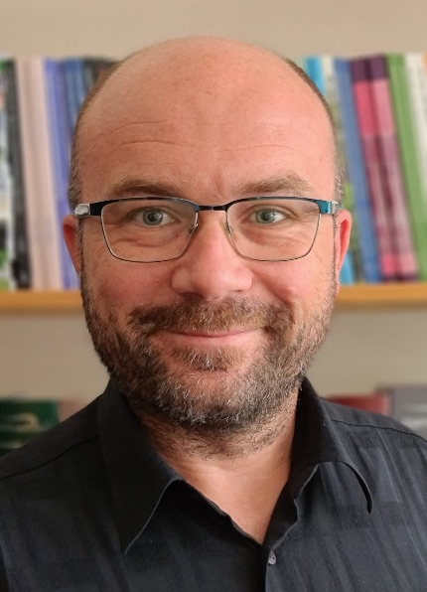
E-mail: Rico.Ihle@wur.nl
Office: Leeuwenborch, C2114
You might know me from: Econometrics; Agriculture, Food and Policy; Economics of EU Policies for Sustainability Transitions
Areas of interest: structure and developments of markets (prices, trade etc.) and policies for agricultural and food products, impacts of market shocks, food supply chains in & around the EU & in Indonesia, food system resilience in the Middle East, Africa & Eastern Europe
Methods I typically use: traditional & spatial econometrics, multivariate analysis, machine learning, primary data gathering & questionnaire design
You can see my publications at research@wur and a more detailed profile at we@wur.

Dr. Roel Jongeneel
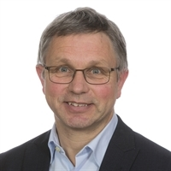
E-mail: roel.jongeneel@wur.nl
Office: Leeuwenborch, C2106
You might know me from: Agriculture, Food and Policy,
Areas of interest: (Dutch) agricultural policy, dairy farming, rural policy
Methods I typically use: simulation models
You can see my publications at research@wur and a more detailed profile at we@wur.

Dr. Jack Peerlings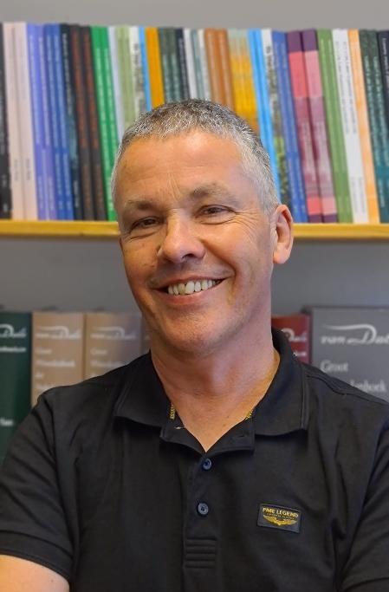
AEP internship, BSc, and MSc theses examiner
E-mail: Jack.Peerlings@wur.nl
Office: Leeuwenborch, C2108
You might know me from: Economics of Agribusiness, Landscape Economics and Politics, Spatial and Regional Economics, Industrial Organization, Economic modeling of sustainability challenges
Areas of interest: (Dutch) agricultural policy, land use, agribusiness
Methods I typically use: partial and general equilibrium models, input-output models, linear programming, micro-econometrics
You can see my publications at research@wur and a more detailed profile at we@wur.

Prof. Hans van Meijl
E-mail: hans.vanmeijl@wur.nl
Office: Leeuwenborch, C2106
You might know me from: Agriculture, Food and Policy,
Areas of interest: agro-industrial chains, technology, innovations, international trade
Methods I typically use: large computable general equilibrium models (e.g. GTAP, MAGNET)
You can see my publications at research@wur and a more detailed profile at we@wur.

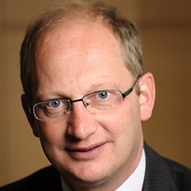

Prof. Justus Wesseler
E-mail: Justus.Wesseler@wur.nl
Office: Leeuwenborch, C2107
You might know me from: Life Science Economics and Policies, Advanced Course on Economic Regulation, Cost-Benefit Analysis and Environmental Valuation
Areas of interest: bioeconomy economics and policies, technology assessment, risk analysis
Methods I typically use: real options, cost-benefit analysis
You can see my publications at research@wur and a more detailed profile at we@wur.

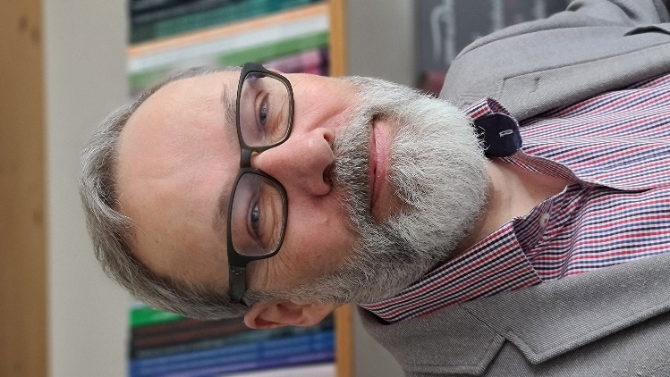

The Steps I Need To Take

- Contact the AEP theses coordinator (Dušan Drabik, Dusan.Drabik@wur.nl) to make an appointment and obtain guidance on who your potential supervisor could be.

- You can skip the previous point if you already have a clear idea of the thesis topic or whom you want to work with. In that case, you can talk directly to the AEP professor of your choice.

- After you have reached an agreement with your supervisor, you’ll need to initiate the administrative process (the case) of registering for your thesis in OSIRIS: https://wur.eu/tir-start. This step currently applies only to MSc theses; BSc theses still follow the “offline” version of the process (for more info, talk to the theses coordinator or your supervisor).

