BSc-thesis contract CPT-81812 – BSc thesis Communication and Life Sciences
Gegevens student:
Naam: …………………………………………………………………………………………
Reg. nr: …………………………………………………………………………………………
Adres: …………………………………………………………………………………………
Opleiding: …………………………………………………………………………………………
Tel.: ……………………………………………………
Verklaring studieadviseur:
Naam: ………………………………………………………………….. heeft zich op de hoogte gesteld van de studievorderingen, en gaat akkoord met de plannen voor het maken van een BSc-thesis.

Datum: Handtekening:

Gegevens thesisbegeleiders/examinators:
Naam thesisbegeleider/eerste beoordelaar CPT: ………………………………………………………………………

Naam examinator/tweede beoordelaar CPT:……………………………………………………………………………..

Naam Life-Science thesisbegeleider: ………………………………………………………………………………………….

Leerstoelgroep van de Life-Science thesisbegeleider: ………………………………………………………………..

Verdeling begeleiding in % over de begeleiders/leerstoelgroepen:………….…………………………………

Afspaken over te maken BSc thesis:
Onderwerp: ………….…………………………………………………………………………………………………………………

………………………………………………………………………………………………………………………………………………..

Omvang en code: 12 ECTS, CPT-81812

Streefdata: Start werkzaamheden: ……………………………………………………………………
Inleveren concept werkplan: ………………………………………………………….
Bespreking concept werkplan: ……………………………………………………….
Inleveren conceptversie thesis: ……………………………………………………..
Bespreking conceptversie: ……………………………………………………………..
Inleveren eindversie thesis: ……………………………………………………………

Andere afspraken: ……………………………………………………………………………………………………….
……………………………………………………………………………………………………….

……………………………………………………………………………………………………….
……………………………………………………………………………………………………….
……………………………………………………………………………………………………….
……………………………………………………………………………………………………….
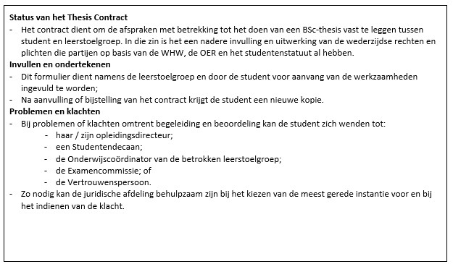

De percentages die gehanteerd worden voor de beoordeling:
Learning outcomes (assessment criteria) | Percentage (%)
A. Research competence | 30
B. Thesis report | 60
C. Colloquium | 5
D. Final Discussion | 5

De beoordeling wordt gedaan in op: ………………………….. (datum), in week …………….. (nummer)
Ondertekening:
CPT thesisbegeleider: ………………………………………………
Life Science thesis begeleider: ………………………………………………
Student: .………………………………………………

