
Logo of local host organization

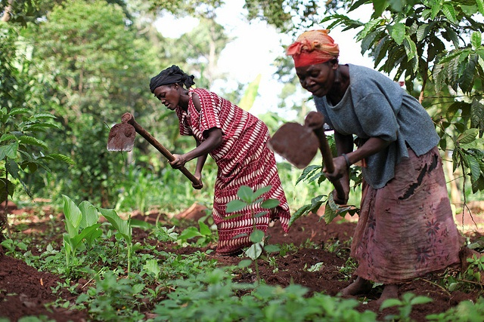


Title of MSc thesis (Verdana 22)

Sub-title (Verdana 18)

MSc thesis by < your name > (Verdana 13)
< month > < year > (Verdana 12)
Soil Physics and
Land Management Group

Title and sub-title of MSc thesis (Verdana 14)

Master thesis Soil Physics and Land Management Group submitted in partial fulfillment of the degree of Master of Science in International Land and Water Management at Wageningen University, the Netherlands

Study program:
MSc International Land and Water Management

Student registration number:
123456789

SLM 803xx

Supervisors:
WU Supervisor:
Host supervisor:
(others)

Examinator:
Prof. Coen Ritsema

Date:
dd/mm/yy

Soil Physics and Land Management Group, Wageningen University

