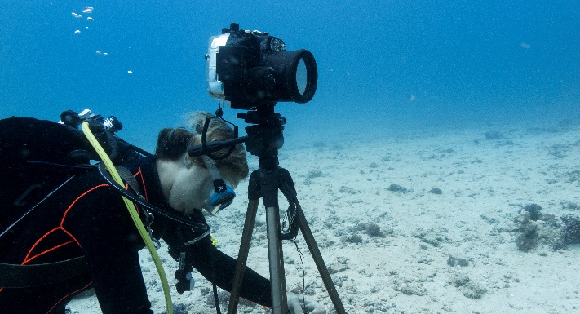
Motivation
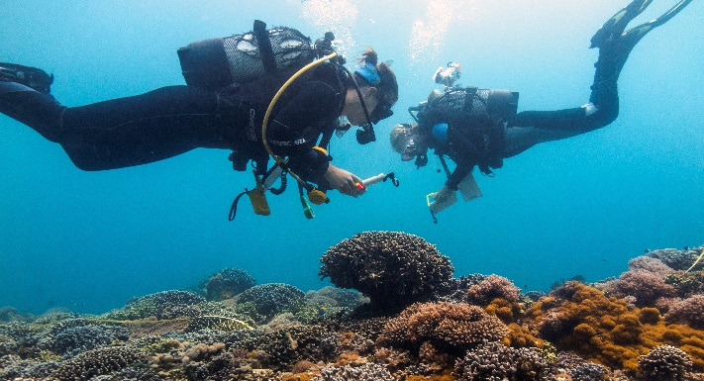
Despite the evident services coral reefs provide, failing local management and global climate change are rapidly annihilating these beautiful ecosystems. To restore reefs, coral is maricultured in nurseries and outplanted onto degraded reefs to kick-start recovery (coral gardening). However, coral gardening is often inefficient and could be optimized by using biological assistance to: (1) reduce cleaning time in nurseries by facilitating grazing by herbivores, (2) improve performance of outplanted corals by reducing competition with other benthic life forms and (3) reduce coral predation by facilitating corallivore predators.
Recording grazing by herbivores

Research questions
- RQ1: What are key herbivores and is their grazing associated with reef condition?
- RQ2: What are key corallivores and is their impact associated with reef condition?
- RQ3: Can the local reef-bound fish community facilitate coral mariculture?
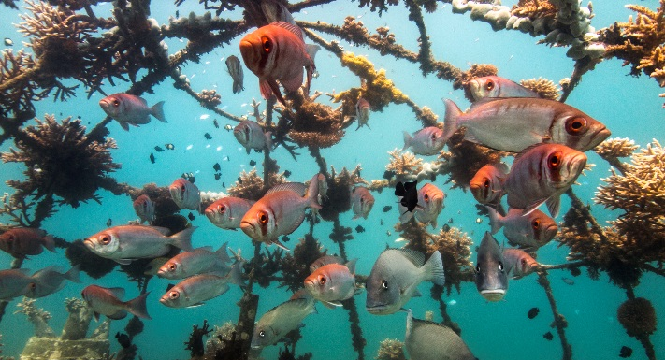
- RQ4: How can artificial reefs be optimized to accommodate grazers and reduce corallivores?
Quantifying predation on coral colonies

Method
The research questions are investigated by surveying healthy and degraded coral reefs (RQ1 & RQ2), as well as by using field experiments manipulating fish and invertebrate access to coral nurseries (RQ3) and artificial reefs (RQ4). All research is performed in Shimoni, southern Kenya.
Monitoring the biological interactions with cultured corals and various artificial reef types

