Migrating your Onegini account to eduID
Version 20200504, PO

Why migrate?
As an external user of WUR Library, you have a Onegini account to access our digital library. This account is a service from an external party, SURF. SURF has decided to replace all Onegini accounts with eduID accounts. Therefore, you need to migrate your Onegini account to an eduID account. After this migration you can start using your eduID account to log on to WUR Library.
If you don’t migrate to eduID, you will lose access to your personal settings in MyLibrary and to your saved searches, loan history and items on loan information in WUR Library Search.

When migrate?
You can do the migration now, but you need to do it before 1 July 2020. After that date, you won’t be able to use your Onegini account to access our Digital Library.

Important to know before you migrate
The new eduID has two ways of checking your identity:
- By sending an email with a link to the email address that is linked to your eduID account. Clicking this link will log you on with your eduID account. This is a ‘magic link’ in eduID terms.
- With a user / password combination.
The first option might be the most convenient, because you don’t need to remember yet another password. But please keep in mind that this only works when you access our digital library services on the same device where your read your email. E.g. when you receive your email on your mobile phone, and you want to access our digital services from a computer, you can’t use the link in your email.
In that case you need to log on to eduID using your password.
So when creating a eduID account, we advise you to create a password for your account as well.

How to migrate?
- You can start the migration by clicking this link: https://login.eduid.nl/migration
You can choose between English and Dutch (in this manual we use the English version).
Click the ‘Start migration’ button to start the migration.
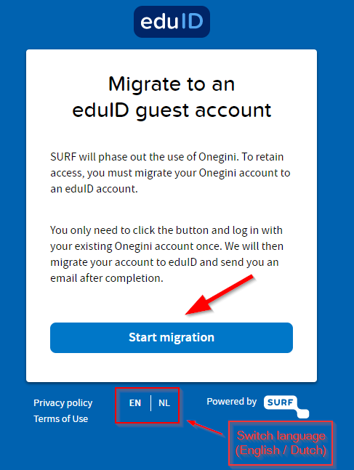
- In the next step you log on with your Onegini account as you normally do.
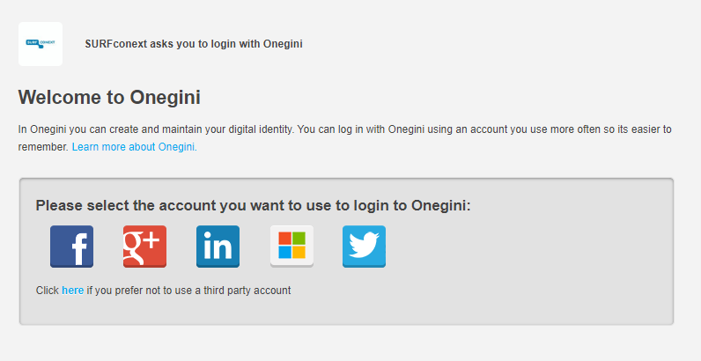
- Next you see a window with your user information that is migrated to eduID. You need to give permission for migrating this information.
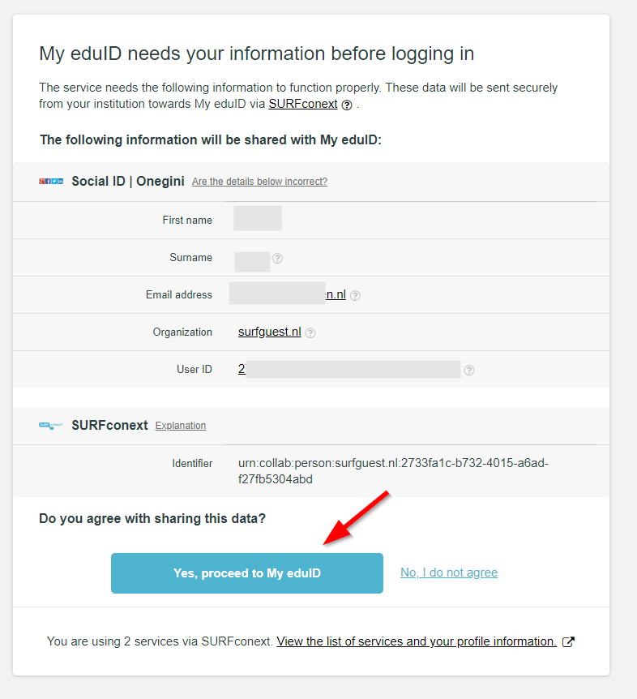
Click ‘Yes, proceed to My eduID’ to continue the migration process.
- Your eduID account has been created. From now on, you can use your eduID when logging on to WUR Library, instead of your Onegini account.
However, we advise you to create a password for your eduID. When you have created a password, you can still use the ‘magic link’ in your email for your eduID, but in case you don’t have access to your email, you still can use your eduID.
To create a password, click on the ‘Security’ option in the left hand menu.
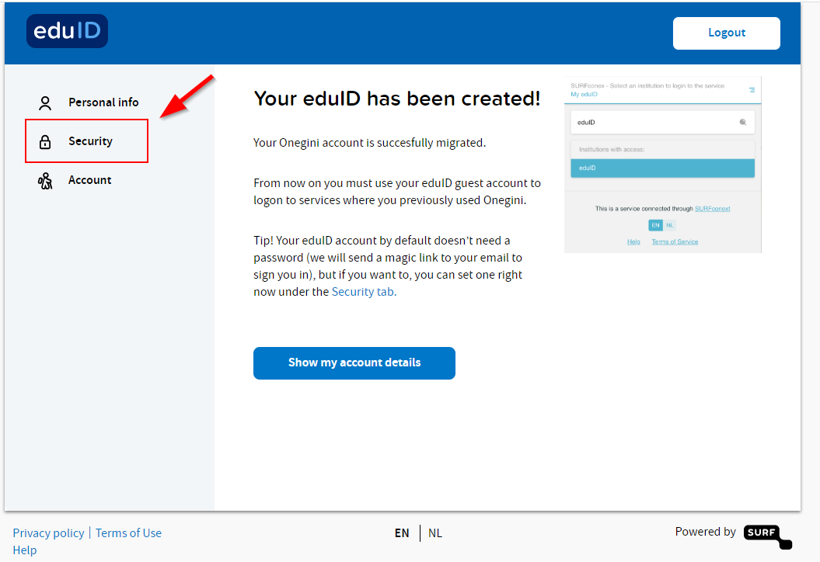
- In the next window, click in the ‘not set’ area behind ‘Password’.
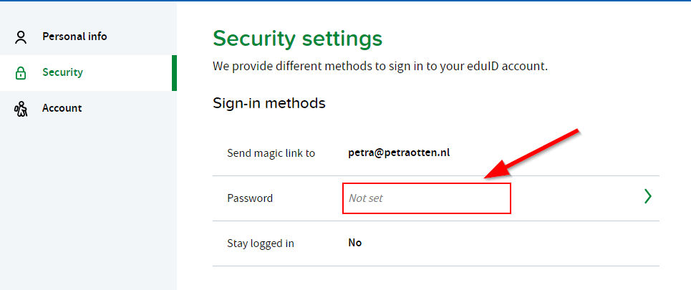
- Type your password and confirm it. Please note that a valid password is at least 15 characters OR at least 8 characters including a number and an uppercase letter.
When you’ve entered two identical valid passwords, the ‘Set password’ button becomes blue. Click this button.
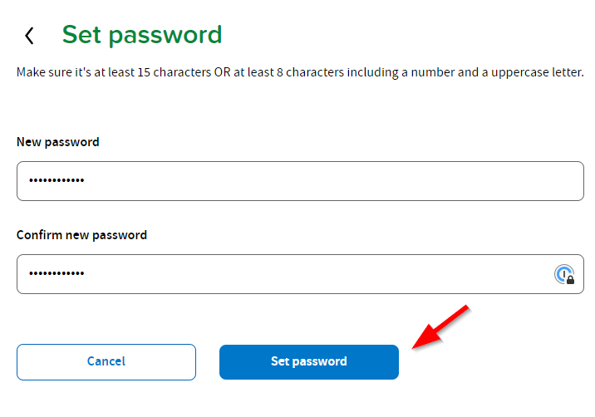
Now you’ve added a password to your eduID account. This is the last step. You can click ‘Logout’ on the upper right corner.

How to log on to MyLibrary?
- Go to https://www.wur.eu/en/Library.htm.
- In the login menu in the upper right corner select ‘Guest user (eduID)’.
- Type your email address. If you have access to your email on the device that you want to use to access MyLibrary, you can click the ‘Send magic link’ button. Otherwise, click the ‘Type a password anyway’ link in this window (assuming that you’ve created a password when migrating to your eduID account, see step 4 in the previous section).
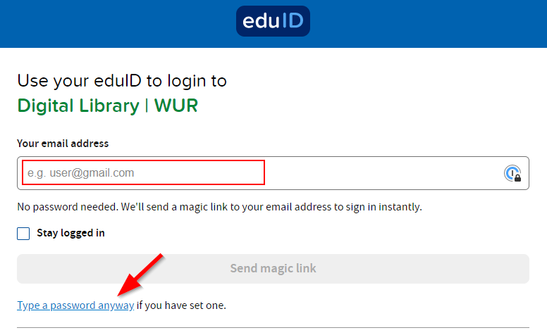
- Use the magic link in your email or enter your email address and password and you will proceed to MyLibrary.

In case of questions or problems
Contact our ServiceDesk
Phone: 0317 486666
Email: servicedesk.facilities@wur.nl
Or visit the Information Desk in Forum Library.

