2019-2020

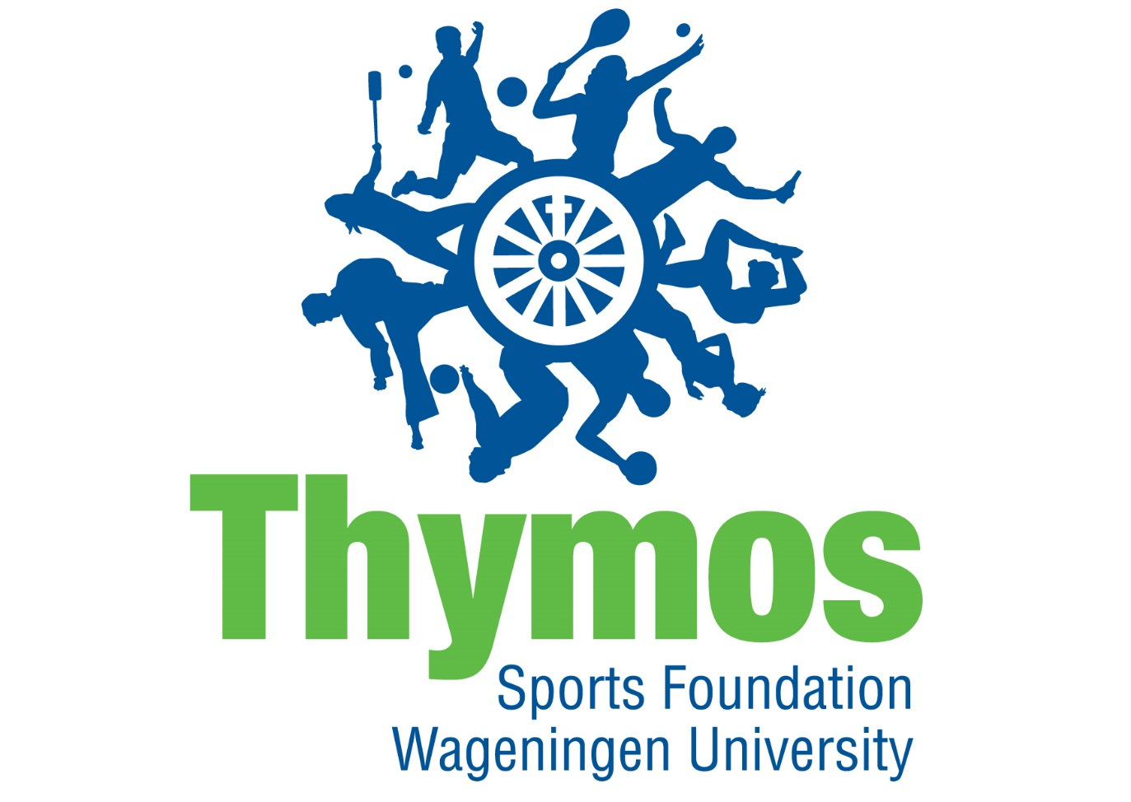
Dear potential board member!

In this information booklet you will find all the information about a full time board year at SWU Thymos. We will explain the goal of the sports foundation and what has been done the last years. Furthermore, we will explain what each and every board position entails. The positions are chair, secretary/vice-chair, treasurer, commissioner of publicity and commissioner of sports. Finally we will explain in detail how you can apply and what we expect from you. We hope that after reading this booklet that you know the basics about SWU Thymos and that you have become enthusiastic to dedicate yourself a year to student sports in Wageningen. If you have questions or just want to drink a cup of coffee you can always visit us in our office.

Good luck with making your choice!

Daily Board SWU Thymos 2018/2019
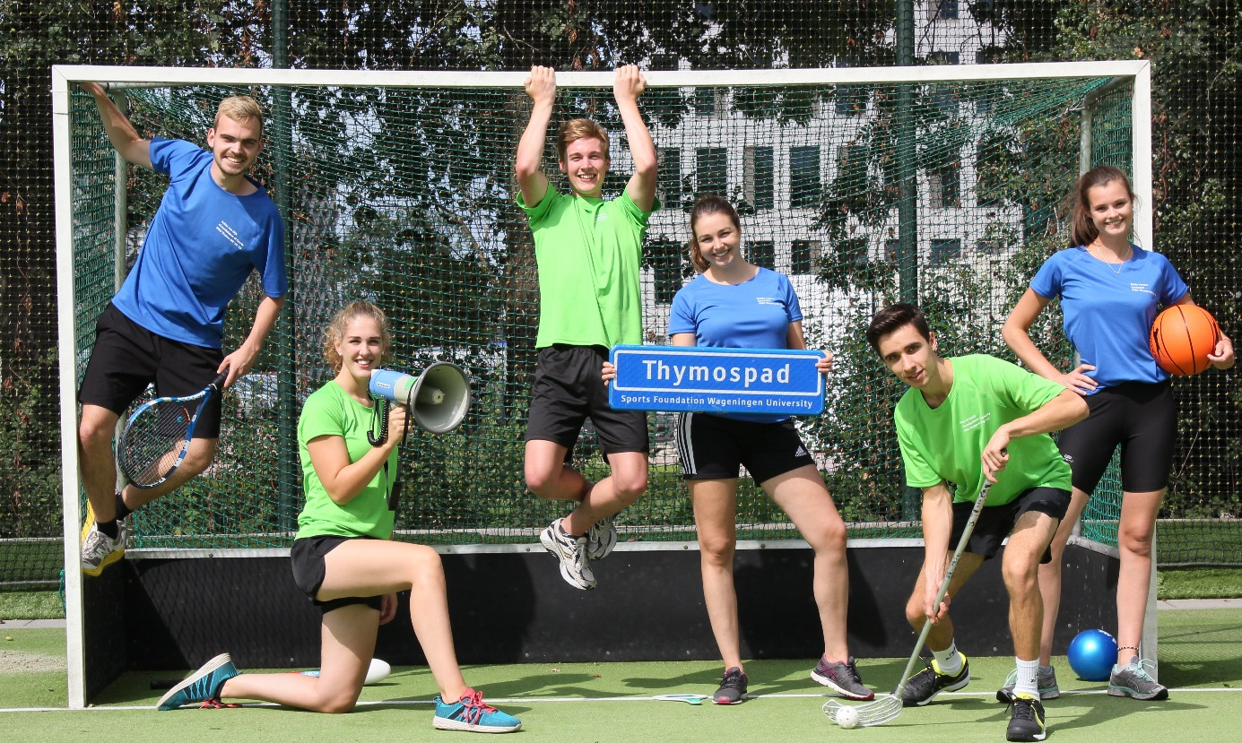

Daily Board of Sports foundation Wageningen University Thymos

We are looking for a new Daily Board and maybe we are looking for you! Do you want to have a break from studying for a year, but still want to learn something? Do you think student sports are important? The Daily Board of SWU Thymos might be something for you!

Who are we?
The Daily Board (DB) of SWU Thymos consists of six persons: a chair, secretary/vice-chair, treasurer, commissioner of publicity and two commissioners of sports. All six board members receive a grand from the University. They commit themselves every day to student sports in Wageningen.

What is our goal?
Our goal is to create a favourable and beneficial sports climate by offering the needed facilities (together with Sports Centre de Bongerd (SCB)) and by organising events for students. These are all kinds of activities like Thymos Experiences, tournaments and yearly events.

What we do
We organise more than 30 sports activities in a year! All these activities are very different from each other, like tournaments, experiences and events. There are several activities that return every year, but we also try to think of something new every year.

At the moment there are 29 student sports associations (ssa’s) in Wageningen. SWU Thymos is looking after their interests in several ways. Besides that, we support students who want to establish a new student sports association. Finally, we also look after the interests of students that are not bound to a ssa.

We also try to look after the interests of students that are not bound to a ssa. Think of users of the gym and the squash courts. They can always come to us with their complaints or remarks. Furthermore, we work together with Sports Centre de Bongerd. We discuss the sports programme and our policy with each other.

On national level we work together with Student Sports Netherlands (SSN). This umbrella organisation helps us with organising Dutch Students Championships and offers us workshops to develop our skills as a board. Because of SSN we have contacts with a lot of other student sports foundations in the Netherlands.

Next year, SWU Thymos will become 65 years old, which means that we will celebrate our 13th lustrum! Previous years, we reserved money to make this lustrum a big success! You, as a board, can organise this lustrum in the way you want!

Board positions:

Because of practical reasons it is not possible to fill the position of chair, secretary/vice-chair of treasurer when you are not fluent in Dutch. Therefore, we only explain the positions that you can fill. These are commissioner of publicity and commissioner of sports.

Commissioner of publicity

As the commissioner of publicity you are responsible for the promotion and appearance of SWU Thymos. It is one of the most creative functions and you have a lot of personal input. You have to make sure that the students know what SWU Thymos has to offer for them. Due to the many different channels of promotion it is a very diverse function. You learn a variety of things such as, planning, designing, creative thinking and also being flexible.
One of the best parts of this function is that you are involved in almost every event as you are responsible for one of the most important parts, making sure people know about the event and are excited to join!

In the process of designing and coming up with ideas you can use a variety of different illustrative programmes. This year I worked a lot with Adobe Photoshop, InDesign and Adobe Premier Pro for example. You can even learn how to work with these programmes by following online workshops, financed by SWU Thymos, how cool is that!

The great thing about the PR-Function is that you can tweak and perfect the appearance of SWU Thymos every single day. A lot of people will see your work and this brings quite the responsibility with it. However, once you have done all the standard types of promotion you can get as creative as you want and come up with new ideas to get people even more enthusiastic about our events!
Down here I summed up all the important tasks that a commissioner of publicity is responsible for:

Main tasks:
Posters and Flyers:
One of the things you will have to do is to design, print and spread the posters and flyers for the organised events. You can do this as comprehensive as you like, as long as the time and budget allows it. The content you will have to discuss with the commissioners of sports, they decide what the event will entail. Together with the treasurer you’ll have to decide what is possible within the appointed budget.

The Sports Guide
One of SWU Thymos greatest expenses is the sports guide. This booklet includes all the different student sports associations (SSA’s) and the different classes that the Sports centre offers. You will take care of the entire layout, including the text (submitted by others or written yourself) and photo’s.

Website and photos:
Sometimes you will also have to work on the maintenance of the website. It is an important measure for the communication and subscriptions for events and competitions.
It is really interesting to learn about how a website functions and all the different things that you can do with it. You will also make photo’s during the events and other activities that can then be posted on the website and our Facebook page.

Social Media
Another important responsibility are our social media channels. Facebook is one of the most important ones, we have over 3000 followers! As Com Pub you will try different and playful ways to use Facebook to make students enthusiastic for sports and SWU Thymos activities. Besides Facebook we also have an Instagram account on which we post more personal pictures about our board lives.

Sports calendar:
This A6-flyer is an overview of all our upcoming events for the next 2 months. It will be handed out in Forum and possibly other buildings and its main purpose is to reach people that for example do not follow our Facebook page. It is always a challenge to stand out between all the other flyers!

Remaining promotion:
Next to the larger projects there are also smaller cases which you can work on. Trying to make it into the Resource and making sure that our events are broadcasted on the tv-screens on campus for instance. Next to that, you will take care of the promotion on the information days of the University but also on the AID-info market and the sports day. If you like you can also make use of the GoPro and shoot some cool videos!

Secondary tasks:
In between your primary tasks you will discuss policy matters and other important decisions regarding SWU Thymos with your fellow board members. In the beginning of the year the secondary tasks will be divided among the six board members. This year the Health Week, lectures and ‘ fun activities committee’ just to name a few.

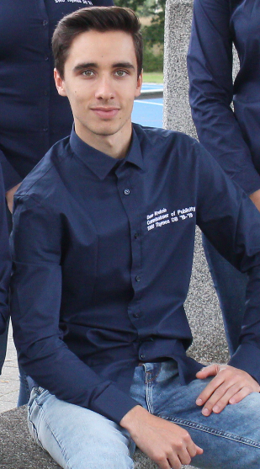
In conclusion:
Your days are very diverse, you can be really creative in your work and you learn to work with different types of promotion channels. All in all you are responsible for making sure that the students know what SWU Thymos has to offer and that they are enthusiastic to participate. It is a fun and challenging function! You will learn things you simply cannot learn to this extent from following classes at the university. Things such as publishing, effective communicating, the importance of teamwork, organising and how to discuss properly. These are all very useful skills for the future and you’ll definitely have a head start on the other students.
Besides, it is just a really, really awesome year in which you meet a lot of new people and get to do a lot of sports ;)

With sportive regards,

Daan Krekels
Commissioner of Publicity 2018-2019

Commissioner of Sports
As Commissioner of Sports you are responsible for the organisation of events, experiences and the Thymos Internal Competitions (TICs). These are the marquee activities that SWU Thymos provides to the students of Wageningen. They also offer a low-threshold to get students moving. This accessibility aligns with the motto of SWU Thymos: ‘Move and your body will recharged’. SWU Thymos represents sports in the broad sense, so we want everybody to be able to join our activities. Since there are over thirty activities every year, there are two Commissioners of Sports.
Besides your main tasks you are responsible for the policy- and decision making of SWU Thymos alongside your fellow board members. Your activities, policies and decisions will be discussed during the weekly meetings of the daily board of SWU Thymos.

Main Tasks
Events
Events are activities that often take up an entire evening. Our events usually consist of multiple games or sports and return every year. Think about the Ball Tournament, Squash Tournaments and the Dance Evening, all of which attract a major crowd! The size of each event differs, which means the amount of organisation effort also differs. For large events like the Battle of the Studies and the Sports Night you will form a committee. This committee will be guided by you and your fellow Commissioner of Sports. For smaller events you will often involve the student sports associations in the organisation of the evening. As a Commissioner of Sports, you have the freedom to organise new events. You can also decide to cancel existing events if you so wish.

Experiences
Experience are often one-time activities. During an experience, we offer the possibility of practicing a sports which you probably wouldn’t try out by yourself. Because of this, experiences are a unique activity. In contrast to events – which are usually free – there are costs for participating in an experiences. A number of experience are currently recurring every year, including the Indoor Ski Experience in Bottrop and Ice Skating in Biddinghuizen. Other experiences we organized this year include the Padel Experience, the Ice Karting Experience and the archery tag experience. Again, you are free to come up with new experiences. Dare to be creative!

Organisation of Events and Experiences
For both events and experiences you are in charge of finances (budget and clearance), planning, promotion (the Commissioner of Publicity will help of course), registrations, informing the rest of your board, coordination during the event and finally the evaluation. For events you will have to communicate inside de Bongerd to make sure reservations of halls and other parts of the accommodation are given to you. This is not necessary for experiences, which regularly take place outside de Bongerd. You do however need to organise transport for these (provided they do not take place at de Bongerd).

Thymos Internal Competitions (TICs)
Thymos offers internal competitions for soccer, futsal, knotsball and (beach) volleyball. Additionally, there is always the possibility to look into new additional TICs. During these TICs, students play against each other in different levels. Teams may consist of housemates, club mates, study mates, AID group members or any other kind of group. Every year we host three rounds of the TICs. TICs are ideal for students who do not want to be part of a student sports association but do like to play games together. During the TICs you are responsible for subscriptions, scheduling, contact with the teams and maintenance of material. You also discuss the available hours with the Sports Centre in which you can organise the TICs. You are completely in charge of the TICs. A huge responsibility!

Expectations
This function is unique because you share it with someone else. This means you have to discuss and cooperate properly. Your main concern will be organising, which means you need to be an organised planner! Furthermore, being capable of dealing with stress and being flexible are also important. Events and experiences won’t always go as smooth as you planned, so it is your job to find out why and make sure problems do not recur. As you will often contact institutions and student boards, communication skills and professionalism are also useful qualities.

Secondary Tasks
Besides the usual day-to-day activities, the Commissioners of Sports fill a wide range of other tasks as well. Rijk helped organise the board education days and the Thymos policy week. Rijk is also busy with the AID, the Thymos-website, the swimming lessons and sports clothing for students. Julien on the other hand is busy with the Wageningen University Batavierenrace-team. Meanwhile he also works on the Health Week with our Commissioner of Publicity, in which they’ll try to organise a series of health-oriented activities.
In conclusion, Commissioner of Sports is a challenging and beautiful board position! You will be in close contact with sports and the organisation of activities. Throughout the year, you will notice your own development in your position. Best of all; you can put your own creativity into practice!
If you have any more questions about the position of Commissioner of Sports or if you would like to join us for a day, you are always very welcome to contact us!

With sportive regards,

Rijk Dersjant and Julien van Dijk,
Commissioners of Sports 2018-2019

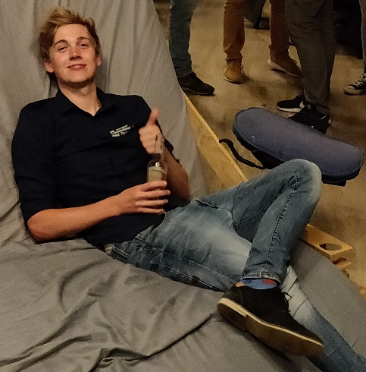
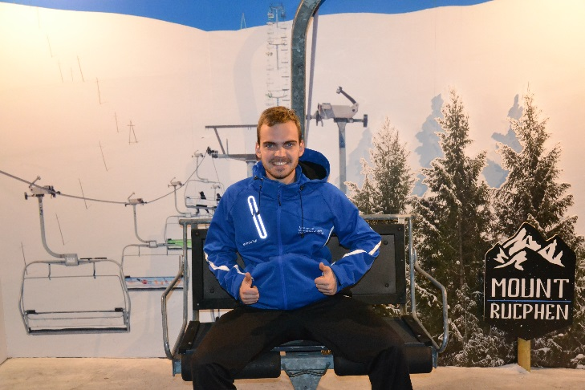

Interested?
Do you want to come a long for one day with one of the board members to get a better picture of a board year? Come by our office or send an e-mail to make an appointment. For further question you can also contact us by e-mail or phone.

Letter of application

We would like to receive your CV and letter of application, which should be maximum 2 A4s. The purpose of this letter is to get to know you better and to discover what your motivations are to become a member, before actually having an interview. There are several questions we would like to see answered, but you are free to fill in the remainder. De questions we like to see answered are written down below.

- Which studies are you in? And in which year?
- What are your connections to sports? And your connections with sports in Wageningen?
- Have you already been active in a board/committee? Which ones, and what did you learn?
- What is your motivation to apply for a board year at SWU Thymos?
- Did you already think about positions within the board? Which positions do you want to take in the board and why? Which function(s) do you not want to take, and why?
- What are your qualities? And what do you want to learn within you board year?
- What are your bad and good personality traits. How can this contribute to the board and which traits might be challenging for the rest of the board members?

If you want to apply for a board year at SWU Thymos you can send an e-mail to swu.thymos@wur.nl. In the attachments we would like to see a letter of application with a maximum of 2 A4s in which you describe the topics you find below. Furthermore, you have to send your CV. The deadline to apply is Sunday the 24th of March 2019. If you have any further questions, you can always visit us at our office or call to 0317-482746.

With sportive regards ,

Charlotte Stam & Steffie Loenen
Selection committee SWU Thymos 2018-2019

