- Data Management Protocol –
MSc-version
Horticulture and Product Physiology group

Part 1: Data Management Plan

Thesis title:

Author:

Date:

Table of Contents
Part 1 – Data Management Plan (MSc)
1. Describe the organizational context 1
2. Give a short description of your research project 1
3. Define data management roles 2
4. Give an overview of expected type of research data, software choices, data size & growth 2
5. Short term storage solutions 3
6. Structuring your data and information 4
Part 2 - Data Management Report (MSc)
1. Describe the organizational context 1
2. Give an overview of collected type of research data, software choices, data size 1
3. Structure of archived data and information 2
4. Long term storage solutions 3
5. Completion of data storage and approval 3

Note: for explanations and examples you are referred to documentation which will become available on the HPP-website (http://www.hpp.wur.nl). For more information contact menno.bakker@wur.nl.
For more detailed information on the Wageningen UR policy for Data Management see information on the Data Management Support Hub.
1. Describe the organizational context
Name
Date
Chair group(s) | Horticulture and Product Physiology
Supervisor(s)
Technical staff *)
Start date of project
(dd-mm-yyyy)
File name of the DMP
yymmdd-WUR_account
*) only fill in when applicable
2. Give a short description of your research project
Title
(max. 3 lines)
Abstract

3. Define data management roles
Roles
Who is collecting the data? | student
Who is storing data (short term) | student (regularly hands in subsets to supervisor)
Who is storing data (long term/archive) | HPP-staff (contact Menno Bakker)
Who is analysing the data? | student (in consultation with supervisor)
Other  (Is there a person in the research group with a specific responsibility for data management? Do other persons contribute, for example by writing code?) | Menno Bakker (HPP)
What is the role of your supervisor? | Advice and responsibility for completion of short and long term storage

4. Give an overview of expected type of research data, software choices, data size & growth

Data stage | Specification of type of research data | Software choice | File  type ***) | Data size/  growth
Raw data ( original and corrected * *)
Processed data
Models (description/ code/ scenarios) *)
Other? *)
*) only fill in when applicable
^{**)} error correction of raw data, other than typing errors, should be marked and described
***) specify file type by extension (.csv, .xlsx, ….)
5. Short term storage solutions
Describe where the data will be stored physically and how the back-up is organised.

Data stage | Storage medium/location | Backup procedures  (how often?)
Raw data
Processed data
Models (description/code/ scenarios/in- & output) *)
Copy at home
Copy for supervisor **)
*) only fill in when applicable
**) only relevant data, e.g. data used for presenting and discussing (intermediate) results

6. Structuring your data and information
Give a visual representation of the system for directory- and file names you intend to use.

Proposed directory- and file naming structure:
Note: the suggested main directory- and file-naming structure must be followed from the start. When changes are made afterwards then there is a risk that the full name (root+sub-folders+filenames) will become too long and storage/retrieval of the data may become impossible.
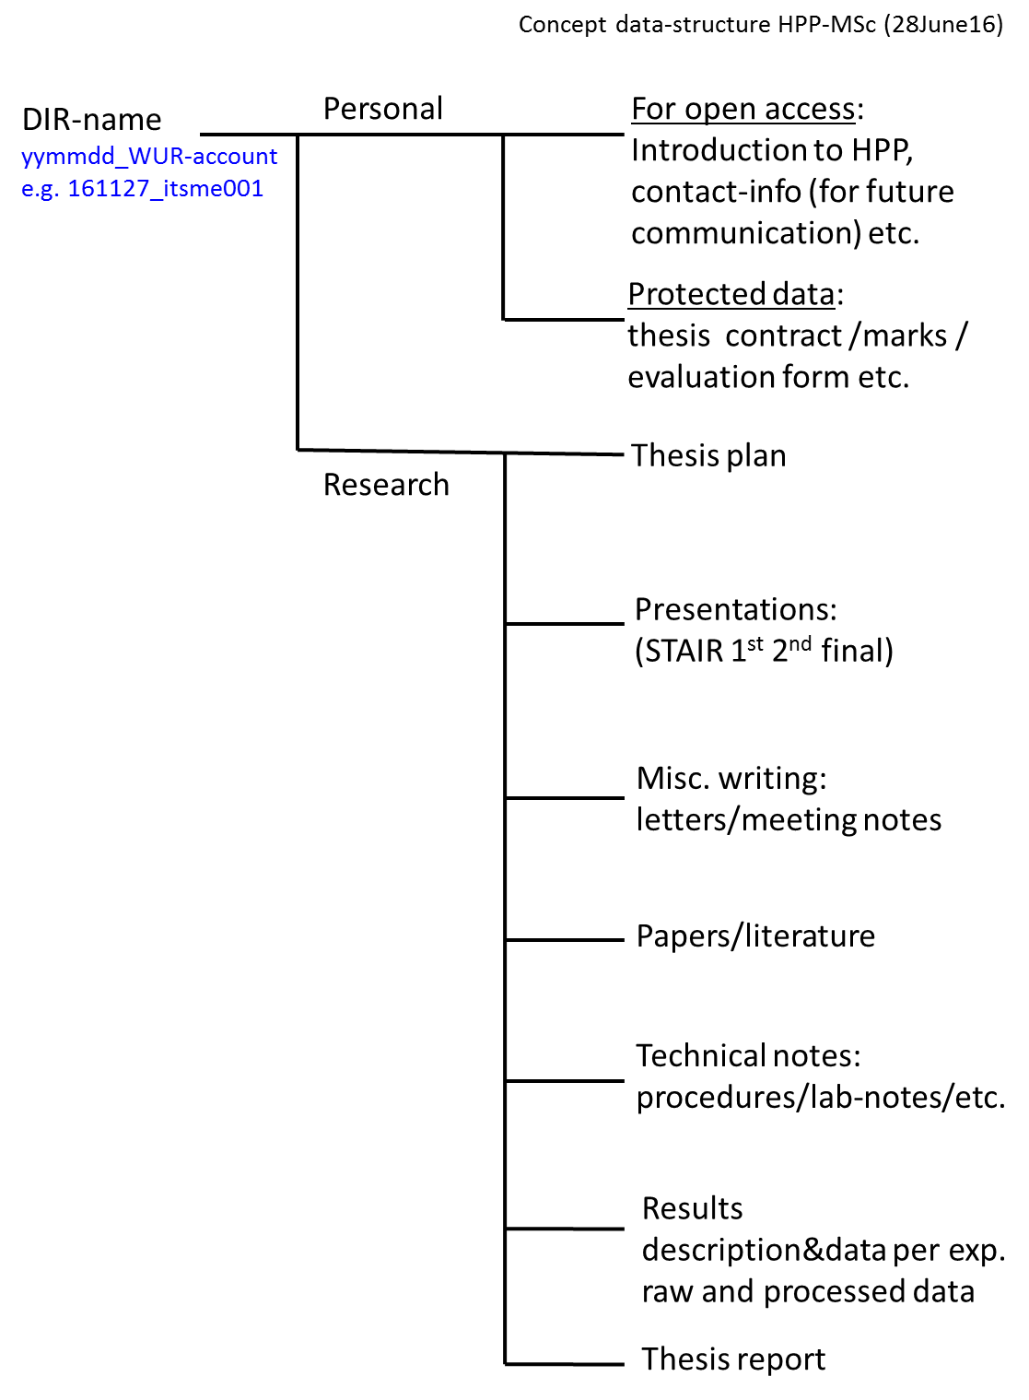

- Data Management Protocol -
MSc-version
Horticulture and Product Physiology group

Part 2: Data Management Report

Thesis title:

Author:

Date:

Note: for explanations and examples you are referred to documentation which will become available on the HPP-website (http://www.hpp.wur.nl). For more information contact menno.bakker@wur.nl.
For more detailed information on the Wageningen UR policy for Data Management see information on the Data Management Support Hub.
1. Describe the organizational context
Name
Date
Chair group | Horticulture and Product Physiology
Title of the project
(max. 3 lines)
Supervisor(s)
Technical staff *)
Start date of project
(dd-mm-yyyy)
End date of project
(dd-mm-yyyy)
File name of the DMP
yymmdd-WUR_account
*) only fill in when applicable

2. Give an overview of collected type of research data, software choices, data size (answers can be the same as in the Data Management Plan)

Data stage | Specification of type of research data | Software choice | File  type ***) | Data size
Raw data ( original and corrected * )
Processed data
Models (description/ code/ scenarios) *)
Other? *)
*) only fill in when applicable
^{**)} error correction of raw data, other than typing errors, should be marked and described
***) specify file type by extension (.csv, .xlsx, ….)
3. Structure of archived data and information
Give a visual representation of the system for directory- and file names applied for the archived data.

Present the applied directory- and file naming structure:

4. Long term storage solutions
Describe where the data have been stored physically and how archive management is organised.
Data stage | Storage location
Raw data
Processed data
Models (description/code/ scenarios/in- & output) *)
Who will manage archived data | Storage of accepted data-sets handed in by students will be arranged by HPP (contact Menno Bakker)
*) only fill in when applicable
5. Completion of data storage and approval.
Date:
Data-set was handed in to: …………………………………..
Handed in by: ………………………………….. Signature: …………………………………..
Approved by: ………………………………….. Signature: …………………………………..

