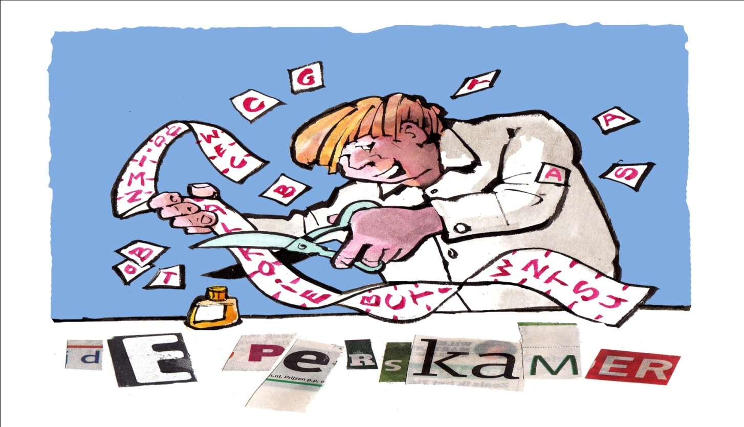

Societal Impact of your research

WIAS Training Course: 6, 13 and 20 February 2019
Wageningen Campus, Zodiac Building, room E1244
(group work also in room E1240)

Workshop 1, 6 February

13.30-14.00: Introduction Training Course.

14.00-15.15: Presentation Pitches:

Before the workshop, the participants will be provided with information on a few basic techniques on how to effectively present their work in a pitch. During the workshop, the participants will present their research in a very short pitch, max three minutes, in two groups. The other group members will comment on that.

15.15 – 15.30: Break

15.30 – 16.30: Societal Impact, by science journalists Astrid Smit and Rob Buiter.

Who is your target audience?
How do you reach your audience?
How to write an effective press release or a short news article?
In this presentation, theory and practice will be combined. We analyze some good and bad examples of articles. There’s also the option to practice a live interview for e.g. a radio program.

16.30 – 17.00 The workshop will be closed with a round of questions/discussion and the explanation of the ‘homework’ for workshop 2 and 3: write a short news article or press release and prepare a debate on a topic out of your scientific field.

Workshop 2, 13 February

13.30 – 13.45: Welcome and short evaluation of the homework

13.45 - 15.15: We make two groups and will discuss the written articles and press releases.

15.15- 15.30: Break.

15.30-16.15: The pitfalls: what’s the risk when you bring your research in the open?
What can you expect form a journalist? What’s the cost, and what’s the benefit?

16.15 - 16.45: WUR researcher Arnold van Vliet on his experience in presenting research to a broader audience.

16.45 – 17.00: Questions, discussion and finally: the ‘Golden Pen’ for the best article of the participants.

Workshop 3, 21 February

13.30 – 13.45: Welcome and short evaluation of the homework

13.45 - 15.15: We make two groups and Astrid Smit and Marianne Heselmans will discuss the ‘debates’ that the course- members have prepared. The course member chooses a societal topic out of his scientific field and describes in about 400-500 words what the issue is, which speakers he wants to invite to get a good discussion and which outcomes and arguments he expects of the different speakers.

15.15 - 15.30: Break.

15.30 - 16.00: Second round of the news articles, ready to publish?

16.00 – 16.30: Adriaan Rijnsdorp of WUR, gives a presentation about his experiences with debating his research topic with the broad audience.

16.30 – 16.45: Questions, discussion

16.45 – 17.00: Finally: the ‘Golden Glove’ for the best debate of the participants.

www.deperskamer.eu
www.astridsmit.nl
www.robbuiter.nl
www.sciencejournalist.eu/

