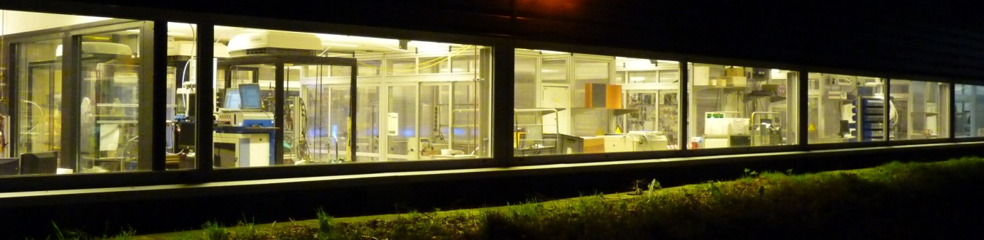

**Modular Biobased and Environmental Sciences and Technology Facility**

A big part of our research is done at the ModuTech.

This are ( 300 m^2 ) has a good infrastructure to do research. It has 24 small cabinets (2 x1 m) and 4 big cabinets (2 x 3 m). Depending on the research projects we change the set-up of the cabinets

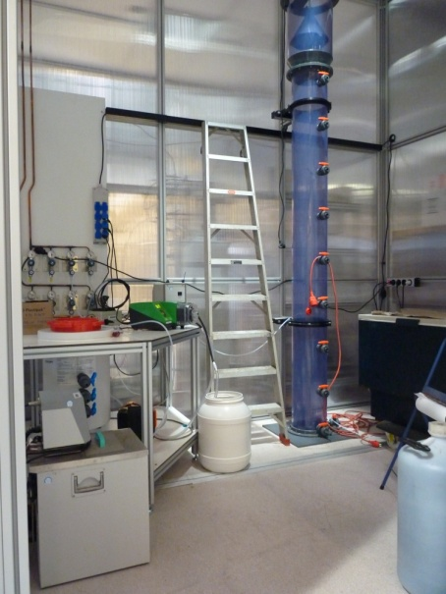 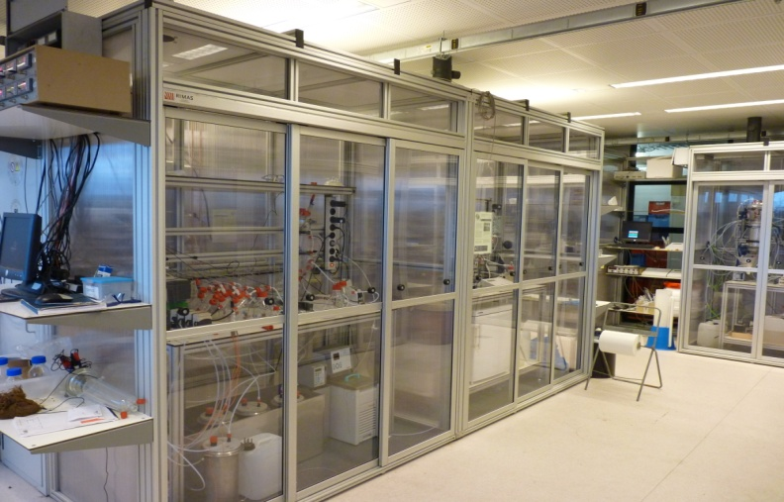

Twelve cabinets are temperature controlled. Four we can control between 25-40 0C and eight we can control between 10-40 0C.

All cabinets are vented. In case of a temperature controlled cabinet we reduce the venting flow to save energy. The venting flow is also switched by the cabinet doors. This means high flow when a door is open, low flow when all doors are closed.

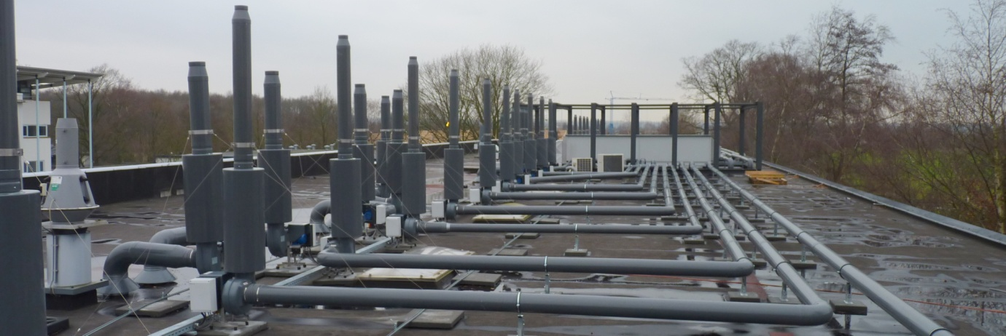

Furthermore we can provide 18 cabinets with gas sensors. This Draeger safety system will detect different toxic gasses as well explosive gases. We have sensors for CH4, H2, H2S and NO2 but Draeger can provide more sensors.

All cabinets are provided with sufficient power 240 V and 380 V. All the cabinets can make use of pressurised Air, Nitrogen and water. For usage of CO2 and O2 ModuTech has some extra connections.

For other gasses like CH4 or H2S ModuTech has gas bottle cabinets for safer storage, placed between the cabinets.

If we want to protect the reactor from direct sun light we can blind the cabinets.

This is also done in the algae project to protect people from artificial light.

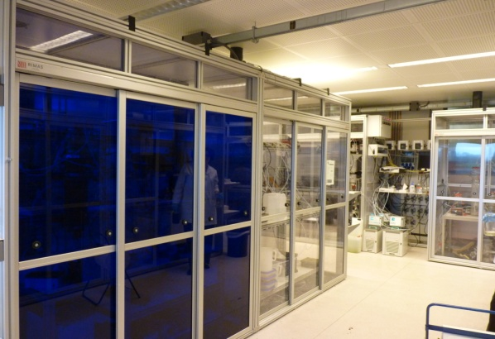 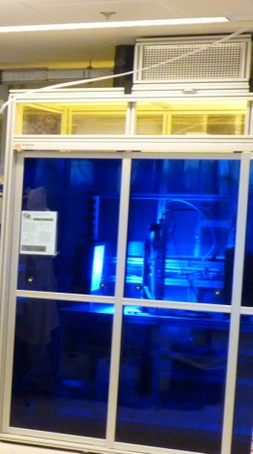

The liquid waste form ModuTech goes via a storage tank to the sewer. In case of accidents we can stop the discharge to the sewer, sample and analyse. If it’s safe we can continue the discharge otherwise we will take proper action.

One of the four big experimental cabinets has a permanent influent station for wastewater.

This wastewater comes from the sewage treatment plant Bennekom.

Bennekom has no industry so it’s mainly municipal wastewater.

If we want to use industrial wastewater we can make use of two 5 m^3 cooled storage tanks

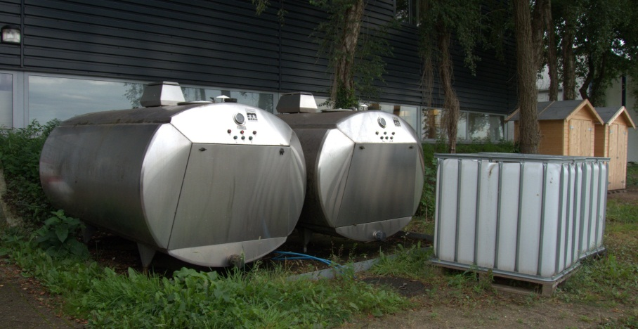

For sanitation research ETE has 2 Roediger Vacuum Toilets, 2 Gustafberg No-mix Toilets, 2 Urimat water free Urinals and a separate grey water collection.

We can choose to put these streams to the sewer or collect them in cooled storage tanks. From these tanks we pump the waste to cabinets in ModuTech.

In combination with long year experience ModuTech is a unique facility for biobased research.

Manny different ETE research projects are now using the facility. It’s even possible to rent a cabinet.

Alterro, Waste2Chemicals, LeAF and Plant-e are companies that are already making use of ModuTech.