Yoda Cookbook
I want to create an account in Yoda
To create an account in Yoda, you have to be invited by an existing user. If you want an invite, but don’t know any existing users, please email data@wur.nl. After you have been invited, you will receive an email with a link and instructions to register a new account.
Note: You will create a separate password for the Yoda service, together with your WUR email to login.
I want to add the Yoda drive to my file explorer
To upload and manage files, you can add Yoda as a network drive to your local pc / Mac. This needs to be done after you have created an account (see step above).
For the below instructions, the URL address of your research environment is:
https://data.yoda.wur.nl
To mount the network drive, follow the steps:
- Generate a Data Access Password: Go to https://yoda.wur.nl and sign in. Click on your profile name in the top right, and select ‘Data Access Password’ in the drop-down menu. In the Data Access Password screen, click ‘Generate new data access password’. In the screen that appears, fill in a label (can be anything you like), and click ‘Generate data access password’. Make sure to copy the generated password to a safe place (i.e. password manager) as it will only be shown once!
- Add the network drive to your PC. Follow the guide here: https://servicedesk.surf.nl/wiki/display/WIKI/Connecting+to+Yoda+via+network+disk . Scroll down for Mac and Linux instructions.
I want to upload files
There are two ways to upload files to Yoda:
- Through the web-portal at https://yoda.wur.nl . Click the ‘Research’ tab and navigate to a folder. In the top bar, there is an ‘Upload’ button.
- Through the network drive (see step above). For large files and datasets, this is more reliable than through the portal. Once the network drive is present on your system, you can copy files to it, create subfolders, etc. This will be uploaded automatically to the system. Note: the network drive uses a different URL: https://data.yoda.wur.nl .
I want to edit metadata
To edit metadata, click the ‘Research’ tab at https://yoda.wur.nl . Enter a folder that you wish to edit the metadata of and press the ‘Metadata’ button. A form appears to edit metadata.
Note: metadata can only be edited at a folder level. Subfolders can inherit metadata by pressing the ‘Clone from parent folder’ button in the metadata form.
I want to invite someone to join Yoda (Group or data manager)
To invite a new user, click the ‘Group manager’ tab at https://yoda.wur.nl . Select the group in which the user should be invited and click the link ‘Click here to add a new user to this group’. Type the full email address of the person you want to invite; it will appear in a dropdown menu with ‘(create)’ at the end. Press this dropdown prompt and the invite will be sent.
Note: you can only invite users if you are ‘Group manager’ of a group. Ask your ‘Data manager’ to promote you if this is not the case.
I want to create a new group (Data manager only)
As data manager, you can create new groups (top level folders) in Yoda. Navigate to the ‘Group manager’ tab in the web portal. In the left column with existing groups, press the ‘Add group’ button at the bottom. A prompt appears in which you can set the properties of the new group; finish by pressing the ‘Add group’ button. The new group now appears in the overview column, select it to add users to the new group.
I want to add specific people to a group
A group manager can add people to a group by selecting the group and pressing ‘Click here to add a new user’. Type the user email to find the new user. If a non-registered user email is typed, ‘(Create)’ appears in brackets behind the email, the user will be automatically invited. See also the ‘I want to invite someone to join Yoda’ above.
Data manager, group manager? What is the difference between these terms?
See the overview below:
Data Manager | Group Manager
- Release data to vault (archive)  - Invite new users by email  - Create / remove groups  - Add / remove users to groups, promote users to group manager | - Add / remove existing Yoda users to the group they are manager of  - Invite new users by email

I want to archive my data
To archive your data, complete the metadata for the folder containing the dataset (and subfolders if applicable) from the web portal. Open the “Actions” menu top right, and select “Submit”. This will put the dataset in the submission queue to review for your data manager. Once the data steward has checked your submission, your data will be released to the Vault and can be viewed at any time in the Vault area of the web portal.
I want to check data that is submitted to the Vault for archive (Data manager only)
As a data manager, you must release submitted data to the vault for archiving. To view the submission queue in the Yoda web portal, open the search menu at the top and select “Search by status”. As a status, select “Submitted for vault”. This will give a list of all submitted data. Select the data you want to inspect, it will open below the results. Inspect the data structure and metadata for compliance with your groups policy, open the “Actions” menu and select “Accept”. See below screenshot.
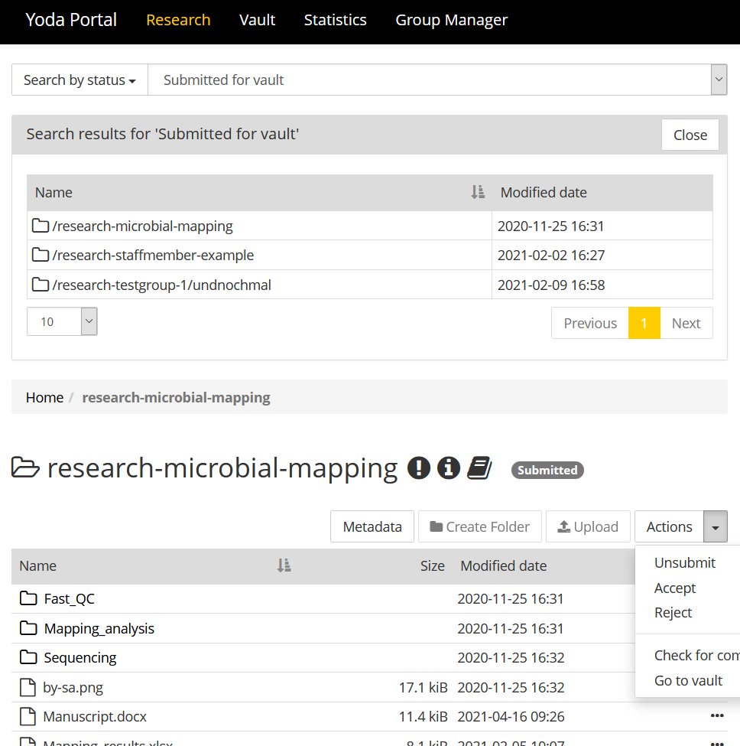
How do I restore a deleted file, or bring back a previous version?
In the YODA portal, access the ‘Research’ tab. In the search box, select ‘Search revision by name’. Search for the file, this search is case sensitive! The file will pop up, with all stored versions. Click on a version to restore it. This also works for deleted files. See also the screenshot below:
